|  |  |  |  |
| --- | --- | --- | --- |
|  |  | E/ECE/324/Rev.2/Add.128/Rev.4−E/ECE/TRANS/505/Rev.2/Add.128/Rev.4 | |
|  |  | | 24 September 2020 |

Agreement

Concerning the Adoption of Harmonized Technical United Nations Regulations for Wheeled Vehicles, Equipment and Parts which can be Fitted and/or be Used on Wheeled Vehicles and the Conditions for Reciprocal Recognition of Approvals Granted on the Basis of these United Nations Regulations[1]*

(Revision 3, including the amendments which entered into force on 14 September 2017)

________________

Addendum 128: UN Regulation No. 129

Revision 4

Supplement 3 to the 02 series of amendments – Date of entry into force: 29 December 2018  
03 series of amendments – Date of entry into force: 29 December 2018

Uniform provisions concerning the approval of Enhanced Child Restraint Systems used on board of motor vehicles

This document is meant purely as documentation tool. The authentic and legal binding texts are:

ECE/TRANS/WP.29/2018/42 and ECE/TRANS/WP.29/2018/45.

_______________



**UNITED NATIONS**

UN Regulation No. 129

Uniform provisions concerning the approval of Enhanced Child Restraint Systems used on board of motor vehicles

Contents

*Page*

Regulation

1. Scope 5

2. Definitions 5

3. Application for approval 12

4. Markings 13

5. Approval 19

6. General specifications 20

7. Tests 43

8. Test reports of type approval and of production qualification 61

9. Production qualification 62

10. Conformity of production and routine tests 63

11. Modification and extension of approval of an Enhanced Child Restraint System 64

12. Penalties for non-conformity of production 64

13. Production definitively discontinued 64

14. Information for users 65

15. Names and addresses of Technical Services responsible for conducting approval tests and   
 of Type Approval Authorities 67

16. Transitional provisions 67

Annexes

1 Communication 68

2 Arrangements of the approval mark 70

3 Arrangement of apparatus for dust resistance test 75

4 Corrosion test 76

5 Abrasion and microslip test 78

6 Description of trolley 81

Appendix 1 86

Appendix 2 - Arrangement and use of anchorages on the test trolley 88

Appendix 3 - Definition of side impact door 91

Appendix 4 - Stopping device frontal impact 94

7 Curve of trolley's deceleration or acceleration, as function of time 97

Appendix 1 - Frontal impact 98

Appendix 2 - Rear impact 99

Appendix 3 - Lateral impact 100

8 Description of dummies 101

9 Frontal impact test against a barrier 106

10 Rear impact test procedure 107

11 Type approval scheme (Flow chart ISO 9002:2000) 109

12 Control of conformity of production 111

13 Test of energy absorbing material 115

14 Method of defining head impact area of devices with backrests or impact shields and   
for rearward-facing devices defining the minimum size of side wings 116

15 Description of conditioning for adjusters connected to a strap 117

16 Typical buckle strength test device 118

17 Determination of performance criteria 119

18 Geometrical dimensions of Enhanced Child Restraint Systems 120

19 Assessment volumes for i-size support-legs and support-leg feet 128

20 Minimum list of documents required for approval 132

21 Load application devices 133

22 Flammability of materials intended to be used in built-in Enhanced Child Restraint Systems 137

23 Standard safety-belt 140

24 Additional attachment points required for securing rearward facing Enhanced Child Restraint   
System, of category Specific vehicle Belted, to motor vehicles 145

1. Scope

This Regulation applies (in Phases 1, 2 and 3) to the following child restraint system for child occupants of power driven vehicles:

(a) Integral Universal ISOFIX Enhanced Child Restraint Systems (i-Size);

(b) Integral Specific vehicle ISOFIX Enhanced Child Restraint Systems;

(c) Non-integral Universal Enhanced Child Restraint Systems (i-Size booster seat);

(d) Non-integral Specific vehicle Enhanced Child Restraint Systems (Specific vehicle booster seat);

(e) Integral Universal Belted Enhanced Child Restraint Systems;

(f) Integral Specific vehicle Belted Enhanced Child Restraint Systems.

2. Definitions

For the purposes of this Regulation,

2.1. "*Enhanced* *Child Restraint System*" (ECRS) means a device capable of accommodating a child occupant in a sitting or supine position. It is so designed as to diminish the risk of injury to the wearer, in the event of a collision or of abrupt deceleration of the vehicle, by limiting the mobility of the child's body.

2.2. "*Child restraint type*" means an Enhanced Child Restraint System which does not differ in such essential respects as:

The category in which the restraint is type approved;

The design, material and construction of the Enhanced Child Restraint System.

Convertible or modular Enhanced Child Restraint Systems shall be considered to not differ in their design, material and construction.

2.3. "*Integral Universal*" and "*Non-Integral Universal*"

2.3.1. "*i-Size*" (Integral Universal ISOFIX Enhanced Child Restraint Systems) is a category of Enhanced Child Restraint System primarily designed for use in all i-Size seating position of a vehicle, as defined and approved according to UN Regulations Nos. 14 or 145 and 16.

2.3.2. "*Universal Belted*" (Integral Universal Belted Enhanced Child Restraint System) is a category of Enhanced Child Restraint System primarily designed to be attached only by the adult safety-belt in all universal seating positions of a vehicle, as defined and approved according to UN Regulation No. 16.

2.3.3. "*i-Size booster seat*" (Non-Integral Universal Enhanced Child Restraint System) is a category of Enhanced Child Restraint Systems with integrated backrest and stowable ISOFIX attachments if any, primarily designed for use in all i-Size seating positions of a vehicle.

2.4. "*Integral*" and "*Non-Integral*"

2.4.1. "*Integral*" is a class of Enhanced Child Restraint System, meaning that the child is restrained only by components which comprise the Enhanced Child Restraint System (e.g. strap harness, impact shield, etc.), and not by means connected directly to the vehicle (e.g. adult seat belt).

2.4.2. "*Non-Integral*" is a class of Enhanced Child Restraint System, meaning that the retention of the child within the Enhanced Child Restraint System is achieved by means connected directly to the vehicle (e.g. adult seat belt).

2.5. "*ISOFIX*" is a system that provides a method of connecting an Enhanced Child Restraint System to a vehicle. It is based on two vehicle anchorages and two corresponding attachments on the Enhanced Child Restraint System in conjunction with a means to limit the pitch rotation of the Enhanced Child Restraint System. All three vehicle anchorages are to be approved according to UN Regulation No. 14. or UN Regulation No.145.

2.6. "*Integral Universal ISOFIX*" is an ISOFIX Enhanced Child Restraint System comprising either a top-tether or a support-leg, to limit the pitch rotation of the Enhanced Child Restraint System, attached to, or supported by, the corresponding vehicle.

2.7. "*Specific vehicle ECRS*"

2.7.1. "*Specific vehicle ISOFIX*" is a category of Integral Enhanced Child Restraint System connecting to specific vehicle types. All vehicle anchorages are to be approved according to UN Regulation No. 14 or UN Regulation No. 145. It is also an indication for Enhanced Child Restraint Systems including dashboard as a vehicle contact zone.

2.7.2. *"Specific vehicle booster seat"* is a category of Non-Integral Enhanced Child Restraint System, with integrated backrest, for use in specific vehicle types, with vehicle anchorages approved according to UN Regulation No. 14 or UN Regulation No. 145. This category includes "Built-in booster seats".

2.7.3. "*Specific vehicle Belted*" is a category of Integral Enhanced Child Restraint System connected to specific vehicle types by using the vehicle safety belt. Additional vehicle anchorage points approved by UN Regulation No. 145 may be used. Any attachment points required for securing rearward facing Enhanced Child Restraint System shall be checked according to Annex 25. Enhanced Child Restraint Systems that use the vehicle dashboard as a contact zone are permitted.

2.8. "*Size*" indicates the stature of the child.

2.8.1. "*Size range*" is a range for which the Enhanced Child Restraint System has been designed and approved.

2.8.2. Enhanced Child Restraint Systems may cover any size range provided that all requirements of this Regulation are fulfilled.

2.9. "*Orientation*" indicates a direction in which an Enhanced Child Restraint System has been approved for use. The following distinctions are made:

(a) Forward-facing means facing in the normal direction of travel of the vehicle;

(b) Rearward-facing means facing in the direction opposite to the normal direction of travel of the vehicle;

(c) Lateral-facing means facing perpendicular to the normal direction of travel of the vehicle.

2.10. *"Special Needs Restraint*" is an Enhanced Child Restraint System designed for children who have special needs as a result of either a physical or mental disability; this device may in particular permit additional restraining devices for any part of the child, but it shall contain as a minimum a primary means of restraint which complies with the requirements of this Regulation.

2.11. "*ISOFIX anchorage system*" means a system made up of 2 ISOFIX low anchorages fulfilling the requirements of UN Regulation No. 14 or UN Regulation No. 145 which is designed for attaching an ISOFIX Enhanced Child Restraint System in conjunction with an anti-rotation device.

2.11.1. "*ISOFIX low anchorage*" means one 6 mm diameter rigid round horizontal bar, extending from vehicle or seat structure to accept and restrain an ISOFIX Enhanced Child Restraint System with ISOFIX attachments.

2.11.2. "*ISOFIX attachment*" means one of the two connections, fulfilling the requirement of paragraph 6.3.3. of this Regulation, extending from the ISOFIX Enhanced Child Restraint System structure, and compatible with an ISOFIX low anchorage.

2.12. "*Anti-rotation device*"

Means a device intended to limit the rotation of the Enhanced Child Restraint System during a vehicle impact and consisting of:

(a) A top-tether strap; or

(b) A support-leg.

Meeting the requirements of this Regulation and fitted to an ISOFIX anchorage system and ISOFIX top tether anchorages or vehicle floor contact surface meeting the requirements of UN Regulation No. 14 or UN Regulation No. 145.

An "Anti-rotation device" for a "specific vehicle" Enhanced Child Restraint System may comprise a top tether, a support-leg or, any other means capable of limiting the rotation**.**

2.13. "*ISOFIX top tether strap*" means a webbing strap (or equivalent) which extends from the top of an ISOFIX Enhanced Child Restraint System to the ISOFIX top tether anchorage, and which is equipped with an adjustment device, a tension-relieving device, and an ISOFIX top tether connector.

2.13.1. "*ISOFIX top tether anchorage*" means a feature fulfilling the requirements of UN Regulation No. 14 or UN Regulation No. 145, such as a bar, located in a defined zone, designed to accept an ISOFIX top tether connector and transfer its restraint force to the vehicle structure.

2.13.2. "*ISOFIX top tether connector*" means a device intended to be attached to an ISOFIX top tether anchorage.

2.13.3. "*ISOFIX top tether hook*" means an ISOFIX top tether connector typically used to attach an ISOFIX top tether strap to an ISOFIX top tether anchorage as defined in figure 3 of UN Regulation No. 14 or UN Regulation No. 145.

2.13.4. "*ISOFIX top tether attachment*" is a device to secure the ISOFIX top tether strap to the ISOFIX Enhanced Child Restraint System.

2.14. "*Tension relieving device*" means a system which allows to release the device that adjusts and maintains the tension in the ISOFIX top tether strap.

2.15. "*Support-leg*" means an anti–rotation device permanently attached to an Enhanced Child Restraint System creating a load path between the Enhanced Child Restraint System and the vehicle structure. A support-leg shall be adjustable in length (Z direction) and may be additionally adjustable in other directions.

2.15.1. "*Support-leg foot*" means one or more part(s) of the support-leg of the Enhanced Child Restraint System intended (by design) to engage with the vehicle floor contact surface and designed to transmit the loading from the support-leg to the vehicle structure during a frontal impact.

2.15.2. "*Support-leg foot contact surface*" means the surface of the support-leg foot physically in contact with the vehicle floor contact surface and designed to spread the loads across the vehicle structure.

2.15.3. "*Support-leg foot assessment volume*" describes a spatial volume which denotes both the extent and limitations for the movement of the support-leg foot. It corresponds to the support-leg foot assessment volume for vehicles, as defined in Annex 10 of UN Regulation No. 14 or UN Regulation No. 145, Annex 5.

2.15.4. "*Support-leg dimension assessment volume*" means a volume defining the maximum dimensions of a support-leg, corresponding to the support-leg installation assessment volume for vehicles, as defined in Annex 17 to UN Regulation No. 16, ensuring the dimensional installation of a support-leg of an i-Size ECRS in an i-Size seating position of a vehicle.

2.16. "*CRF pitch angle*" is the angle between the bottom surface of the fixture "ISO/F2 (B) as defined in UN Regulation No. 16 (Annex 17, Appendix 2, Figure 2) and the horizontal Z plane of the vehicle as defined in UN Regulation No. 14 (Annex 4, Appendix 2) or UN Regulation No. 145 (Annex 3, Appendix 2), with the fixture installed in the vehicle as defined in UN Regulation No. 16 (Annex 17, Appendix 2).

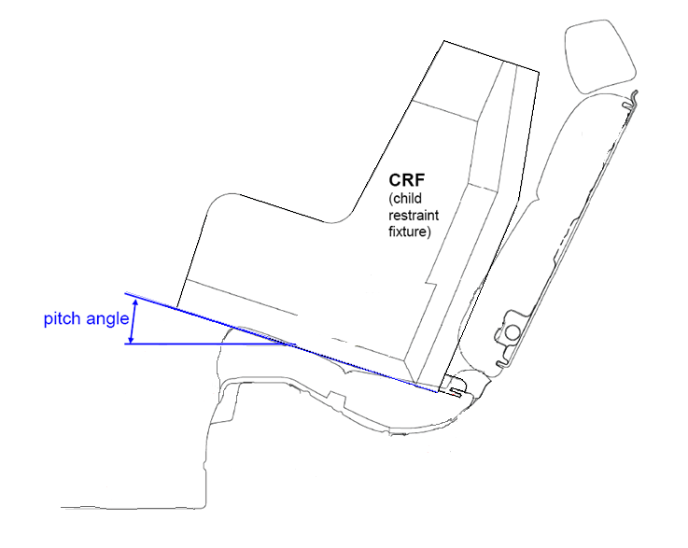

2.17. "*Vehicle Seat Fixture*"

2.17.1. "*ISOFIX Vehicle seat fixture*" means a fixture, according to ISOFIX size envelopes whose dimensions are given in Figures 1 to 7 of Appendix 2 to Annex 17 to UN Regulation No. 16, used by an Enhanced Child Restraint System manufacturer to determine the appropriate dimensions of an Integral Universal Belted Enhanced Child Restraint System or an ISOFIX Enhanced Child Restraint System including the location of its ISOFIX attachments.

2.17.2. "*i-Size booster seat fixture*" means a fixture, of the dimensions given in Figure 1 of Annex 17, Appendix 5 to UN Regulation No. 16 and used by an Enhanced Child Restraint System manufacturer to determine the appropriate dimensions of a i-Size booster seat and its compatibility with most vehicle seating positions and, in particular, those which have been assessed without ISOFIX attachments,[2] according to UN Regulation No. 16 as being compatible with such a category of an Enhanced Child Restraint System.

2.18. "*Child-safety chair*" means an Enhanced Child Restraint System incorporating a chair in which the child is held.

2.19. "*Chair*" means a structure which is a constituent part of the Enhanced Child Restraint System and is intended to accommodate a child in a seated position.

2.20. "*Chair support*" means that part of an Enhanced Child Restraint System by which the chair can be raised.

2.21. "*ECRS Belt*" means an Enhanced Child Restraint System comprising a combination of straps with a securing buckle, adjusting devices and attachments.

2.22. "*Harness belt*" means an ECRS belt assembly comprising a lap strap, shoulder restraints and a crotch strap.

2.23. "*Y-shaped belt*" means an ECRS belt where the combination of straps is formed by a strap to be guided between the child's legs and a strap for each shoulder.

2.24. "*Carry cot*" means a restraint system intended to accommodate and restrain the child in a supine or prone position with the child's spine perpendicular to the median longitudinal plane of the vehicle. It is so designed as to distribute the restraining forces over the child's head and body excluding its limbs in the event of a collision.

2.25. "*Carry-cot restraint*" means a device used to restrain a carry-cot to the structure of the vehicle.

2.26. "*Infant carrier*" means an Integral Enhanced Child Restraint System that restrains a child up to 15 months old and up to 83 cm stature intended to accommodate the child in a rearward-facing semi-recumbent position. It is so designed as to distribute the restraining forces over the child's head and body excluding its limbs in the event of the frontal collision. It is designed to be removed from the vehicle with the child inside and without opening any harness, and to be carried it outside of the vehicle.

2.27. "*Child support*" means that part of an Enhanced Child Restraint System by which the child can be raised within the Enhanced Child Restraint System.

2.28. "*Impact shield*" means a device secured in front of the child and designed to distribute the restraining forces over the greater part of the height of the child's body in the event of a frontal impact.

2.29. "*Strap*" means a flexible component designed to transmit forces.

2.30. "*Lap strap*" means a strap which, either in the form of a complete ECRS belt or in the form of a component of such an ECRS belt passes across the front of, and restrains, directly or not, the child's pelvis.

2.31. "*Shoulder strap*" means that part of an ECRS belt which restrains the child's upper torso.

2.32. "*Crotch strap*" means a strap (or divided straps, where two or more pieces of webbing make it) attached to the Child Restraint System and the lap strap and is so positioned as to pass between the child's thighs; it is designed to prevent the child sliding under the lap strap in normal use and prevent the lap strap moving up off the pelvis in an impact.

2.33. "*Child-restraining strap*" means a strap which is a constituent part of the ECRS belt (harness) and restrains only the body of the child.

2.34. "*Buckle*" means a quick release device which enables the child to be held by the restraint or the restraint by the structure of the car and can be quickly opened. The buckle may incorporate the adjusting device.

2.35. "*Enclosed buckle release button*", a buckle release button such that it shall not be possible to release the buckle using a sphere having a diameter of 40 mm.

2.36. "*Non-enclosed buckle release button*", a buckle release button such that it shall be possible to release the buckle using a sphere having a diameter of 40 mm.

2.37. "*Adjusting device*" means a device enabling the ECRS belt or its attachments to be adjusted to the physique of the wearer. The adjusting device may either be part of the buckle or be a retractor or any other part of the ECRS belt.

2.38. "*Quick adjuster*" means an adjusting device which can be operated by one hand in one smooth movement.

2.39. "*Adjuster mounted directly on Enhanced Child Restraint System*" means an adjuster for the harness belt which is directly mounted on the Enhanced Child Restraint System, as opposed to being directly supported by the strap that it is designed to adjust.

2.40. "*Energy absorber*" means a device which is designed to dissipate energy independently of or jointly with the strap and forms part of an Enhanced Child Restraint System.

2.41. "*Retractor*" means a device designed to accommodate a part or the whole of the strap of an Enhanced Child Restraint System. The term covers the following devices:

2.41.1. "*Automatically-locking retractor*", a retractor which allows extraction of the desired length of a strap and, when the buckle is fastened, automatically adjusts the strap to the wearer's physique, further extraction of the strap without voluntary intervention by the wearer being prevented.

2.41.2. "*Emergency-locking retractor*", a retractor which does not restrict the strap wearer's freedom of movement in normal driving conditions. Such a device has length-adjusting devices which automatically adjust the strap to the wearer's physique, and a locking mechanism actuated in an emergency by:

2.41.2.1. Deceleration of the vehicle, extraction of the strap from the retractor, or any other automatic means (single sensitivity);

2.41.2.2. A combination of any of these means (multiple sensitivity).

2.42. "*Inclined position*" means a special position of the chair which allows the child to recline.

2.43. "*Lying down/supine/prone position*" means a position where at least the child's head and body excluding its limbs are on a horizontal surface when at rest in the restraint.

2.44. "*Vehicle seat*" means a structure, which may or may not be integral with the vehicle structure, complete with trim and intended to seat one adult person. In this respect:

2.44.1. *"Group of vehicle seats*" means either a bench seat or a plurality of seats which are separate but side by side (i.e. so fixed that the front anchorages of one seat are in line with the front or rear anchorages of another seat or on a line passing between those anchorages), each seat accommodating one or more seated adult persons.

2.44.2. "*Vehicle bench seat*" means a structure complete with trim and intended to seat more than one adult person.

2.44.3. "*Vehicle front seats*" means the group of seats situated foremost in the passenger compartment, i.e. having no other seat directly in front of them.

2.44.4. *"Vehicle rear seats*" are fixed, forward-facing seats situated behind another group of vehicle seats.

2.45. "*Seat type*" means a category of adult seats which do not differ in such essential respects as the shape, dimensions and materials of the seat structure, the types and dimensions of the seat-lock adjustment and locking systems, and the type and dimensions of the adult safety-belt anchorage on the seat, of the seat anchorage, and of the affected parts of the vehicle structure.

2.46. "*Adjustment system*" means the complete device by which the vehicle seat or its parts can be adjusted to suit the physique of the seat's adult occupant; this device may, in particular, permit longitudinal displacement, and/or vertical displacement, and/or angular displacement.

2.47. "*Vehicle seat anchorage*" means the system, including the affected parts of the vehicle structure, by which the adult seat as a whole is secured to the vehicle structure.

2.48. "*Displacement system*" means a device enabling the adult seat or one of its parts to be displaced angularly or longitudinally, without a fixed intermediate position, to facilitate the entry and exit of passengers and the loading and unloading of objects.

2.49. "*Locking system*" means a device ensuring that the adult seat and its parts are maintained in the position of use.

2.50. "*Seat bight"* means the area close to the intersection of the surfaces of the vehicle seat cushion and the seat-back.

2.51. "*ECRS position*"

2.51.1. *"ISOFIX position"* means a location as defined in UN Regulation No. 14 or UN Regulation No. 145.

2.51.2. "*i-Size seating position*" means a seating position, declared by the vehicle manufacturer, which is designed to accommodate any i-Size Enhanced Child Restraint System, as defined in this Regulation.

2.51.3. "*Universal seating position*" means a location in accordance with paragraph 8.2.2.5.2.(b) of UN Regulation No. 16.

2.52. "*Type approval test*", means a test to determine the extent to which an Enhanced Child Restraint System type submitted for approval is capable of satisfying the requirements.

2.53. "*Production qualification test (qualification of production test)*", means a test to determine whether the manufacturer is able to produce an Enhanced Child Restraint System in conformity with the Enhanced Child Restraint Systems submitted for type approval.

2.54. "*Routine testing*" (or conformity of production testing), means the testing of a number of restraint systems selected from a single batch to verify the extent to which they satisfy the requirements.

2.55. "*Shoulder strap positioner*" means a device intended to maintain, the appropriate shoulder strap position on the child's torso, during normal transit conditions by connecting the shoulder straps to one another.

2.56. "*Lock-off device*" locks and prevents movement of one section of the webbing of an adult safety-belt relative to another section of the webbing of the same belt. Such devices may act upon either the diagonal or the lap sections or secure together both lap and diagonal sections of the adult belt. The term covers the following classes:

2.56.1."*Class A device*" prevents the child from pulling the webbing of the retractor through to the lap part of the belt, when the adult belt is used to restrain the child directly (Non-Integral Enhanced Child Restraint System).

2.56.2."*Class B device*" allows the retention of an applied tension in the lap part of an adult safety-belt, when the adult belt is used to restrain IntegralEnhanced Child Restraint System. The device intends to prevent the webbing from slipping from the retractor through the device, which would release the tension and place the restraint in a non-optimal position.

2.57. "*Module*", is a part of an Enhanced Child Restraint System that is separate from the ISOFIX attachments and hosts and restrains the child. A module can be used in combination with one or more base if allowed in this Regulation, as a stand-alone Integral Universal Belted to restrain a child in a vehicle.

2.58. "*Base*", is a part of an Enhanced Child Restraint System that forms an interface between the vehicle and the module of an Enhanced Child Restraint System and has no direct contact with the child. A base is connected to the vehicle using ISOFIX anchorages or a vehicle safety-belt and an anti-rotation device if applicable.

A base is allowed to accept more than one module (Module A can be replaced by Module B, etc.).

2.59. "*Built in*", is an Enhanced Child Restraint System made as an integral part or incorporated as an add-on part of a vehicle. The vehicle manufacturer shall be the applicant for approval.

2.60. "*Belt route*", means the trajectory of the adult safety-belt to be used to fasten the ECRS (integral ECRS) or to restrain the child (non integral ECRS). Trajectories for symmetrical installation of the ECRS are considered as a single belt route.

2.61. "*Webbing path*", means the defined points on the ECRS where the webbing of the adult safety-belt must pass to conform with the belt route as specified by the ECRS manufacturer.

3. Application for approval

3.1. The application for approval of a type of Enhanced Child Restraint System shall be submitted by the holder of the trade mark or by his duly accredited representative and follow the type approval scheme described in Annex 11.

3.2. The application for approval, relating to each type of Enhanced Child Restraint System, shall be accompanied by:

3.2.1. A technical description of the Enhanced Child Restraint System, specifying the straps and other materials used together with the predicted and reproducible behaviour of load limiting devices. It shall be accompanied by drawings of the parts making up the Enhanced Child Restraint System and in the case of retractors, installation instructions for these retractors and their sensing devices, declaration on toxicity (paragraph 6.3.1.1. of this Regulation) and flammability (paragraph 6.3.1.2. of this Regulation), the drawings shall show the position intended for a single approval number and additional symbol(s) in relation to the circle of the approval mark;

3.2.2. The applicant shall indicate the kind of application:

(a) Application for an i-Size Enhanced Child Restraint Systems; or

(b) Application for a specific vehicle ISOFIX Enhanced Child Restraint System; or

(c) Application for a i-Size booster seat Enhanced Child Restraint System; or

(d) Application for a specific vehicle booster seat Enhanced Child Restraint System; or

(e) Application for a Universal Belted Enhanced Child Restraint Systems; or

(f) Application for Specific vehicle Belted Enhanced Child Restraint Systems; or

(g) Any combination of (a), (b), (c) and (d) as long as they fulfil paragraph 5.4.2.2., 6.1.2. and 6.1.3. provided there is only one belt route or

(h) Any combination of (c), (d), (e), (f), as long as they fulfil paragraphs 5.4.2.2., 6.1.2. and 6.1.3. provided there is only one belt route and that the booster seat is not equipped with ISOFIX connectors

3.2.3. For Enhanced Child Restraint Systems tested on the test trolley in a vehicle body shell in conformity with paragraph 7.1.3.2. of this Regulation or in a complete vehicle in conformity with paragraph 7.1.3.3. of this Regulation, the applicant shall submit documentation (drawings and/or pictures) regarding the combination of the Enhanced Child Restraint System and the car or the ISOFIX seating position and the relevant car environment for which the manufacturer has requested a Specific vehicle approval. This documentation needs to indicate:

(a) The available area around the Enhanced Child Restraint System when installed on the vehicle seating position. In particular it shall include parts which might interfere with the Enhanced Child Restraint System during an impact;

(b) All relevant vehicle parts which might influence the (rotational) movement of the Enhanced Child Restraint System during an impact, due to their strength or stiffness.

3.2.4. Samples of the Enhanced Child Restraint System requested by the Technical Service responsible for conducting the test;

3.2.5. A 10-metre length of each type of strap used in the Enhanced Child Restraint System; and

3.2.6. Instructions and details of packaging in accordance with paragraph 14. of this Regulation.

3.2.7. In case of a specific vehicle application when tests are performed in a vehicle body shell, a body of the vehicle, including adult seats and the relevant parts of the car environment shall be available.

3.3. Annex 20 lists the minimum documents required to accompany the application for approval as indicated in paragraph 3.2. above and required elsewhere in this Regulation.

3.4. The Type Approval Authority of a Contracting Party shall verify, before granting type approval the existence of satisfactory arrangements and procedures for ensuring effective control so that Enhanced Child Restraint Systems, equipment or parts when in production conform to the approved type.

4. Markings

4.1. The samples of Enhanced Child Restraint Systems, including all modules submitted for approval in conformity with the provisions of paragraphs 3.2.4. and 3.2.5. above shall be clearly and indelibly marked with the manufacturer's name, initials or trade mark.

4.2. The Enhanced Child Restraint System, including all modules, except the strap(s) or harness, shall be marked clearly and indelibly with the year of production.

4.3. The following information shall be clearly indicated on the product:

(a) The orientation of the Enhanced Child Restraint System relative to the vehicle;

(b) The size range(s) of the Enhanced Child Restraint System in centimetres;

(c) The maximum occupant mass allowed for the Integral Enhanced Child Restraint System in kilograms.

4.4. On the visible inner surface (including the side wing beside the child's head) in the approximate area where the child's head rests within the Enhanced Child Restraint System, rearward facing restraints shall have the following label permanently attached (the information shown is a minimum).

Label minimum size: 60 x 120 mm.

The label shall be stitched to the cover around its entire perimeter and/or permanently bonded to the cover over its entire back surface. Any other form of attachment that is permanent and not liable to removal from the product or to becoming obscured is acceptable. Flag type labels are specifically prohibited.

If sections of the restraint or any accessories supplied by the Enhanced Child Restraint System manufacturer are able to obscure the label an additional label is required. One warning label shall be permanently visible in all situations when the restraint is prepared for use in any configuration.

**Pictogram according to   
ISO 2575:2004 - Z.01 shall be exact or larger as well as in the specified colours red, black and white**

**Top symbols black, with yellow or amber background**

**White background**

**White background**

**Label outline, vertical and horizontal line black**

**Pictogram images shall be grouped, exact or larger as well as in the indicated colours red, black and white**

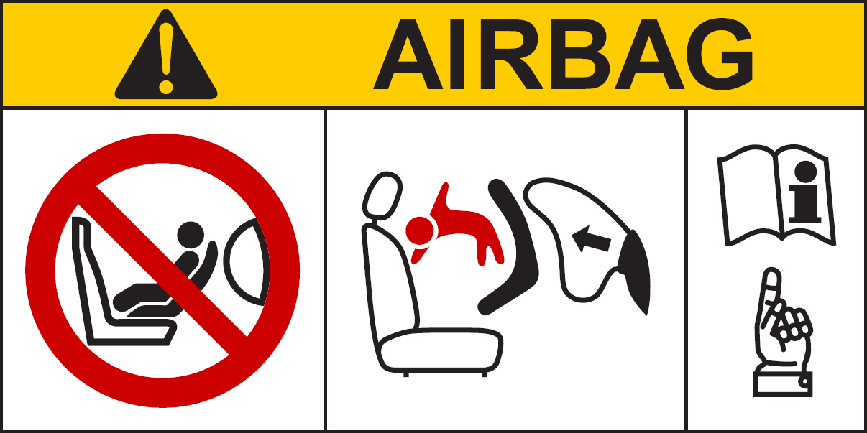

* 1. In the case of Integral Enhanced Child Restraint Systems that can be used forward facing, it shall have the following label permanently attached on the part hosting the child and visible to the person installing an Enhanced Child Restraint System in the vehicle:

The manufacturer shall be permitted to include the word "months" to explain the symbol "M" in the label. The word "months" should be in a language commonly spoken in the country or countries where the product is sold. More than one language is allowed.

Minimum label size 40 x 40 mm

**All text black on yellow or amber background**

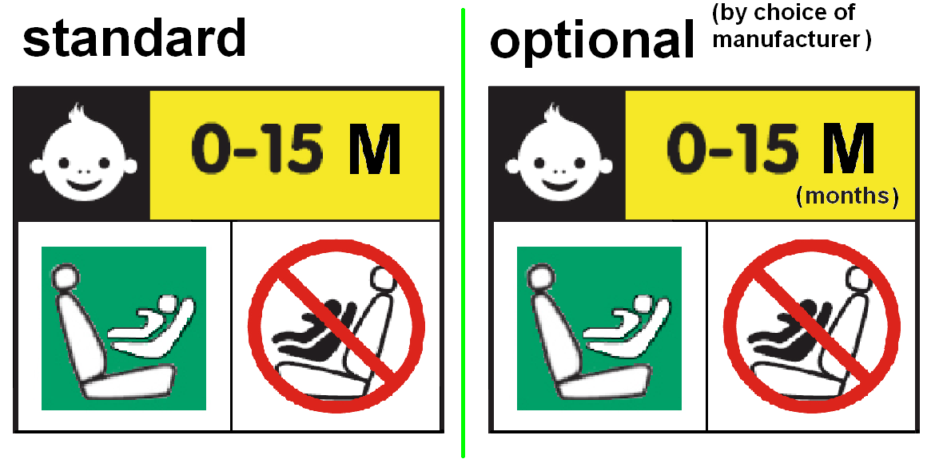

**Background white**

**Square - green**

**Forbidden sign – red**

**Backgroundwhite**

**Top symbol white on black background**

**Label outline, vertical and horizontal lines black**

4.6. Webbing path

The markings defined in this paragraph shall be permanently and durably attached and visible on the Enhanced Child Restraint System installed in the vehicle, and with the child seated in the Restraint System. The markings shall be placed on both sides of the Enhanced Child Restraint System. The vehicle seat illustrated on the marking shall face the same direction as the actual vehicle seat.

There shall be a clear differentiation between the intended paths for the lap section and the diagonal section of the safety-belt. Indication such as colour coding, words, shapes, etc. shall distinguish between sections of the adult safety-belt.

4.6.1. The adult safety-belt route markings shall be placed on all belt guides and lock off devices. The adult safety-belt route markings shall be at least the width of the adult webbing path.

4.6.2. For Non-Integral Enhanced Child Restraint System to be used in combination with an adult safety-belt to restrain the child, the correct webbing path according to paragraph 6.1.3.4. shall be clearly marked on the product. This shall be by means of an installation drawing on a label permanently attached to the Enhanced Child Restraint System that shows the correct path across the child’s body. The colour used for the adult belt route marking of the safety-belt when the device is installed shall be green. The same colour shall also be used for the webbing path on the labels on the device that illustrate the installation.

4.6.3. For Integral Belted Enhanced Child Restraint System held in place by the adult safety-belt, the webbing paths according to paragraph 6.1.2.5. shall be clearly marked on the product, and indicated by means of a drawing permanently attached to the Enhanced Child Restraint System. The colour used for the path of the adult belt route marking, when the device is installed in the forward-facing or rearward-facing positions shall be green, same colour shall also be used on the labels on the device that illustrate the installation

4.7. Marking for integral ECRS including ISOFIX connections attachments.

The marking shall be located on the part of the ECRS which includes the ISOFIX attachments.

One of the following information labels shall be permanently visible to someone installing the Enhanced Child Restraint System in a vehicle:

4.7.1. i-Size ECRS:

*i-Size logo*. The symbol shown below shall have minimum dimension of 25 x 25 mm and the pictogram shall contrast with the background. The pictogram shall be clearly visible either by means of contrasting colors or by adequate relief if it is moulded or embossed;

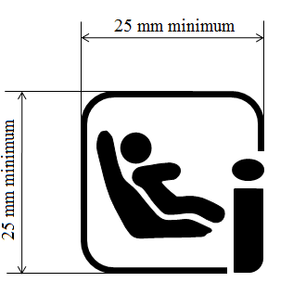

4.7.2. Specific Vehicle ISOFIX ECRS

If the product includes ISOFIX attachments, the following information shall be permanently visible to someone installing the restraint in a vehicle:

The ISO ISOFIX logo followed by the reference(s) that is/are appropriate for the ISOFIX size fixture(s) into which the product fits. As a minimum, a symbol consisting of a circle with a diameter of minimum 13 mm and containing a pictogram, the pictogram shall contrast with the background of the circle. The pictogram shall be clearly visible either by means of contrast colors or by adequate relief if it is moulded or embossed.

** ISO/F2, ISO/R3 and ISO/L1

The Specific vehicle ISOFIX Enhanced Child Restraint System shall have a permanently attached label visible to the person installing the Enhanced Child Restraint System in the car, containing the following information:

Specific Vehicle ISOFIX 

4.7.3. An international approval mark as defined in paragraph 5.4.1. In case the ECRS containing module(s) this marking shall be permanently attached to the part of the ECRS which includes the ISOFIX attachments.

4.7.4. An international module mark as defined in paragraph 5.4.3. In case the ECRS containing module(s) this marking shall be permanently attached to the module part of the ECRS.

4.8. Marking for non-integral ECRS

4.8.1. *i-Size booster seat* Enhanced Child Restraint Systems shall have a permanently attached label with the following information visible to the person installing the Enhanced Child Restraint System in the car:

i-Size booster seat 

4.8.2. S*pecific vehicle booster seat* Enhanced Child Restraint System (except built-in) shall have a permanently attached label with the following information visible to the person installing the Enhanced Child Restraint System in the car:

Specific vehicle booster seat 

4.9. An impact shield that is not permanently attached to the seat shall have a permanently attached label to indicate the brand and model of the Enhanced Child Restraint System to which it belongs and the size range. The minimum size of the label shall be 40 x 40 mm or the equivalent area.

4.10.Enhanced Child Restraint Systems shall have a permanently attached label to inform the user of the appropriate method of restraint of the child over the entire stature range declared by the manufacturer.

The label shall be visible to the person installing the Enhanced Child Restraint System in a vehicle and when a child is seated in the restraint. The label shall have a minimum size of 40 x 60 mm or the equivalent area and shall feature a pictogram of each restraint configuration adjacent to the stature range.

4.11. Marking for Integral Belted Enhanced Child Restraint System.

The marking shall be located on the part of the Enhanced Child Restraint System which includes the main load-bearing contact points.

One of the following information labels shall be permanently visible to the person installing the Enhanced Child Restraint System in a vehicle:

4.11.1. *Universal Belted* Enhanced Child Restraint Systems shall have a permanently attached label with the following information visible to the person installing the Enhanced Child Restraint System in the vehicle:

Universal Belted 

4.11.2. *Specific vehicle Belted* Enhanced Child Restraint System (including built-in systems) shall have a permanently attached label with the following information visible to the person installing the Enhanced Child Restraint System in the vehicle:

Specific Vehicle Belted 

4.11.3. An international approval mark as defined in paragraph 5.4.1. In case the Enhanced Child Restraint System containing module(s) this marking shall be permanently attached to the part of the Enhanced Child Restraint System that includes the main load-bearing contact points.

4.11.4. An international module mark as defined in paragraph 5.4.3. In case the Enhanced Child Restraint System containing module(s) this marking shall be permanently attached to the module part of the Enhanced Child Restraint System.

4.12. Additional markings

The following information may be conveyed by pictograms and/or text. The marking shall indicate:

(a) The essential relevant steps needed for making the Enhanced Child Restraint System ready for installation. For example, the method of extending the ISOFIX attachment(s) shall be explained;

(b) The position, function, and interpretation of any indicator shall be explained;

(c) The position and if necessary the routing of top tethers, or other means of limiting Enhanced Child Restraint System rotation requiring action by the user, shall be indicated using one of the following symbols as appropriate;

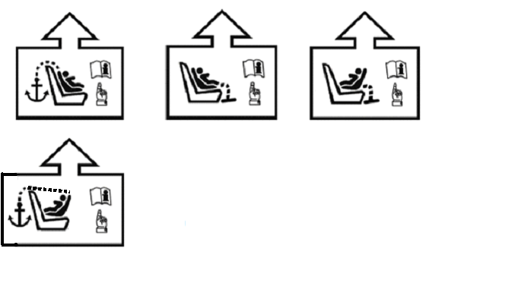

(d) The adjustment of ISOFIX latches and the top tether, or other means of limiting Enhanced Child Restraint System rotation, requiring action by the user shall be indicated;

(e) The marking shall be permanently attached and be visible to a user installing the Enhanced Child Restraint System;

(f) Where necessary reference should be made to the Enhanced Child Restraint System user instructions and to the location of that document using the symbol below.



(g) The shoulder belt part and the lap belt part of the adult safety-belt used for attaching the infant carrier shall be indicated with specific icons for the shoulder webbing path and lap belt webbing paths, visible for the user, close to the belt guiding area (icon A and B) or on the installation drawings (icon C). Icons A, B and C shall have the same colour coding (darker green on lap belt) as used on the installation drawings and the minimum size is 20 mm in diameter.



**A**

**Icons for use on/near**

**belt guide**



**B**



**C**

**Icons for use on installation label**



**or**

5. Approval

5.1. Each sample submitted in conformity with paragraphs 3.2.4. and 3.2.5. above shall meet the specifications set forth in paragraphs 6. to 7. of this Regulation in every respect before approval can be granted.

5.2. An approval number shall be assigned to each type approved. Its first two digits (at present 03 corresponding to the 03 series of amendments) shall indicate the series of amendments incorporating the most recent major technical amendments made to this Regulation at the time of issue of the approval. The same Contracting Party shall not assign the same number to another type of Enhanced Child Restraint System covered by this Regulation.

A type of Enhanced Child Restraint System approved according to this Regulation shall not bear another approval mark according to UN Regulation No. 44 (Child Restraint Systems).

5.3. Notice of approval or of extension or refusal of approval of an Enhanced Child Restraint System pursuant to this Regulation shall be communicated to the Contracting Parties to the Agreement which apply this Regulation by means of a form conforming to the model in Annex 1 to this Regulation. If part of the Enhanced Child Restraint System could be used as an infant carrier module and installed as defined in Annex 22, approvals according to this Regulation can only be granted if the infant carrier module complies with the requirements of this annex.

5.4. In addition to the marks prescribed in paragraph 4. above, the following particulars shall be affixed in a suitable space to every Enhanced Child Restraint System conforming to a type approved under this Regulation:

5.4.1. An international approval mark consisting of:

5.4.1.1. A circle surrounding the letter "E" followed by the distinguishing number of the country which has granted approval;[3]

5.4.1.2. An approval number, the words "UN Regulation No." followed by the number of this Regulation, a slash and the series of amendment ("UN Regulation No. 129/00");

5.4.2. The following additional symbols:

5.4.2.1. The words "i-Size universal ISOFIX", or "i-Size booster seat", or "specific vehicle ISOFIX" or "specific vehicle booster seat" or "Universal Belted", or "Specific vehicle Belted", depending on the category of Enhanced Child Restraint System;

5.4.2.2. The size range for which the Enhanced Child Restraint System has been designed;

5.4.2.3. In case the ECRS is equipped with a module, the size range is not on the approval mark but on the module mark.

5.4.2.4. The symbol "S" in the case of a "Special Needs Restraint".

5.4.3. An international module mark as defined in Annex 2 to this Regulation consisting of:

5.4.3.1. The words "R129" followed by a dash and the same approval number as the part of the Enhanced Child Restraint System which includes the ISOFIX attachments or main load bearing contact points;

5.4.3.2. The words Module "name of the Module", depending on the name of the module of Enhanced Child Restraint System;

5.4.3.3. The size range including maximum weight for which the Module of the Enhanced Child Restraint System has been designed;

5.5. The approval mark prescribed in paragraph 5.4. above may not be replaced by an Unique Identifier (UI) as referred to in Schedule 5 of the 1958 Agreement.

5.6. Annex 2 to this Regulation gives an example of the arrangement of the approval mark.

5.7. The particulars referred to in paragraph 5.4. above shall be clearly legible and be indelible, and may be affixed either by means of a label or by direct marking. The label or marking shall be resistant to wear.

5.8. The labels referred to in paragraph 5.6. above may be issued either by the Type Approval Authority which has granted the approval or, subject to that Type Approval Authority's authorization, by the manufacturer.

6. General specifications

6.1. Positioning and securing on the vehicle

6.1.1. Enhanced Child Restraint Systems in the i-Size category are primarily designed for use in i-Size seating positions, when the Enhanced Child Restraint Systems are fitted in conformity with the vehicle manufacturer's instructions.

The instructions of a forward facing i-Size integral ECRS that utilize a top tether as the anti-rotation device may declare that the ECRS can be used in any ISOFIX seating positions.

The instructions of other i-Size integral ECRS may declare that the ECRS can be used in ISOFIX seating positions specified in a car fitting list.

Enhanced Child Restraint Systems in the i-Size booster seat category are primarily designed for use in all i-Size seating positions.

Enhanced Child Restraint Systems in the specific vehicle ISOFIX category are for use in all ISOFIX positions and also in the luggage area, if the restraints are fitted in conformity with the vehicle manufacturer's instructions.

Enhanced Child Restraint Systems in the specific vehicle booster seat category are to be used according to manufacturer's instructions.

6.1.2. According to the category in which it belongs to, see Table 1, the integral Enhanced Child Restraint System shall be secured to the vehicle structure or to the vehicle seat structure:

6.1.2.1. For i**-**Size category, this shall be by means of two ISOFIX attachments with the addition of an anti-rotation device for both forward and rearward-facing Enhanced Child Restraint Systems;

6.1.2.2. For "Specific Vehicle ISOFIX" category: this shall be by means of the ISOFIX attachments designed by the manufacturer of the Enhanced Child Restraint System, secured to ISOFIX anchorage system as designed by the vehicle manufacturer.

Table 1  
**Possible configurations for type approval for Integral Enhanced Child Restraint Systems**

|  | *Orientation* | *Category* | | | |
| --- | --- | --- | --- | --- | --- |
|  |  | i-Size ECRS | Integral Specific Vehicle ISOFIX ECRS | Universal Belted | Specific vehicle Belted |
| INTEGRAL | Lateral facing (Carry-cot) | NA | A | NA | A |
| Rearward facing | A | A | A | A |
| Forward facing | A | A | A | A |

*Note*: ECRS: Enhanced Child Restraint System  
A: Applicable  
NA: Non-Applicable

6.1.2.3. For the "Universal Belted" category, this shall be by means of the adult safety-belt only.

6.1.2.4. For the "Specific vehicle Belted" category, this shall be primarily by means of the adult safety-belt.

6.1.2.5. Integral Enhanced Child Restraint Systems of the Belted categories shall have only one adult safety-belt route and a main load-bearing contact point, between the Enhanced Child Restraint System and the adult safety-belt on each side of the Enhanced Child Restraint System. This point shall not be less than 150 mm from the Cr axis when measured with the Enhanced Child Restraint System on the dynamic test bench installed in accordance with paragraph 7.1.3.5.2.3. of this Regulation, without a dummy. This shall apply to all adjustment set-ups and webbing paths.

6.1.2.6. The adult safety-belt required to secure a Belted Integral Enhanced Child Restraint System on the dynamic test bench is defined in Annex 23 to this Regulation. The Enhanced Child Restraint System shall be secured onto the test bench using the appropriate standard safety-belt described in Annex 23 using a preload tension of 50N ± 5N. The dummy shall not be installed unless the design of the restraint is such that the installation of a dummy would increase the length of belt used. With the Enhanced Child Restraint System in the installed position as declared by the ECRS manufacturer, there shall be no additional tension in the belt, apart from that exerted by the standard retractor (4 ± 3 N), where fitted. Where the retractor belt is used, this condition shall be met with at least 150 mm of belt remaining on the spool.

A clamping mechanism used according to paragraph 7.1.3.5.2.3. shall not influence the webbing path.

6.1.2.7. For children under the age of 15 months only lateral facing or rearward facing Enhanced Child Restraint System shall be used.

That means:

(a) A rearward facing Enhanced Child Restraint System designed for children up to 15 months of age shall accommodate a child with a stature up to 83 cm as a minimum;

(b) A forward facing Enhanced Child Restraint System shall not be designed to accommodate a stature below 76 cm;

(c) A convertible seat in its rearward facing configuration shall be able to accommodate a child with a stature up to 83 cm. This shall not preclude a child stature greater than 83 cm.

The use of rearward facing Enhanced Child Restraint System may be applied to any age of child.

6.1.3. According to the category as defined by Table 2, the Non-Integral Enhanced Child Restraint System and the child shall be secured in a vehicle seating position:

6.1.3.1. For the i-Size booster seat category, by means of the adult safety seat belt and possibly with optional ISOFIX attachments, if these are stowable (see UN Regulation No. 16, Annex 17, Appendix 5, Figure 1, Detail B).

6.1.3.2. For the specific vehicle booster seat category, by means of the adult safety seat belt and possibly with attachments designed by the manufacturer of the Enhanced Child Restraint System, secured to anchorages as designed by the vehicle manufacturer. Only ISOFIX attachments shall be used in conjunction with ISOFIX anchorage system.

# Table 2

**Possible configurations of Non-Integral Enhanced Child Restraint Systems for type approval**

|  | *Orientation* | *Category* | |
| --- | --- | --- | --- |
| Non-Integral |  | i-Size  booster seat | Specific vehicle booster seat (Built-in included) |
| Forward Facing | A | A |
| Rearward Facing | NA | NA |

A: Applicable

NA: Non-Applicable

6.1.3.3. For non-integral Enhanced Child Restraint Systems, type approval shall not be granted for a stature below 100 cm. Non-integral Enhanced Child Restraint Systems shall not be declared for use below a stature of 100 cm.

Non integral ECRS shall not be approved with an upper stature limit of 105 cm or below.

Booster seats shall insure lateral protection of the child as described in paragraph 7.1.3.1.3. up to a stature of 135 cm.

ECRS shall accommodate an uninterrupted range of child statures.

*Note*: For example, a booster seat shall not accommodate children of 100 cm to 130 cm and then children of 140 cm to 150 cm with an "interruption".

6.1.3.4. Enhanced Child Restraint Systems of the booster seat categories shall have only one adult safety-belt route and a main load-bearing contact point, between the Enhanced Child Restraint System and the adult safety-belt on each side of the Enhanced Child Restraint System. This point shall not be less than 150 mm from the Cr axis when measured with the Enhanced Child Restraint System on the dynamic test bench installed in accordance with paragraph 7.1.3.5.2.2. of this Regulation, without a dummy. This shall apply to all adjustment set-ups and webbing paths.

6.1.3.5. The adult seat belt required to secure a i-Size booster seat on the dynamic test bench is defined in Annex 24 to this Regulation. The Enhanced Child Restraint System shall be secured onto the test bench using the appropriate standard seat belt described in Annex 24 using a preload tension of 50N ± 5N. The dummy shall not be installed unless the design of the restraint is such that the installation of a dummy would increase the amount of belt used. With the Enhanced Child Restraint System in the installed position, there shall be no additional tension in the belt, apart from that exerted by the standard retractor (4 ± 3 N), where fitted. Where the retractor belt is used, this condition shall be met with at least 150 mm of belt remaining on the spool.

A clamping mechanism used according to paragraph 7.1.3.5.2.2. shall not have any influence on the belt path.

6.2. Configuration of the Enhanced Child Restraint System

6.2.1. The configuration of the Enhanced Child Restraint System shall be such that:

6.2.1.1. The restraint of the child shall give the required protection in any position specified for the Enhanced Child Restraint System;

For"Special Needs Restraints" the primary means of restraint shall give the required protection in any intended position of the Enhanced Child Restraint System without the use of the additional restraining devices which may be present;

6.2.1.2. The Enhanced Child Restraint System shall be such that the child may be easily and readily restrained or removed. In the case of an Enhanced Child Restraint System in which the child is restrained by means of a harness belt or a Y-shaped belt without a retractor each shoulder restraint and lap strap shall be capable of movement relative to each other during the procedure prescribed in paragraph 6.7.1.4. below; in these cases the Enhanced Child Restraint System belt assembly may be designed with two or more connecting parts.

For Special Needs Restraints it is recognized that the additional restraining devices will restrict the speed by which a child can be restrained and removed. However, the additional devices shall be designed to release quickly so far as possible;

6.2.1.3. If it is possible to change the inclination of the Enhanced Child Restraint System, this change in inclination shall not require manual readjustment of any other part of the Enhanced Child Restraint System. A deliberate hand-action shall be necessary in order to change the inclination of the Enhanced Child Restraint System.

During the dynamic tests, the standard safety-belt used to install an integral belted Enhanced Child Restraint System shall not become disengaged from any guide or locking device utilized for the test conducted.;

6.2.1.4. To prevent submarining, either by impact or through restlessness, a crotch strap shall be required on all integral forward-facing restraints incorporating an integral harness belt system. Enhanced Child Restraint Systems which incorporate a shield instead of a harness shall ensure that the shield extendsacross the full width of the child's body and sits low on the pelvis.

6.2.1.5. All restraint devices utilizing a lap strap shall positively guide the lap strap to ensure that the loads transmitted by the lap strap are transmitted through the pelvis. The assembly shall not subject weak parts of the child's body (abdomen, crotch, etc.) to excessive stresses.

In the case of booster seats, the lap portion of the adult safety-belt shall be positively guided on both sides to ensure that the loads transmitted by the adult lap belt are transmitted through the pelvis. The positive guidance of loads over the pelvis shall be realised from the moment that the child is installed; the lap belt shall pass over the top of the thigh, just touching the fold with the pelvis. The angles α and β between the tangent line in which the belt touches the thighs and the horizontal shall be greater than 10°.

# **Figures of Strapped child**

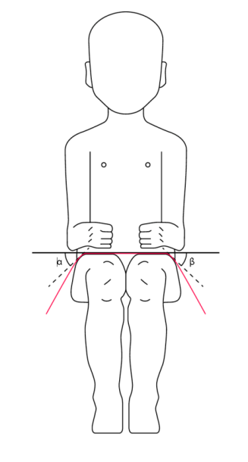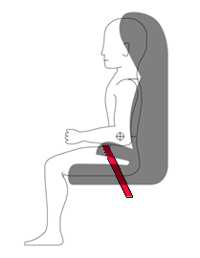

The shoulder portion of the adult safety belt shall be positively guided to ensure that the child torso and neck do not escape.

6.2.1.6. During the dynamic tests, the standard safety-belt used to install a non-integral Enhanced Child Restraint System, shall not become disengaged from any guide or locking device utilized for the test conducted; however, for the shoulder portion of the standard safety-belt this shall be judged up to the moment that the maximum horizontal head excursion of the dummy is reached.

6.2.1.7. All straps of the restraint shall be so placed that they cannot cause discomfort to the wearer in normal use or assume a dangerous configuration. Y-shaped belts are not permitted on forward facing Enhanced Child Restraint Systems and may only be used in dedicated rearward facing and or lateral facing Enhanced Child Restraint Systems (carrycots). The distance between the shoulder-straps in the vicinity of the neck should be at least the width of the neck of the appropriate dummy.

6.2.1.8. With the crotch strap attached and in its longest position if adjustable, it shall not be possible to adjust the lap strap to lie above the pelvis of both the smallest and largest dummy within the size range covered by the approval. For all forward-facing restraints, it shall not be possible to adjust the lap strap to lie above the pelvis of both the smallest and largest dummy within the size range covered by the approval.

An impact shield shall be adjustable so that it comes in contact with the pelvis and abdomen of the smallest and largest dummy within the size range covered by the approval, leaving no gap between the impact shield and the dummy.

6.2.1.9. During the dynamic test, as prescribed in paragraph 7.1.3., the lap belt shall not pass fully beyond the pelvic structure of the dummy during the period prior to maximum horizontal head excursion. An assessment shall be carried out using high speed video imaging.

6.2.1.10. At least the worst case of the dynamic test for the Enhanced Child Restraint System shall be performed after conditioning according to paragraph 7.2.6.

6.2.2. The Enhanced Child Restraint System shall be designed and installed so as to:

6.2.2.1. Not exhibit sharp edges or protrusions liable to cause damage to vehicle-seat covers or to occupant's clothing;

6.2.2.2. To ensure that its rigid parts do not, at any point**,** where they are in contact with straps, exhibit sharp edges capable of abrading the straps.

6.2.3. It shall not be possible to remove or detach without the use of specific tools, any components not designed to be removable or detachable for maintenance or change of configuration purpose. Any components that are designed to be removable or detachable shall be so designed as to avoid any risk of incorrect assembly and use, as the assembly and disassembly processes shall be explained in detail in the restraint user guides. For integral Enhanced Child Restraint Systems any harness belt or impact shield shall be capable of its full range of adjustment without disassembly.

6.2.4. "Special Needs Restraints" may have additional restraining devices; these shall be designed to avoid any risk of incorrect assembly, and shall be designedso that their means of release and mode of operation is immediately obvious to any rescuer in an emergency.

6.2.5. An Enhanced Child Restraint System may be designed for use in any size range specified by the manufacturer provided that it satisfies the requirements laid down in this Regulation.

6.2.6. Enhanced Child Restraint Systems incorporating inflatable elements shall be so designed that the conditions of use (pressure, temperature, humidity) have no influence on their ability to comply with the requirements of this Regulation.

6.3. Enhanced Child Restraint System specifications

6.3.1 Material

6.3.1.1. The Enhanced Child Restraint System manufacturer shall declare in writing that the toxicity of materials used in the manufacture of restraint systems and accessible to the restrained child is in conformity with the relevant parts of EN 71-3:2013+A1:2014 (paragraph 4.2., Table 2, Category III for specific requirements and paragraph 7.3.3. for test methodology). Tests confirming the validity of the declaration may be carried out at the discretion of the Technical Service**.** This paragraph does not apply to Non-integral ECRS with a stature range starting at 100 cm or above.

6.3.1.2. The flammability of Enhanced Child Restraint Systems submitted for approval shall be assessed by one of the following methods:

Method 1 is applicable only to non-built-in Enhanced Child Restraint Systems and Method 2 is applicable only to vehicle specific built-in Enhanced Child Restraint Systems.

Method 1

The Enhanced Child Restraint System manufacturer shall declare in writing that the flammability of materials used to manufacture the Enhanced Child Restraint System is in conformity with the method of section 5.4 of EN 71-2:2011+A1:2014 with a maximum rate of spread of flame of 30 mm/s. Tests confirming the validity of the declaration may be carried out at the discretion of the Technical Service. Where fabrics are assembled together, these shall be tested as a composite.

*“Composite material*" means a material composed of several layers of similar or different materials intimately held together at their surfaces by cementing, bonding, cladding, welding, etc. In such a case, the material shall be tested as a composite. When different materials are connected together intermittently, such materials shall not be considered as composite materials and therefore tested separately.

Tests confirming the validity of the declaration may be carried out at the discretion of the Technical Service.

Method 2

The applicant shall declare in writing that when testing materials in accordance with Annex 22 of this regulation, the materials used shall not burn, nor transmit a flame front across its surface, at a rate of more than 100 mm per minute. Each material used in an enhanced child restraint system shall conform to these requirements. However, the requirement concerning transmission of a flame front shall not apply to a surface created by cutting a test specimen for purposes of testing pursuant to Annex 22.

The requirements shall be met in both the "in-use" and in the "stowed" positions of the built-in Enhanced Child Restraint System.

If a material stops burning before it has burned for 60 seconds from the start of timing, and has not burned more than 51 mm from the point where the timing was started, it shall be considered to meet the burn-rate requirement specified above.

Tests confirming the validity of the declaration may be carried out at the discretion of the Technical Service.

6.3.2. General characteristics

6.3.2.1. Internal geometric characteristics

The Technical Service conducting the approval tests shall verify that the internal dimensions of the Enhanced Child Restraint System conform to the requirements of Annex 18. The minimum dimensions for shoulder breadth, hip breadth and sitting height shall be fulfilled simultaneously for any stature within the size range declared by the manufacturer.

Integral Enhanced Child Restraint System shall also fulfil the minimum and maximum dimensions of shoulder height, for any stature within the size range declared by the manufacturer.

Integral Enhanced Child Restraint Systems that feature an impact shield shall also be capable of being adjusted to fulfil:

(a) The 5th percentile upper leg thickness and 5th percentile abdomen depth, simultaneously to the 5th percentile shoulder height;

(b) The 95th percentile upper leg thickness and 95th percentile abdomen depth, simultaneously to the 95th percentile shoulder height, shoulder breadth, hip breadth and sitting height.

For any stature within the size range declared by the manufacturer.

Non-integral Enhanced Child Restraint System shall also fulfil the maximum dimensions of shoulder height, for any stature within the size range declared by the manufacturer.

6.3.2.2. External dimensions

The Technical Service conducting the approval tests shall verify that the external dimensions of the Enhanced Child Restraint System conform to the requirements of paragraphs 6.3.2.2.1. and 6.3.2.2.2., as applicable.

6.3.2.2.1. Integral Class Enhanced Child Restraint Systems

The maximum external dimensions for the width, height and depth of the Enhanced Child Restraint System andif fitted, the locations of the ISOFIX anchorages system, with which its attachments shall engage, shall be defined by the ISOFIX Vehicle Seat Fixture as defined in paragraph 2.17.1. of this Regulation.

(a) i-Size or Universal Belted Forward facing Enhanced Child Restraint Systems shall fit within the ISO/F2x size envelope for a reduced-height forward-facing toddler CRS;

(b) i-Size or Universal Belted Rearward facing Enhanced Child Restraint Systems shall fit within the ISO/R2 size envelope for a reduced-size rearward-facing toddler CRS;

(c) Specific vehicle ISOFIX or Specific vehicle Belted Enhanced Child Restraint Systems shall fit:

(i) In vehicle(s) specified in a list or

(ii) At least in one of the ISO (R1, R2X, R2, R3, F2X, F2, F3, L1, L2) size envelopes as described in Annex 17 Appendix 2 of UN Regulation No. 16.

When conducting this assessment, the Integral Enhanced Child Restraint System shall be adjusted to the largest size of its declared stature range (height, depth and width dimensions as defined in Annex 18). If the Enhanced Child Restraint System is capable of being adjusted to different positions of seat surface inclination, the fitting assessment shall be done in at least one position. If other positions of inclination are outside the limits of the applicable size envelope, the user manual shall indicate that the child restraint may not fit in all approved vehicles when used in one of these positions.

6.3.2.2.2. Non-Integral Class Enhanced Child Restraint Systems

The maximum external dimensions for the width, height and depth of the Enhanced Child Restraint System and the locations of the ISOFIX anchorages system if any, with which its attachments shall engage, shall be defined by the i-Size booster seat fixture as defined in paragraph 2.17.2. of this Regulation.

(a) i-Size booster seat Enhanced Child Restraint Systems shall fit within the ISO/B2 size envelope;

(b) Specific vehicle booster seat Enhanced Child Restraint Systems shall fit:

(i) In vehicle(s) specified in a list; or

(ii) At least in one of ISO/B2 –ISO/B3 size envelope as described in Annex 17, Appendix 2 of UN Regulation No. 16.

When conducting this assessment, the non-integral Enhanced Child Restraint System shall be adjusted to accommodate children of 135 cm stature (height, depth and width dimensions as defined in Annex 18) or to the largest size of its declared stature range if the upper limit is below 135 cm.

The Non-integral Enhanced Child Restraint System shall fit within the booster seat fixture in all angles of inclination of the fixture (90o-110o). The Enhanced Child Restraint System may be adjusted between inclination angles or positions to fit within the different booster seat fixture angles.

If other positions of inclination are outside the limits of the applicable size envelope, the user manual shall indicate that the child restraint may not fit in all approved vehicles when used in one of these positions. If the Non-integral Enhanced Child Restraint System has a declared stature range above 135 cm, and if it is necessary to adjust the child restraint outside the limits of the applicable size envelope for such adjustments (height, depth and width dimensions), the user manual shall indicate that the child restraint may not fit in all approved vehicles when used in one of these positions.

6.3.2.3. Mass

The mass of an integral ISOFIX Enhanced Child Restraint System (i-Size Enhanced Child Restraint System included) combined with the mass of the largest child intended to use the Enhanced Child Restraint System shall not exceed 33 kg. This mass limit is also applicable for "Specific vehicle ISOFIX" Enhanced Child Restraint Systems.

6.3.3. ISOFIX attachments

6.3.3.1. Type

ISOFIX attachments may be according to examples shown in Figure 0(a), or other appropriate designs that are part of a rigid mechanism having provision for adjustment, the nature of which is determined by the ISOFIX Enhanced Child Restraint System manufacturer.

Figure 0(a)

*Key:*

1 ISOFIX Enhanced Child Restraint System attachment — example 1

2 ISOFIX Enhanced Child Restraint System attachment — example 2

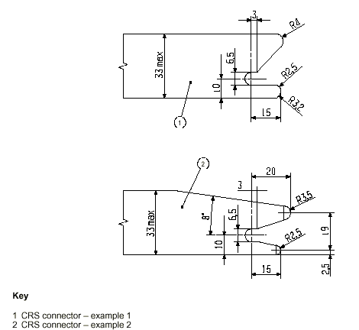

Dimensions in mm

6.3.3.2. Dimensions

Dimensions for the portion of the ISOFIX Enhanced Child Restraint System attachment that engages the ISOFIX anchorage system shall not exceed the maximum dimensions given by the envelope in Figure 0(b).

# Figure 0(b)



Dimensions in mm

6.3.3.3. Partial latching indication

The ISOFIX Enhanced Child Restraint System shall incorporate means by which there is a clear indication that both of the ISOFIX attachments are completely latched with the corresponding ISOFIX lower anchorages. The indication means may be audible, tactile or visual or a combination of two or more. In case of visual indication it shall be detectable under all normal lighting conditions.

6.3.4. ISOFIX Enhanced Child Restraint System top tether strap specifications

6.3.4.1. Top tether connector

The top tether connector shall be ISOFIX top tether hook as shown in Figure 0(c), or similar devices that fit within the envelope given by Figure 0(c).

6.3.4.2. ISOFIX top tether strap features

The ISOFIX top tether strap shall be supported by webbing (or its equivalent), having a provision for adjustment and release of tension.

6.3.4.2.1. ISOFIX Top tether strap length

ISOFIX Enhanced Child Restraint System top tether strap length shall be at least 2,000 mm.

6.3.4.2.2. No-slack indicator

The ISOFIX top tether strap or the ISOFIX Enhanced Child Restraint System shall be equipped with a device that will indicate that all slack has been removed from the strap. The device may be part of an adjustment and tension relieving device.

6.3.4.2.3. Dimensions

Engagement dimensions for ISOFIX top tether hooks are shown in Figure 0(c).

# Figure 0(c)

**ISOFIX top tether connector (hook type) dimensions**





6.3.5. i-SizeEnhancedChild Restraint System support-leg and support-leg foot requirements

i-Size Enhanced Child Restraint Systems fitted with support-legs shall comply in all positions of use (e.g. in case of length adjustable attachment, base, etc. the shortest and longest position) with the geometrical provisions defined in this paragraph and its subparagraphs.

Compliance with the requirements specified in paragraphs 6.3.5.1. and 6.3.5.2. below may be verified by a physical or computer simulation.

The geometrical requirements in paragraphs 6.3.5.1. to 6.3.5.4. below are referenced to a coordinate system, whose origin is located centrally between the two ISOFIX attachments and on the centreline of the corresponding ISOFIX anchorage system.

The orientation of the axes of the coordinate system is referenced to the child restraint fixture(s):

(a) The X' axis shall be parallel to the child restraint fixture (CRF)[4] bottom surface and in the median longitudinal plane of the CRF;

(b) The Y' axis shall be perpendicular to the median longitudinal plane;

(c) The Z' axis shall be perpendicular to the CRF bottom surface.

In fulfilling the requirements of this section, the Enhanced Child Restraint System shall be installed in accordance with the user manual of the Enhanced Child Restraint System. The storage position of the support-leg is excluded from these requirements.

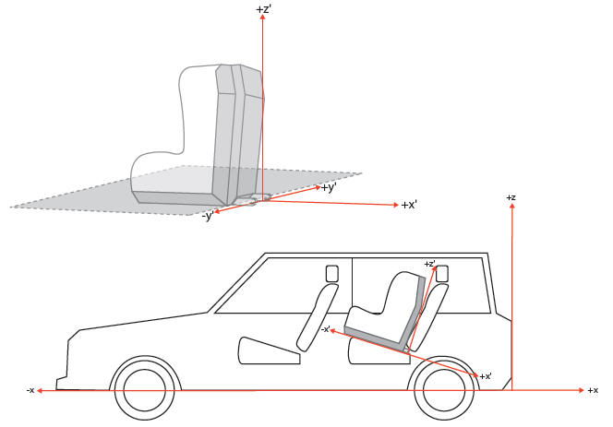

6.3.5.1. Support-leg and support-leg foot geometrical requirements

The support leg, including its attachment to the Enhanced child restraint systems and the support-leg foot shall lie completely within the support leg dimension assessment volume (see also Figures 1 and 2 of annex 19 of this Regulation), which is defined as follows:

(a) In width by two planes parallel to the X'-Z' plane separated by 200 mm, and centered around the origin; and

(b) In length by two planes parallel to the Z'-Y' plane and positioned at distances of 585 mm and 695 mm forward of the origin along the X' axis; and

(c) In height by a plane parallel to the X'-Y' plane, positioned at a distance of 70 mm above the origin and measured perpendicular to the X'-Y' plane. Rigid, non-adjustable parts of the support leg shall not extend beyond a plane parallel to the X'-Y' plane, positioned at a distance of 285 mm below the origin and perpendicular to the X'-Y' plane.

The support-leg may protrude the support-leg dimension assessment volume, providing it remains within the volume of the relevant CRF.

6.3.5.2. Support-leg foot adjustability requirements

The support-leg shall be adjustable in order to ensure that the support-leg foot can be positioned throughout the height range of the support-leg foot assessment volume as specified below (see also Figures 3 and 4 of Annex 19 to this Regulation). Where incremental adjustment is provided, the step between two locked positions shall not exceed 20 mm.

The support leg foot assessment volume is defined as follows:

(a) In width by two planes parallel to the X'-Z' plane, separated by 200 mm, and centered around the origin; and

(b) In length by two planes parallel to the Z'-Y' plane and positioned at distances of 585 mm and 695 mm forward of the origin along the X' axis; and

(c) In height by two planes parallel to the X'-Y' plane positioned at distances of 285 mm and 540 mm below the origin along the X' axis.

It shall be permissible for the support-leg to be adjustable beyond the height limits in the Z' direction (as indicated by key 6 in Figure 3 of Annex 19), providing that no parts extend beyond the limiting planes in the X' and Y'directions.

6.3.5.3. Support-leg foot dimensions

The dimensions of the support-leg foot shall meet the following requirements:

(a) Minimum support-leg contact surface shall be 2,500 mm2, measured as a projected surface 10 mm above the lower edge of the support-leg foot (see Figure 0(d));

(b) Minimum outside dimensions shall be 30 mm in the X' and Y' directions, with maximum dimensions being limited by the support-leg foot assessment volume;

(c) Minimum radius of the edges of the support-leg foot shall be 3.2 mm.

# Figure 0(d)

10 mm

6.3.5.4. Support-leg footjig

A jig shall be used to check that the support-leg foot meets the requirements defined in paragraph 6.3.5.2. above (see Figure 0(e)). As an alternative a computer simulation shall also be considered satisfactory.

The jig is defined as the ISOFIX CRF corresponding to the size class of the Enhanced Child Restraint System. The jig is expanded with two 6 mm diameter ISOFIX low anchorages. The striped box positioned in front of the jig is positioned and sized according paragraph 6.3.5.2. above. The ECRS shall have its attachments latched when conducting the assessment.

# Figure 0(e)

**ISOFIX axle 6 mm round**

6.4. Control of markings

6.4.1. The Technical Service conducting the approval tests shall verify that the markings conform to the requirements of paragraph 4. of this Regulation.

6.5. Control of instructions on installation and the instructions for use

6.5.1. The Technical Service conducting the approval tests shall verify that the instructions on installation and the instructions for use conform to paragraph 14. of this Regulation.

6.6. Provisions applicable to the assembled Enhanced Child Restraint System

6.6.1. Resistance to corrosion

6.6.1.1. A complete Enhanced Child Restraint System, or the parts thereof that are liable to corrosion, shall be subject to the corrosion test specified in paragraph 7.1.1. below.

6.6.1.2. After the corrosion test as prescribed in paragraphs 7.1.1.1. and 7.1.1.2. below, no signs of deterioration likely to impair the proper functioning of the Enhanced Child Restraint System, and no significant corrosion, shall be visible to the unaided eye of a qualified observer.

6.6.2. Energy absorption

6.6.2.1. For all devices with backrests, the areas defined in Annex 14 to this Regulation, when tested according to Annex 13, shall give a peak acceleration of less than 60 g. This requirement applies also to areas of impact shields which are in the head strike area as defined in Annex 14.

6.6.2.2. In the case of Enhanced Child Restraint Systems with permanent mechanically attached adjustable head support devices, in which the height of either the adult safety belt or of the child harness is directly controlled by the adjustable head support, it is not necessary to demand energy absorption in areas as defined in Annex 18, which are not contactable by the manikin's head, i.e. behind the head support.

6.6.3. Overturning

6.6.3.1. The Enhanced Child Restraint System shall be tested as prescribed in paragraph 7.1.2. of this Regulation; at no point during the whole test shall the manikin be fully ejected from the device, in addition when the test bench is in the upside down position the manikin's head shall not move more than 300 mm from its original position in a vertical direction relative to the test bench, once the applied load has been removed.

6.6.4. Dynamic test

6.6.4.1. General: The dynamic test shall be performed on Enhanced Child Restraint Systems which have not previously been under load and the Enhanced Child Restraint System shall be subjected to dynamic tests, in accordance with Table 3, in conformity with paragraph 7.1.3. below:

# Table 3

**Application of different criteria depending on test set up**

|  |  |  |  |  |  |  |  |
| --- | --- | --- | --- | --- | --- | --- | --- |
| *Frontal impact* | | | | *Rear impact* | | *Lateral impact* | |
| *Test on trolley+ standard seat* | | *Test in car body* | | *Test on trolley+ standard seat* | *Test in car body* | *Test on trolley+ standard seat* | |
| Forward facing | Rearward and lateral facing | Forward facing | Rearward and lateral facing | Rearward and lateral facing | Rearward and lateral facing | Forward facing | Rearward and lateral facing |
| *Note 1:* Standard seat means a test seat or test bench as defined in Annex 6.  *Note 2:* For lateral facing Enhanced Child Restraint Systems in lateral impact, if two positions are possible, then the dummy's head shall be situated near the side door. | | | | | | | |

6.6.4.1.1. i-Size category Enhanced Child Restraint Systems shall be tested on the test bench prescribed in [Annex 6](#_Annex_6_(to), and in conformity with paragraph 7.1.3.1. below.

6.6.4.1.2. Enhanced Child Restraint Systems of the specific vehicle categories shall be assessed for fit with each vehicle model for which the Enhanced Child Restraint System is intended. The Technical Service responsible for conducting the test may reduce the number of vehicle arrangements tested if they do not differ greatly in the aspects listed in paragraph 6.6.4.1.2.3. of this Regulation. This Enhanced Child Restraint System shall be dynamically tested in one of the following ways:

6.6.4.1.2.1. Enhanced Child Restraint Systems according to paragraph 2.7. and in conformity with paragraph 6.3. of this Regulation and which fit in at least an envelope defined in UN Regulation No. 16, Annex 17, Appendix 2, on the test bench prescribed in Annex 6 and in conformity with paragraph 7.1.3.1. of this Regulation or in a vehicle body shell in conformity with paragraph 7.1.3.2. of this Regulation.

6.6.4.1.2.2. For Enhanced Child Restraint Systems which are in conformity with paragraph 6.3. of this Regulation (for example ECRS using no anti-rotation device or using additional anchorages) or do not fit in any envelope defined in UN Regulation No. 16, Annex 17, Appendix 2 on the test trolley in a vehicle body shell in conformity with paragraph 7.1.3.2. or in a complete vehicle in conformity with paragraph 7.1.3.3. of this Regulation.

6.6.4.1.2.3. Using sufficient parts of the vehicle body shell to be representative of the vehicle structure and impact surfaces. If the Enhanced Child Restraint System is intended for use in the rear seat, these shall include the back of the front seat, the rear seat, the floor pan, the B and C pillars and the roof. If the Enhanced Child Restraint System is intended for use in the front seat, the parts shall include the dashboard, the A pillars, the windscreen, any levers or knobs installed in the floor or on a console, the front seat, the floor pan and the roof. The Technical Service responsible for conducting the test may permit items to be excluded if they are found to be superfluous. Testing shall be as prescribed in paragraph 7.1.3.2. of this Regulation, except for lateral impact.

6.6.4.1.3. The dynamic test shall be performed on Child Restraint Systems which have not previously been under load. The Enhanced Child Restraint System of the i-Size booster seat category shall be tested on the test bench described in [Annex 6](#_Annex_6_(to), and in conformity with paragraph 7.1.3.1. below.

6.6.4.1.4. If an "Specific vehicle ISOFIX" Enhanced Child Restraint System is installed in the area behind the rearmost forward facing adult seat positions (for example, the luggage area), one test with the largest dummy/dummies, as allowed by the Enhanced Child Restraint System, on a complete vehicle as prescribed in paragraph 7.1.3.3. of this Regulation shall be performed. The other tests, including the conformity of production, may be done as prescribed in paragraph 7.1.3.2. of this Regulation, at the request of the manufacturer.

6.6.4.1.5. In the case of a "Special Needs Restraint" every dynamic test specified by this Regulation for the range of size specified by the manufacturer shall be performed twice: first, using the primary means of restraint and second, with all restraining devices in use. In these tests, special attention shall be given to the requirements in paragraphs 6.2.1.5. and 6.2.1.6. of this Regulation.

6.6.4.1.6. In the case of an Enhanced Child Restraint System making use of an anti-rotation device and / or a shoulder strap positioner, the dynamic test shall be carried out as follows:

6.6.4.1.6.1. With the anti-rotation device and with the shoulder strap positioner in use, and

6.6.4.1.6.1.1. Without the anti-rotation device in use, unless:

(a) A mechanism or;

(b) A visual and audible warning signal.

is provided to prevent incorrect use of the anti-rotation device.

6.6.4.1.6.1.2. Without the shoulder strap positioner in use, unless:

(a) A mechanism or;

(b) A visual and audible warning signal.

is provided to prevent incorrect use of the shoulder strap positioner.

6.6.4.1.7. In the case of non-integral Enhanced Child Restraint System making use of ISOFIX attachments, the dynamic test shall be carried out as follows:

6.6.4.1.7.1. With the ISOFIX attachments in use, and

6.6.4.1.7.2. Without the ISOFIX attachments in use.

6.6.4.1.8. In the case of a convertible integral Enhanced Child Restraint System that is equipped with a means of restraining the child that is intended for one orientation only, the dynamic test shall be carried out as follows:

6.6.4.1.8.1. With the means of restraint used in the orientation for which it is intended; and

6.6.4.1.8.2. With the means of restraint used in the orientation for which it is not intended, unless a mechanism is provided to prevent such incorrect use.

6.6.4.2. During the dynamic tests, no part of the Enhanced Child Restraint System affecting the restraint of the occupant shall fully or partially fracture, and no buckle, locking system or displacement system shall release or unlock.  The only exception is where such parts or systems are identified as having a load limiting function in the manufacturer's technical description, as defined in paragraph 3.2.1. of this Regulation, and they comply with the following criteria:

6.6.4.2.1. Perform as predicted by the manufacturer.

6.6.4.2.2. Do not compromise the ability of the Enhanced Child Restraint System to protect the occupant.

6.6.4.3. Dummy criteria for frontal and rear impact.

6.6.4.3.1. Injury assessment criteria for frontal and rear impact as in Table 4.

# Table 4

| *Criterion* | *Abbreviation* | *Unit* | *Q0* | *Q1* | *Q1.5* | *Q3* | *Q6* | *Q10* |
| --- | --- | --- | --- | --- | --- | --- | --- | --- |
| Head performance criterion (only in case of contact during in-vehicle testing) | HPC* (15) |  | 600 | 600 | 600 | 800 | 800 | 800 |
| Head acceleration 3 ms | A head Cum3 ms *** | g | 75 | 75 | 75 | 80 | 80 | 80 |
| Upper neck tension Force | Fz | N | For monitoring purpose only** | | | | |  |
| Upper neck flexion moment | My | Nm |  | | | | |  |
| Chest acceleration 3 ms | A chest Cum 3 ms *** | g | 55 | 55 | 55 | 55 | 55 | 55 |
| Chest deflection | TBC | mm | NA | For monitoring purpose only** | | | | |
| Abdominal pressure**** | P | Bar | NA | NA | 1.2 | 1.0 | 1.0 | 1.2 |

* HPC: see Annex 17.

** To be reviewed within 3 years following entry into force of the series 01 of this Regulation.

*** Cum 3ms means cumulative 3ms value.

**** Abdominal pressure, the highest recorded value is applicable for injury assessment (i.e., when the right handed sensors record 1.3 bar and the left handed sensor 1.0 bar, the recorded 1.3 bar is to be used for injury assessment)

6.6.4.4. Dummy's head displacement for frontal and rear impact

6.6.4.4.1. Enhanced Child Restraint Systems of universal categories:

6.6.4.4.1.1. Forward facing Enhanced Child Restraint Systems

Head excursion: No part of the head of the dummy shall pass beyond the planes BA, DA and DE as defined in Figure 1 below. This shall be judged up to 300 ms or the moment that the dummy has come to a definitive standstill whatever occurs first. Except for booster seats when testing using Q10 dummy where:

(a) The value in relation to the DA plane is 840 mm; and

(b) The value in relation to the BA plane is 550 mm; and

(c) The rebound phase is not considered for the assessment of the plane DA and DE.

6.6.4.4.1.1.1. Where a test is conducted in accordance with paragraphs 6.6.4.1.6.1.1, 6.6.4.1.6.1.2. or paragraph 6.6.4.1.8.2. above, a tolerance of +10 per cent shall be applicable to the head excursion value distance between Cr point and plane AB.

# Figure 1

**Arrangement for testing a forward-facing device**



**E**

500

Dimensions in mm

6.6.4.4.1.2. Rearward-facing Enhanced Child Restraint Systems and carrycots:

6.6.4.4.1.2.1. Head excursion: no part of the head of the dummy shall pass beyond the planes FD, FG and DE, as shown in figure 2 below. This shall be judged up to 300 ms or the moment that the dummy has come to a definitive standstill whatever occurs first.

Except when testing using Q6 or Q3 dummy where the value in relation to the FD plane is 840 mm.

Where a test is conducted with paragraphs 6.6.4.1.6.1.1. or paragraph 6.6.4.1.6.1.2. or paragraph 6.6.4.1.8.2. above, only the second test results without 100 mm diameter bar will be considered.

Figure 2  
**Arrangement for testing a rearward-facing device, not supported by the dashboard**

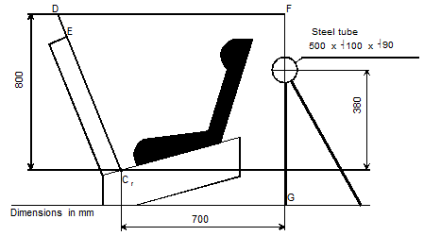

6.6.4.4.2. When Enhanced Child Restraint Systems of the specific vehicle categories are tested in a complete vehicle or a vehicle body shell, the head performance criterion (HPC) and the Head Acceleration 3 ms shall be used as assessment criteria. Where there is No Head Contact, these criteria shall be satisfied without measurement, and recorded only as no head contact. After a test, using a complete vehicle, it shall be possible to remove the fully assembled dummy from the Enhanced Child Restraint System without the use of mechanical leverage, or the use of tools on the Enhanced Child Restraint System or vehicle structure.

6.6.4.4.3 During the dynamic tests, no part of the Enhanced Child Restraint System restraining the child in position shall fail. This includes buckles, locking systems and reclining systems, except where identified as a load limiting device. Any load limiting device shall be identified in the manufacturers' technical descriptions as defined in paragraph 3.2.1. of this Regulation.

6.6.4.5. Dummy criteria for lateral impact for forward, lateral and rearward facing Enhanced Child Restraint System.

6.6.4.5.1. Main injury assessment criterion — Head containment

During the loading phase of lateral impact testing, up to 80 ms, side protection shall always be positioned at the level at the dummy'shead centre of gravity perpendicular to the direction of the door intrusion. Head containment will be assessed by the following criteria:

(a) No head contact with the door panel;

(b) Head shall not exceed a vertical plane identified by a red line on top of the door (top view camera). This vertical plane is identified by a line on the impacted door as defined in Annex 6, Appendix 3, Figure 1. This criteria is for monitoring purpose only for tests with a Q10 dummy.

6.6.4.5.2. Additional Injury assessment criteria for lateral impact

# Table 5

| *Criterion* | *Abbreviation* | *Unit* | *Q0* | *Q1* | *Q1.5* | *Q3* | *Q6* | *Q10* |
| --- | --- | --- | --- | --- | --- | --- | --- | --- |
| Head performance criterion | HPC (15) |  | 600 | 600 | 600 | 800 | 800 | For monitoring purpose only |
| Head acceleration  3 ms | A head Cum 3 ms** | g | 75 | 75 | 75 | 80 | 80 |
| Upper neck tension force | Fz | N | For monitoring purpose only* | | | | | |
| Upper neck flexion moment | Mx | Nm | For monitoring purpose only**\*** | | | | | |

*  To be reviewed within 3 years following entry into force of this Regulation.

** Cum 3ms means cumulative 3ms value

6.6.5. Resistance to temperature

6.6.5.1. Buckle assemblies, retractors, adjusters and lock-off devices that are liable to be affected by temperature, shall be subject to the temperature test specified in paragraph 7.2.7. below. This requirement is applicable to any such components that are found on the Enhanced Child Restraint System, regardless of the means of restraint.

6.6.5.2. After the temperature test as prescribed in paragraph 7.2.7.1. below, no signs of deterioration likely to impair the proper functioning of the restraint of the child, shall be visible to the unaided eye of a qualified observer. The dynamic tests should then be performed.

6.7. Provisions applicable to individual components of the restraint

This paragraph is applicable to any such components that are found on the Enhanced Child Restraint System, regardless of the means of restraint.

6.7.1. Buckle

6.7.1.1. The buckle shall be so designed as to preclude any possibility of incorrect manipulation. This means, inter/alia, that it shall not be possible for the buckle to be left in a partially closed position; it shall not be possible to exchange the buckle parts inadvertently when the buckle is being locked; the buckle shall only lock when all parts are engaged. Wherever the buckle is in contact with the child, it shall not be narrower than the minimum width of strap as specified in paragraph 6.7.4.1.1. below. This paragraph is not applicable to belt assemblies already approved according to UN Regulation No. 16 or any equivalent standard in force. In the case of a "Special Needs Restraint" only the buckle on the primary means of restraint need comply with the requirements of paragraphs 6.7.1.2. to 6.7.1.8. inclusive.

6.7.1.2. The buckle, even when not under tension, shall remain closed whatever its position. It shall be easy to operate and to grasp. It shall be possible to open it by pressure on a button or on a similar device.

The surface to which this pressure shall be applied shall have, in the position of actual unlocking and when projected into a plane perpendicular to the button's initial direction of motion:

(a) For enclosed devices, an area of not less than 4.5 cm2 with a width of not less than 15 mm;

(b) For non-enclosed devices, an area of 2.5 cm2 and a width of not less than 10 mm. The width shall be the smaller of the two dimensions forming the prescribed area and shall be measured rectangular to the direction of movement of the release button.

6.7.1.3. The buckle release area shall be coloured red. No other part of the buckle shall be of this colour.

6.7.1.4. It shall be possible to release the child from the restraint by a single operation on a single buckle after release of the shoulder strap positioner, if any. It is allowed to remove the child together with devices such as infant carrier/carry-cot/carry-cot restraints if the Enhanced Child Restraint System can be released by operation of a maximum of two release buttons.

6.7.1.4.1. Shoulder strap positioner

If a shoulder strap positioner is provided, it shall be designed so as to prevent incorrect manipulation. It shall not be possible to use the device in a manner which would cause the shoulder straps to twist. It shall be possible to fasten the device in no more than one action. The force required to fasten the device shall not exceed 15 N.

6.7.1.4.2. The shoulder strap positioner shall be easy to operate and to grasp. It shall be possible to open it in one simple action, but it shall be difficult for the child occupant to manipulate the release mechanism. The force required to release the device shall not exceed 15 N.

6.7.1.4.3. The shoulder strap positioner shall not exceed 60 mm in height.

6.7.1.5. Opening of the buckle shall enable the child to be removed independently of the "*chair*", "*chair support*" or "*impact shield*", if fitted, and if the device includes a crotch strap the crotch strap shall be released by operation of the same buckle.

6.7.1.6. The buckle shall be capable of withstanding the temperature test operation requirements given in paragraph 7.2.7. below and repeated operation, and shall, before the dynamic test prescribed in paragraph 7.1.3. below undergo a test comprising 5,000 ± 5 opening and closing cycles under normal conditions for use.

6.7.1.7. The buckle shall be subjected to the following tests of opening:

6.7.1.7.1. Test under load

6.7.1.7.1.1. An Enhanced Child Restraint System having already undergone the dynamic test prescribed in paragraph 7.1.3. below shall be used for this test.

6.7.1.7.1.2. The force required to open the buckle in the test prescribed in paragraph 7.2.1.1. below shall not exceed 80 N.

6.7.1.7.2. No-load test

6.7.1.7.2.1. A buckle which has not previously been subjected to a load shall be used for this test. The force needed to open the buckle when it is not under load shall be in the range of 40–80 N in the tests prescribed in paragraph 7.2.1.2. below

6.7.1.8. Strength

6.7.1.8.1. During the test in accordance with paragraph 7.2.1.3.2. below no part of the buckle or the adjacent straps or adjusters shall break or be detached.

6.7.1.8.2. Depending on the mass limit declared by the manufacturer, a buckle shall withstand:

6.7.1.8.2.1. 4 kN, if the mass limit is less or equal to 13 kg;

6.7.1.8.2.2. 10 kN, if the mass limit is greater than 13 kg.

6.7.1.8.3. The Type Approval Authority may dispense with the buckle strength test if information already available renders the test superfluous.

6.7.2. Adjusting device

6.7.2.1. The range of adjustment shall be sufficient to permit correct adjustment of the Enhanced Child Restraint System with all size for which the device is intended and to permit satisfactory installation in all i-Size compatible vehicles.

6.7.2.2. All adjusting devices shall be of the "quick adjuster" type.

6.7.2.3. Devices of the "quick adjuster" type shall be easy to reach when the Enhanced Child Restraint System is correctly installed and the child or dummy is in position.

6.7.2.4. A device of the "quick adjuster" type shall be easily adjustable to the child's physique. In particular, in a test performed in accordance with paragraph 7.2.2.1. below, the force required to operate a manual adjusting device shall not exceed 50 N.

6.7.2.5. Two samples of the Enhanced Child Restraint System adjusting devices shall be tested as prescribed by the temperature test operation requirements given in paragraph 7.2.7.1. and paragraph 7.2.3. below.

6.7.2.5.1. The amount of strap slip shall not exceed 25 mm for one adjusting device or 40 mm for all adjusting devices.

6.7.2.6. The device shall not break or become detached when tested as prescribed in paragraph 7.2.2.1. below.

6.7.2.7. An adjuster mounted directly on the Child Restraint System shall be capable of withstanding repeated operation and shall, before the dynamic test prescribed in paragraph 7.1.3. undergo a test comprising 5,000 ± 5 cycles as specified in paragraph 7.2.6.1.

An adjuster mounted on a strap shall be capable of withstanding repeated operation and shall, before the dynamic test prescribed in paragraph 7.1.3. undergo a test comprising 5,000 ± 5 cycles that applies the principles of the test specified in paragraph 7.2.3. This test shall be defined by the Technical Service in consultation with the manufacturer.

6.7.3. Retractors

6.7.3.1. Automatically-locking retractors

6.7.3.1.1. The strap equipped with an automatically-locking retractor shall not unwind by more than 30 mm between locking positions of the retractor. After a rearward movement of the wearer the strap shall either remain in its initial position or return to that position automatically on subsequent forward movement of the wearer.

6.7.3.1.2. If the retractor is part of a lap strap, the retracting force of the strap shall be not less than 7 N as measured in the free length between the dummy and the retractor as prescribed in paragraph 7.2.4.1. below. If the retractor is part of a chest restraint, the retracting force of the strap shall be not less than 2 N or more than 7 N as similarly measured. If the strap passes through a guide or pulley, the retracting force shall be measured in the free length between the dummy and the guide or pulley. If the assembly incorporates a device, manually or automatically operated, that prevents the strap from being completely retracted, that device shall not be in operation when these measurements are effected.

6.7.3.1.3. The strap shall be repeatedly withdrawn from the retractor and allowed to retract, in the conditions prescribed in paragraph 7.2.4.2. below, until 5,000 cycles have been completed. The retractor shall then be subjected to the temperature test operation requirements given in paragraph 7.2.7.1. and corrosion test described in paragraph 7.1.1. below and the dust-resistance test described in paragraph 7.2.4.5. below. It shall then satisfactorily complete a further 5,000 cycles of withdrawal and retraction. After the above tests the retractor shall continue to operate correctly and to meet the requirements of paragraphs 6.7.3.1.1. and 6.7.3.1.2. above.

6.7.3.2. Emergency-locking retractors

6.7.3.2.1. An emergency-locking retractor shall when tested as prescribed in paragraph 7.2.4.3. satisfy the conditions below:

6.7.3.2.1.1. It shall be locked when the deceleration of the vehicle reaches 0.45 g;

6.7.3.2.1.2. It shall not lock for strap accelerations of less than 0.8 g as measured in the axis of strap extraction;

6.7.3.2.1.3. It shall not lock when its sensing device is tilted by not more than 12° in any direction from the installation position specified by its manufacturer;

6.7.3.2.1.4. It shall lock when its sensing device is tilted by more than 27° in any direction from the installation position specified by its manufacturer.

6.7.3.2.2. Where the operation of a retractor depends on an external signal or power source, the design shall ensure that the retractor locks automatically upon failure or interruption of that signal or power source.

6.7.3.2.3. A multiple-sensitivity emergency-locking retractor shall meet the requirements set out above. In addition, if one of the sensitivity factors relates to strap extraction, locking shall have occurred at a strap acceleration of 1.5 g as measured in the axis of strap extraction.

6.7.3.2.4. In the tests referred to in paragraphs 6.7.3.2.1.1. and 6.7.3.2.3. above, the amount of strap extraction occurring before the retractor locks shall not exceed 50 mm, starting at the length of unwinding specified in paragraph 7.2.4.3.1. below. In the test referred to in paragraph 6.7.3.2.1.2. above, locking shall not occur during the 50 mm of strap extraction starting at the length of unwinding specified in paragraph 7.2.4.3.1. below.

6.7.3.2.5. If the retractor is part of a lap strap, the retracting force of the strap shall be not less than 7 N as measured in the free length between the dummy and the retractor as prescribed in paragraph 7.2.4.1. below. If the retractor is part of a chest restraint, the retracting force of the strap shall be not less than 2 N or more than 7 N as similarly measured. If the strap passes through a guide or pulley, the retracting force shall be measured in the free length between the dummy and the guide or pulley. If the assembly incorporates a device, manually or automatically operated, that prevents the strap from being completely retracted, that device shall not be in operation when these measurements are effected.

6.7.3.2.6. The strap shall be repeatedly withdrawn from the retractor and allowed to retract, in the conditions prescribed in paragraph 7.2.4.2. of this Regulation, until 40,000 cycles have been completed. The retractor shall then be subjected to the temperature test operation requirements given in paragraph7.2.7. and corrosion test described in paragraph 7.1.1. and to the dust-resistance test described in paragraph 7.2.4.5.

6.7.4. Straps

6.7.4.1. Width

6.7.4.1.1. The minimum width at the child-restraint straps which contact the dummy shall be 25 mm. These dimensions shall be measured during the strap strength test prescribed in paragraph 7.2.5.1. below, without stopping the machine and under a load equal to 75 per cent of the breaking load of the strap.

6.7.4.2. Strength after room conditioning

6.7.4.2.1. On two sample straps conditioned as prescribed in paragraph 7.2.5.2.1., the breaking load of the strap shall be determined as prescribed in paragraph 7.2.5.1.2. below.

6.7.4.2.2. The difference between the breaking loads of the two samples shall not exceed 10 per cent of the greater of the two breaking loads measured.

6.7.4.3. Strength after special conditioning

6.7.4.3.1. On two straps conditioned as prescribed in one of the provisions of paragraph 7.2.5.2. below (except paragraph 7.2.5.2.1. below), the breaking load of the strap shall be not less than 75 per cent of the average of the loads determined in the test referred to in paragraph 7.2.5.1. below.

6.7.4.3.2. In addition, the breaking load shall be not less than 3.6 kN for the restraints of i-Size Enhanced Child Restraint Systems.

6.7.4.3.3. The Type Approval Authority may dispense with one or more of these tests if the composition of the material used, or information already available, renders the test or tests superfluous.

6.7.4.3.4. The abrasion conditioning procedure of type 1 defined in paragraph 7.2.5.2.6. below shall only be performed when the microslip test defined in paragraph 7.2.3. below gives a result above 50 per cent of the limit prescribed in paragraph 6.7.2.5.1. above.

6.7.4.4. It shall not be possible to pull the complete strap through any adjusters, buckles or anchoring points.

6.7.5. ISOFIX attachment specifications

6.7.5.1. ISOFIX attachments and latching indicators shall be capable of withstanding repeated operations and shall, before the dynamic test prescribed in paragraph 7.1.3. of this Regulation, undergo a test comprising 2,000 ± 5 opening and closing cycles under normal conditions of use.

6.7.5.2. ISOFIX attachments shall have a locking mechanism which complies with the requirements specified in (a) or (b) as follows:

(a) Release of the locking mechanism of the complete seat, shall require two consecutive actions, the first of which should be maintained while the second is carried out; or

(b) The ISOFIX attachment opening force shall be at least 50 N when tested as prescribed in paragraph 7.2.8. below.

6.7.6. Lock-off device

6.7.6.1. The lock-off device shall be permanently attached to the Enhanced Child Restraint System.

6.7.6.2. The lock-off device shall not impair the durability of the adult belt and shall undergo the temperature test operation requirements given in paragraph 7.2.7.1.

6.7.6.3. The lock-off device shall not prevent the rapid release of the child.

6.7.6.4. Class A device

The amount of slip of the webbing shall not exceed 25 mm after the test prescribed in paragraph 7.2.9.1. below.

6.7.6.5. Class B device

The amount of slip of the webbing shall not exceed 25 mm after the test prescribed in paragraph 7.2.9.2. below.

6.8. Classification

6.8.1. Enhanced Child Restraint Systems may cover any size range provided that the requirements for the whole range are fulfilled.

7. Tests

7.1. Tests of the assembled Enhanced Child Restraint System

7.1.1. Corrosion

7.1.1.1. The metal items of the Enhanced Child Restraint System shall be positioned in a test chamber as prescribed in Annex 4. In the case of an Enhanced Child Restraint System incorporating a retractor, the strap shall be unwound to full length less 100 ± 3 mm. Except for short interruptions that may be necessary, for example, to check and replenish the salt solution, the exposure test shall proceed continuously for a period of 50 ± 0.5 hours.

7.1.1.2. On completion of the exposure test the metal items of the Enhanced Child Restraint System shall be gently washed, or dipped, in clean running water with a temperature not higher than 38 °C to remove any salt deposit that may have formed and then allowed to dry at room temperature of 18 °C to 25 °C for 24 ± 1 hours before inspection in accordance with paragraph 6.6.1.2. above.

7.1.2. Overturning

7.1.2.1. The manikin shall be equipped with either of the load application devices as appropriate, and described in Annex 21 to this Regulation. Place the manikin in the restraints installed in accordance with this Regulation and taking into account the manufacturer's instructions and with the standard slack as specified in paragraph 7.1.3.5. below, applied for all systems identically.

7.1.2.2. The restraint shall be fastened to the test bench or vehicle seat. The whole Enhanced Child Restraint System shall be rotated around a horizontal axis contained in the median longitudinal plane of the Enhanced Child Restraint System through an angle of 540° ± 5° at a speed of 2-5 degrees/second and stopped in this position. For the purposes of this test, devices intended for use in specific cars may be attached to the test bench described in [Annex 6.](#_Annex_6_(to)

7.1.2.3. At this static inverted position a mass equivalent to 4 times that of the dummy, with a tolerance of -0/+5 per cent with reference to dummies nominal masses as in Annex 8, shall be applied vertically downwards in a plane perpendicular to the axis of rotation in addition to the dummy utilizing the load application device described in Annex 21. The load shall be applied in a gradual controlled manner at a rate not exceeding gravitational acceleration or 400 mm/min. Maintain the prescribed maximum load for a duration of 30 -0/+5 seconds.

7.1.2.4. Remove the load at a rate not exceeding 400 mm/min and measure residual displacement.

7.1.2.5. Rotate the whole seat for 180° to return to the starting position.

7.1.2.6. This test cycle shall be carried out again rotating in the reverse direction. With the rotational axis in the horizontal plane and at 90° to that of the two earlier tests, the procedure shall be repeated in the two directions of rotation.

7.1.2.7. These tests shall be carried out using both the smallest and the largest appropriate dummy of the size range for which the restraining device is intended. Any adjustment of the dummy or Enhanced Child Restraint Systems during the complete test cycle is not allowed.

7.1.3. Dynamic testing for frontal, rear and lateral impact:

(a) Frontal impact test shall be performed on i-Size (Integral Universal ISOFIX Enhanced Child Restraint Systems), Specific vehicle ISOFIX Enhanced Child Restraint Systems and to non-integral Enhanced Child Restraint Systems i-Size booster seats and specific vehicle booster seats;

(b) Rear impact test shall be performed on i-Size and Specific Vehicle ISOFIX Rearward and Lateral facing Enhanced Child Restraint Systems;

(c) Lateral impact test are performed only on the test bench for i-Size Integral Universal ISOFIX Enhanced Child Restraint Systems, Specific vehicle ISOFIX and for non-integral Enhanced Child Restraint Systems i-Size booster seats and specific vehicle booster seats;

(d) The ECRS shall be tested in its most upright used position. If this upright position falls outside the Seat Fixture, this position shall still to be chosen. However with width positions outside the Seat Fixture, for the lateral test the width position of lateral shock absorbers that still fit in the Vehicle Seat Fixture shall be chosen;

(e) The lateral dynamic test(s) will be performed in this(ese) arrangement(s);

(f) For frontal and rear impacts, the tests shall be performed with the ECRS adjusted to the size of the dummy (ies) selected to cover the entire size range, in the child seating position representing the worst case for this dummy and impact orientation;

(g) An anti rebound device acting on the vehicle seatback shall stay inside the seat fixture in one position, but may protrude beyond the seat fixture in its adjusted position according to the user manual.

7.1.3.1. Tests using the trolley and test bench

7.1.3.1.1. Frontal impact tests.

7.1.3.1.1.1. The trolley and test bench used in the dynamic test shall meet the requirements of [Annex 6](#_Annex_6_(to) to this Regulation.

7.1.3.1.1.2. The trolley shall remain horizontal throughout deceleration or acceleration.

7.1.3.1.1.3. The test bench shall be rotated 180° when testing in compliance with the requirements of the rear impact test.

7.1.3.1.1.4. When testing a rearward-facing Enhanced Child Restraint System intended for use in the front seating position, the vehicle facia shall be represented by a rigid bar attached to the trolley in such a way that all the energy absorption takes place in the Enhanced Child Restraint System.

7.1.3.1.1.5. Deceleration or acceleration devices

The applicant shall choose to use one of the two following devices:

7.1.3.1.1.5.1. The deceleration of the trolley shall be achieved by using the apparatus prescribed in Annex 6 to this Regulation or any other device giving equivalent results. This apparatus shall be capable of the performance specified in paragraph 7.1.3.4. and hereafter specified:

For frontal impact, the trolley shall be so propelled that, at the beginning of the test, its velocity is 50 + 0/- 2 km/h and its acceleration curve is within the hatched area of the graph in Annex 7, Appendix 1.

For rear impact, the trolley shall be so propelled that, at the beginning of the test, its velocity is 30 +2/- 0 km/h and its acceleration curve is within the hatched area of the graph in Annex 7, Appendix 2.

Tests performed at a higher speed and/or with an acceleration that exceeds the upper boundary of the hatched area shall be considered satisfactory if the child restraint system meets the performance requirements for the test.

Tests performed at a lower acceleration shall be considered satisfactory only if the acceleration curve crosses the lower boundary of the hatched area for a cumulative period of up to 3 ms.

In fulfilling the above requirements, the Technical Service shall use a mass of trolley (equipped with its seat), as specified in paragraph 1. of Annex 6, greater than 380 kg.

7.1.3.1.1.5.2. Acceleration test device

Dynamic testing conditions:

For frontal impact, the trolley shall be so propelled that, during the test, its total velocity change ΔV is 52 + 0 – 2 km/h and its acceleration curve is within the hatched area of the graph in Annex 7, Appendix 1 and stay above the segment defined by the coordinates (5 g, 10 ms) and (9 g, 20 ms). The start of the impact (T0) is defined, according to ISO 17 373 for a level of acceleration of 0.5 g.

For rear impact, the trolley shall be so propelled that, during the test, its total velocity change ΔV is 32  + 2 - 0 km/h and its acceleration curve is within the hatched area of the graph in Annex 7, Appendix 2 and stay above the segment defined by the coordinates (5 g, 5 ms) and (10 g, 10 ms). The start of the impact (T0) is defined, according to ISO 17 373 for a level of acceleration of 0.5 g.

Despite the fulfilment of the above requirements, the Technical Service shall use a mass of trolley (equipped with its test bench), as specified in paragraph 1. of [Annex 6,](#_Annex_6_(to) superior to 380 kg.

However, if the tests above were performed at a higher speed and/or the acceleration curve has exceeded the upper level of the hatched area and the Enhanced Child Restraint System meets the requirements, the test shall be considered satisfactory.

7.1.3.1.1.6. The following measurements shall be made:

7.1.3.1.1.6.1. The trolley speed immediately before impact (only for deceleration sleds, needed for stopping distance calculation);

7.1.3.1.1.6.2. The stopping distance (only for deceleration sleds), which may be calculated by double integration of the recorded sled deceleration;

7.1.3.1.1.6.3. The displacement of the dummy's head in the vertical and horizontal direction of the tests with all Q-dummies necessary for the given i-Size indication for at least the first 300 ms;

7.1.3.1.1.6.4. The parameters required to perform the injury assessment against the criteria as mentioned in paragraph 6.6.4.3.1. above for at least the first 300 ms;

7.1.3.1.1.6.5. The trolley acceleration or deceleration for at least the first 300 ms.

7.1.3.1.1.7. After impact, the Enhanced Child Restraint System shall be inspected visually, without opening the buckle, to determine whether there has been any failure or breakage.

7.1.3.1.2. Rear impact

7.1.3.1.2.1. The test bench shall be rotated 180° when testing its compliance with the requirements of the rear impact test.

7.1.3.1.2.2. When testing a rearward-facing child restraint intended for use in the front seating position, the vehicle facia shall be represented by a rigid bar attached to the trolley in such a way that all the energy absorption takes place in the child restraint.

7.1.3.1.2.3. The deceleration conditions shall satisfy the requirements of Annex 7, Appendix 2.

The acceleration conditions shall satisfy the requirements of Annex 7, Appendix 2.

7.1.3.1.2.4. The measurements to be made shall be similar to those listed in paragraphs 7.1.3.1.1.4. to 7.1.3.1.1.5. above.

7.1.3.1.3. Lateral impact

7.1.3.1.3.1. The test benchshall be rotated 90° when testing in compliance with the requirements of the lateral impact test.

7.1.3.1.3.2 The lower ISOFIX anchorages should be movable in the Y direction to avoid damage to the attachments and test equipment. The ISOFIX anchorages shall be fixed to a sliding system allowing a movement of 200mm -0mm +50mm. When measured with a dynamometer at a rate of 600-1200mm/min positioned in a plane parallel the sliding surface and aligned to the central axis of the sliding surface, the force required to move the sliding system (both anchorages together) throughout its entire range, shall not exceed 100N. This verification shall be performed every 50 tests or every 6 months whichever occurs first.

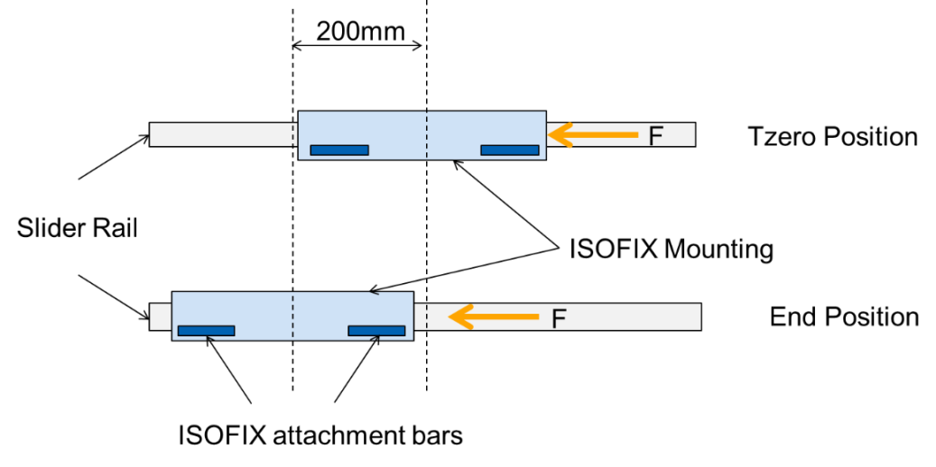

7.1.3.1.3.3. The lateral impact loading to the ECRS shall be generated by a door panel as defined in Annex 6, Appendix 3. The surface of the panel shall be covered with padding as specified in Annex 6, Appendix 3.

7.1.3.1.3.4. The test rig shall reproduce a relative velocity between the door panel and the test bench in compliance with Annex 7, Appendix 3. The maximum intrusion depth of the door panel is defined in Annex 6, Appendix 3. The relative velocity between the door panel and the test bench shall not be affected by contact with the ECRS and shall remain within the corridor defined in Annex 7, Appendix 3. In a test where the door is stationary at time t0, the door shall be fixed and the dummy's ground velocity at t0 shall be between 6.375 m/s and 7.25 m/s. In a test where the door is moving at t0, the door's ground velocity shall remain within the corridor defined in Annex 7, Appendix 3 at least until its intrusion reaches its maximum, and the dummy shall be stationary at t0.

7.1.3.1.3.5. At time t0 defined Annex 7, Appendix 3, the dummyshall be in its initial position as defined in paragraph 7.1.3.5.2.1. below.

7.1.3.2. Test on trolley and vehicle body shell

7.1.3.2.1. For frontal impact tests

7.1.3.2.1.1. The method used to secure the vehicle during the test shall not be such as to strengthen the anchorages of the vehicle seats, adult safety belts and any additional anchorages required to secure the child restraint or to lessen the normal deformation of the structure. No part of the vehicle shall be present which, by limiting the movement of the dummy, would reduce the load imposed on the child restraint during the test. The parts of the structure eliminated may be replaced by parts of equivalent strength, provided they do not hinder the movement of the dummy.

7.1.3.2.1.2. A securing device shall be regarded as satisfactory if it produces no effect on an area extending over the whole width of the structure and if the vehicle or structure is blocked or fixed in front at a distance of not less than 500 mm from the anchorage of the restraint system. At the rear the structure shall be secured at a sufficient distance behind the anchorages to ensure that all requirements of paragraph 7.1.3.2.1.1. above are fulfilled.

7.1.3.2.1.3. The vehicle seat and Enhanced Child Restraint System shall be fitted and placed in a position chosen by the Technical Service conducting the approval tests to give the most adverse conditions in respect of strength, compatible with installation of the dummy in the vehicle. The position of the vehicle seat-back and Enhanced Child Restraint System shall be stated in the report. The vehicle seat-back, if adjustable for inclination, shall be locked as specified by the manufacturer or, in the absence of any specification, at an actual seat-back angle as near as possible to 25°.

7.1.3.2.1.4. Unless the instructions for fitting and use require otherwise, the front seat shall be placed in the most forward normally used position for child restraints intended for use in the front seating position, and in the rearmost normally used position for child restraints intended for use in the rear seating position.

7.1.3.2.1.5. The deceleration conditions shall satisfy the requirements of paragraph 7.1.3.4. below. The test benchwill be the seat of the actual vehicle.

7.1.3.2.1.6. The following measurements shall be made:

7.1.3.2.1.6.1. The trolley speed immediately before impact (only for deceleration sleds, needed for stopping distance calculation);

7.1.3.2.1.6.2. The stopping distance (only for deceleration sleds), which may be calculated by double integration of the recorded sled deceleration;

7.1.3.2.1.6.3. Any contact of the dummy's head with the interior of the vehicle body shell;

7.1.3.2.1.6.4. The parameters required to perform the injury assessment against the criteria as mentioned in paragraph 6.6.4.3.1. above for at least the first 300 ms;

7.1.3.2.1.6.5. The trolley and vehicle body shell acceleration or deceleration for at least the first 300 ms.

7.1.3.2.1.7. After impact, the child restraint shall be inspected visually, without opening the buckle, to determine whether there has been any failure.

7.1.3.2.2. For rear impact tests

7.1.3.2.2.1. The vehicle body shell shall be rotated 180° on the test trolley.

7.1.3.2.2.2. Same requirements as for frontal impact (paragraphs 7.1.3.2.1.1. to 7.1.3.2.1.5. above) shall apply.

7.1.3.3. When testing with a complete vehicle

7.1.3.3.1. The deceleration conditions shall satisfy the requirements of paragraph 7.1.3.4. below.

7.1.3.3.2. For frontal impact tests the procedure shall be that set out in Annex 9 to this Regulation.

7.1.3.3.3. For rear impact tests the procedure shall be that set out in Annex 10 to this Regulation.

7.1.3.3.4. The following measurements shall be made:

7.1.3.3.4.1. The speed of the vehicle/impactor immediately before impact **(**only for deceleration sleds, needed for stopping distance calculation);

7.1.3.3.4.2. Any contact of the dummy's head with the interior of the vehicle;

7.1.3.3.4.3. The parameters required to perform the injury assessment against the criteria as mentioned in paragraph 6.6.4.3.1. above for at least the first 300 ms.

7.1.3.3.5. The front seats, if adjustable for inclination, shall be locked as specified by the manufacturer or, in the absence of any specification, at an actual seat-back angle as near as possible to 25°.

7.1.3.3.6. After impact, the child restraint shall be inspected visually, without opening the buckle, to determine whether there has been any failure or breakage.

7.1.3.4. The conditions for dynamic test are summarized in Table 6:

# Table 6

|  | | *Frontal impact* | | | *Rear impact* | | | *Lateral impact* | |
| --- | --- | --- | --- | --- | --- | --- | --- | --- | --- |
| *Test* | *Restraint* | *Speed km/h* | *Test pulse No.* | *Stopping distance during test (mm)* | *Speed km/h* | *Test pulse No.* | *Stopping distance during test (mm)* | *Relative door/bench velocity* | *Stopping distance during test (mm) Maximum intrusion* |
| Trolley with test bench | Forward  Facing | 50 + 0  -2 | 1 | 650 ± 50 | NA | NA | NA | 3 | 250 ± 50 |
| Rearward  Facing | 50 + 0  -2 | 1 | 650 ± 50 | 30 + 2  -0 | 2 | 275 ± 25 | 3 | 250 ± 50 |
| Lateral  Facing | 50 + 0  -2 | 1 | 650 ± 50 | 30 + 2  -0 | 2 | 275 ± 25 | 3 | 250 ± 50 |

*Legend*:

Test pulse No. 1 – As prescribed in Annex 7 / Appendix 1 – Frontal impact.

Test pulse No. 2 – As prescribed in Annex 7 / Appendix 2 – Rear impact.

Test velocity corridor curve No. 3 – As prescribed in Annex 7 / Appendix 3 – Lateral impact

TBD: to be defined

NA: non-applicable

7.1.3.5. Dynamic test dummies

7.1.3.5.1. The Enhanced Child Restraint System shall be tested using the dummies prescribed in Annex 8 to this Regulation.

7.1.3.5.2. Installation for frontal, rear and lateral impacts.

7.1.3.5.2.1. Installation of Integral Universal ISOFIX Enhanced Child Restraint Systems (i-Size), or Integral Specific vehicle ISOFIX Enhanced Child Restraint Systems on the test bench.

The unoccupied ISOFIX Enhanced Child Restraint System shall be attached to the ISOFIX anchorage system.

Securing the ISOFIX attachments to the ISOFIX lower anchorages shall be permitted to draw the unoccupied Enhanced Child Restraint System towards those anchorages.

An additional force of 135 ± 15N shall be applied in a plane parallel to the surface of the test seat cushion. The force shall be applied along the centre line of the Enhanced Child Restraint System and at a height no more than 100 mm above the cushion.

If present, the top tether shall be adjusted to achieve a tension load of 50 ± 5N. Alternatively, and if present, the support-leg shall be adjusted according to the Enhanced Child Restraint System manufacturer's instructions.

The Enhanced Child Restraint System centre line shall be aligned with the centre line of the test bench.

The dummy shall be placed in the Enhanced Child Restraint System separate from the seat-back of the chair by a flexible spacer. The spacer shall be 2.5 cm thick and 6 cm wide. It shall have length equal to the shoulder height less the thigh height, both in the sitting position and relevant to the dummy size being tested. The resulting height of the spacer is listed in the table below for the different dummy sizes. The board should follow as closely as possible the curvature of the chair and its lower end should be at the height of the dummy's hip joint.

# Table 7

|  | *Q0* | *Q1* | *Q1.5* | *Q3* | *Q6* | *Q10 (design targets)* |
| --- | --- | --- | --- | --- | --- | --- |
|  | Dimensions in mm | | | | | |
| Height of spacer device for positioning of dummy | 173 ± 2 | 229 ± 2 | 237 ± 2 | 250 ± 2 | 270 ± 2 | 359 ± 2 |

Adjust the ECRS belt in accordance with the manufacturer's instructions, but to a tension of 250 ± 25 N above the adjuster force, with a deflection angle of the strap at the adjuster of 45 ± 5°, or alternatively, the angle prescribed by the manufacturer.

The spacer shall then be removed and the dummy pushed towards to the seat back. Distribute the slack evenly throughout the harness.

The longitudinal plane passing through the centre line of the dummy shall be set midway between the two lower ECRS belt anchorages, however note shall also be taken of paragraph 7.1.3.2.1.3. above.

7.1.3.5.2.2. Installation of a non-integral Enhanced Child Restraint Systems i-Size booster seat or specific to vehicle booster seat on the test bench.

The unoccupied booster seat shall be placed on the test bench.

If present and tested, securing the ISOFIX attachments to the ISOFIX lower anchorages shall be permitted to draw the unoccupied Enhanced Child Restraint System towards these anchorages. An additional force of 135 ± 15N shall be applied in a plane parallel to the surface of the test bench seat cushion. The force shall be applied along the centre line of the Enhanced Child Restraint System and at a height of no more than 100 mm above the test bench seat cushion.

The dummy shall be placed in the Enhanced Child Restraint System.

# Figure 3

**Load cell positions**

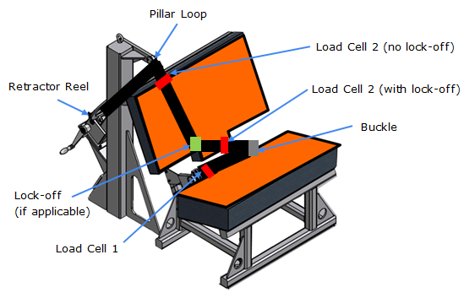

Fit load cell 1 to the outboard position as shown Figure 1. Install the Enhanced Child Restraint System in the correct position. If a lock-off device is fitted to the Enhanced Child Restraint System and acts upon the diagonal belt, place load cell 2 at a convenient position behind the Enhanced Child Restraint System between the lock-off device and the buckle as shown above. If no lock-off device is fitted or if the lock-off device is fitted at the buckle, position the load cell at a convenient position between the pillar loop and the Enhanced Child Restraint System.

Adjust the lap portion of the reference belt to achieve a tension load of 50 N ± 5 N at load cell 1. Make a chalk mark on the webbing where it passes through the simulated buckle.

While maintaining the belt at this position, adjust the diagonal to achieve a tension of 50 N ± 5 N at load cell 2 by either locking the webbing at the Enhanced Child Restraint System webbing locker or by pulling the belt between the belt clamping mechanism and the standard retractor. If the tension in load cell 2 is achieved by pulling the belt between the clamping mechanism and the retractor, the clamping mechanism shall now be locked.

Extract all webbing from the retractor spool and rewind the excess webbing keeping a tension of 4 ± 3 N in the belt between the retractor and the pillar loop. The spool shall be locked before the dynamic test. Conduct the dynamic crash test.

7.1.3.5.2.3. Installation of an Integral Enhanced Child Restraint Systems "Universal Belted" seat or Specific vehicle Belted seat on the test bench.

The unoccupied belted Enhanced Child Restraint System shall be placed on the test bench.

Fit load cell 1 to the outboard position as shown Figure 1. Install the Enhanced Child Restraint System in the correct position. If a lock-off device is fitted to the Enhanced Child Restraint System and acts upon the diagonal belt, place load cell 2 at a convenient position behind the Enhanced Child Restraint System between the lock-off device and the buckle as shown above. If no lock-off device is fitted or if the lock-off device is fitted at the buckle, position the load cell at a convenient position between the pillar loop and the Enhanced Child Restraint System.

Adjust the lap portion of the reference belt to achieve a tension load of 50 N ± 5 N at load cell 1. Make a chalk mark on the webbing where it passes through the simulated buckle.

While maintaining the belt at this position, adjust the diagonal to achieve a tension of 50 N ± 5 N at load cell 2 by either locking the webbing with the Enhanced Child Restraint System webbing locker or by pulling the belt between the belt clamping mechanism and the standard retractor. If the tension in load cell 2 is achieved by pulling the belt between the clamping mechanism and the retractor, the clamping mechanism shall now be locked.

Extract all webbing from the retractor spool and rewind the excess webbing keeping a tension of 4 ± 3 N in the belt between the retractor and the pillar loop. The spool shall be locked before the dynamic test.

The dummy shall be placed in the Enhanced Child Restraint System separate from the seat-back of the chair by a flexible spacer. The spacer shall be 2.5 cm thick and 6 cm wide. It shall have length equal to the shoulder height less the thigh height, both in the sitting position and relevant to the dummy size being tested. The resulting height of the spacer is listed in the table below for the different dummy sizes. The board should follow as closely as possible the curvature of the seat and its lower end should be at the height of the dummy's hip joint.

Table 7

|  | *Q0* | *Q1* | *Q1.5* | *Q3* | *Q6* | *Q10 (design targets)* |
| --- | --- | --- | --- | --- | --- | --- |
|  | Dimensions in mm | | | | | |
| Height of spacer device for positioning of dummy | 173 ± 2 | 229 ± 2 | 237 ± 2 | 250 ± 2 | 270 ± 2 | 359 ± 2 |

Adjust the Enhanced Child Restraint System belt in accordance with the manufacturer's instructions, but to a tension of 250 ± 25 N above the force needed to overcome the friction between the webbing and the adjuster, with a deflection angle of the strap at the adjuster of 45 ± 5°, or alternatively, the angle prescribed by the manufacturer.

The spacer shall then be removed and the dummy pushed towards to the seat back. Distribute the slack evenly throughout the harness.

7.1.3.5.2.4. After installation

After installation, the dummy position shall be adjusted so that:

The dummy centre line and the Enhanced Child Restraint System centre line shall be aligned exactly with the centre line of the test bench.

The arms of the dummy shall be positioned symmetrically. Elbows shall be positioned in such a way that the upper arms are closely aligned with the sternum.

Hands shall be positioned on the thighs.

Legs shall be positioned parallel to one another or at least symmetrically.

For lateral impact, positive measures shall be taken to ensure the stability of the dummy is maintained until t0 and this shall be confirmed using video analysis. Any means used to stabilise the dummy before t0 shall not influence the dummy kinematics after t0.

Because the foam ofthe test bench seat cushion will compress after installation of the EnhancedChild Restraint System, the dynamic test shall be conducted no more than 10 minutes after installation.

To allow the test bench seat cushion to recover, the minimum period between two tests using the same test bench seat cushion shall be 20 minutes.

Example for arm alignment:

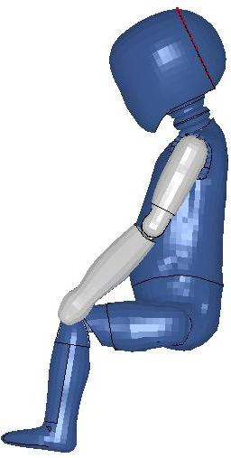 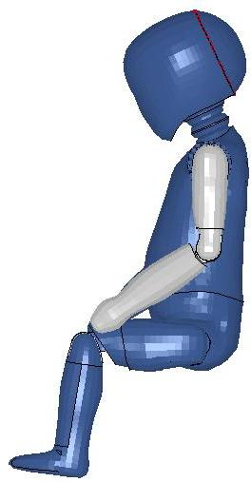

|  |  |
| --- | --- |
| Arms are aligned with sternum | Arms are not aligned with sternum |

7.1.3.6. Size indication

The dynamic tests shall be conducted with the largest dummy and the smallest dummy as defined in the following tables according to the size range indicated by the manufacturerfor the EnhancedChild Restraint System.

# Table 8

**Selection criteria for the dummy according to the range**

|  |  |  |  |  |  |  |
| --- | --- | --- | --- | --- | --- | --- |
| *Size range indication (in cm)* | *≤ 60* | *60 < x ≤ 75* | *75 < x ≤ 87* | *87 < x ≤ 105* | *105 < x ≤ 125* | *>125* |
| Dummy | Q0 | Q1 | Q1.5 | Q32 | Q6 | Q101 |
| 1 No lateral impact testusing the Q10 dummyis required for i-Size booster seats with a size range upper limit between 125 cm and 135 cm.  2 ECRS shall not be approved only on the base of Q3 test results in non-integral configuration | | | | | | |

Where the Enhanced Child Restraint System requires substantial modification for different sizes (e.g., convertible Enhanced Child Restraint System) or if the size range cover more than 3 size ranges a relevant intermediate dummy(ies) shall be tested in addition to the dummy(ies) defined above.

7.1.3.6.1. If the Enhanced Child Restraint System is designed for two or more children, one test shall be carried out with the heaviest dummies occupying all seatingpositions. A second test with the lightest and the heaviest dummies specified above shall be carried out. The tests shall be conducted using the test benchas shown in [Annex 6, Appendix 3, Figure 3](#_Annex_6_(to). The laboratory conducting the tests may, if it deems it advisable, add a third test with any combination of dummies or empty seat positions.

7.1.3.6.2. If the Enhanced Child Restraint System uses a top tether, one test shall be carried out with the smallest dummy with the shorter distance of the top tether (anchorage point G1). A second test shall be carried out with the heavier dummy with the longer distance of the top tether (anchorage point G2). Adjust the top tether to achieve a tension load of 50 ± 5 N. For side lateral impact the ISOFIX Enhanced child restraint shall be tested with only the shorter distance of the top tether.

7.1.3.6.3. If the Enhanced Child Restraint System uses a support-leg, as an anti-rotation device the hereafter mentioned dynamic tests shall be carried out as follows:

(a) The tests for frontal impact shall be conducted with the support-leg adjusted to its maximum adjustment compatible with the positioning of the trolley floor pan. The tests for rear impact shall be conducted with the worst case position selected by the Technical Service. During the tests the support-leg shall be supported by the trolley floor pan as described in Annex 6, Appendix 2, figure 2;

(b) In the case of support-legs out of the plane of symmetry, the worst case shall be selected by the Technical Service for the test;

(c) In the case of "specific vehicle" category, the support-leg shall be adjusted as specified by the Enhanced Child Restraint System manufacturer;

(d) The leg length of a support-leg shall be adjustable in such a way that it is able to cover the complete span of floor pan levels that are allowed for in UN Regulation No. 16, Annex 17 for car seats to be approved for the installation i-Size Enhanced Child Restraint~~s~~ Systems.

7.1.3.6.4. The test specified in paragraph 6.6.4.1.6.2. above is a requirement only for the largest dummy for which the child restraint is designed.

7.1.3.6.5. The test specified in 6.6.4.1.8. above is a requirement only for:

7.1.3.6.5.1. The smallest dummy for which the Enhanced Child Restraint is designed, if the means of restraint is an impact shield.

7.1.3.6.5.2. The largest dummy for which the Enhanced Child Restraint is designed, if the means of restraint is a harness.

7.2. Testing of individual components

7.2.1. Buckle

7.2.1.1. Opening test under load

7.2.1.1.1. An Enhanced Child Restraint System already having been subjected to the dynamic test specified in paragraph 7.1.3. above shall be used for this test.

7.2.1.1.2. The Enhanced Child Restraint System shall be removed from the test bench or the vehicle without opening the buckle. A tension of 200 ± 2 N shall be applied to the buckle. If the buckle is attached to a rigid part, the force shall be applied reproducing the angle formed between the buckle and that rigid part during the dynamic test.

7.2.1.1.3. A load shall be applied at a speed of 400 ± 20 mm/min to the geometric centre of the buckle-release button along a fixed axis running parallel to the initial direction of motion of the button; the geometric centre applies to that part of the surface of the buckle to which the release pressure is to be applied. The buckle shall be secured against a rigid support during the application of the opening force.

7.2.1.1.4. The buckle opening force shall be applied, using a dynamometer or similar device in the manner and direction of normal use. The contact end shall be a polished metal hemisphere with radius 2.5 ± 0.1 mm.

7.2.1.1.5. The buckle opening force shall be measured and any failure noted.

7.2.1.2. Opening test under zero load

7.2.1.2.1. A buckle assembly which has not previously been subjected to a load shall be mounted and positioned under a no load condition.

7.2.1.2.2. The method of measuring the buckle opening force shall be as prescribed in paragraphs 7.2.1.1.3. and 7.2.1.1.4. above.

7.2.1.2.3. The buckle opening force shall be measured.

7.2.1.3. Strength testing

7.2.1.3.1. For the strength test two samples have to be used. All adjusters, except for adjusters mounted directly on an Enhanced Child Restraint System are included in the test.

7.2.1.3.2. Annex 16 shows a typical device for a buckle strength test. The buckle is placed on the upper round plate (A) within the relief. All adjacent straps have a length of at least 250 mm and are arranged hanging down from the upper plate respective to their position at the buckle. The free strap ends are then wound round the lower round plate (B) until they come out at the plate's inner opening. All straps have to be vertical between A and B. The round clamping plate (C) is then lightly clamped against the lower face of (B), still allowing a certain strap movement between them. With a small force at the tensile machine the straps are tensioned and pulled between (B) and (C) until all straps are loaded respective to their arrangement. The buckle shall stay free from plate (A) or any parts at (A) during this operation and the test itself. (B) and (C) are then clamped firmly together and the tensile force is increased at a traverse speed of 100 ± 20 mm/min until the required values are reached.

7.2.2. Adjusting device

7.2.2.1. Ease of adjustment

7.2.2.1.1. When testing a manual adjusting device, the strap shall be drawn steadily through the adjusting device, having regard for the normal conditions of use, at a rate of 100 ± 20 mm/min and the maximum force measured to the nearest integer value of N after the first 25 ± 5 mm of strap movement.

7.2.2.1.2. The test shall be carried out in both directions of strap travel through the device, the strap being subjected to the full travel cycle 10 times prior to the measurement.

7.2.3. Microslip test (see Annex 5, Figure 3)

7.2.3.1. The components or devices to be subjected to the microslip test shall be kept for a minimum of 24 hours before testing in an atmosphere having a temperature of 20 °C ± 5 °C and a relative humidity of 65 ± 5 per cent. The test shall be carried out at a temperature between 15 °C and 30 °C.

7.2.3.2.The free end of the strap shall be arranged in the same wayas when the device is in use in the vehicle, and shall not be attached to any other part.

7.2.3.3. The adjusting device shall be placed on a vertical piece of strap one end of which bears a load of 50 ± 0.5 N (guided in a manner which prevents the load from swinging and the strap from twisting). The free end of the strap from the adjusting device shall be mounted vertically upwards or downwards as it is in the vehicle. The other end shall pass over a deflector roller with its horizontal axis parallel to the plane of the section of strap supporting the load, the section passing over the roller being horizontal.

7.2.3.4. The device being tested shall be arranged in such a way that its centre, in the highest position to which it can be raised, is 300 ± 5 mm from a support table, and the load of 50 N shall be 100 ± 5 mm from that support table.

7.2.3.5. 20 ± 2 pre-test cycles shall then be completed and 1,000 ± 5 cycles shall then be completed at a frequency of 30 ± 10 cycles per minute, the total amplitude being 300 ± 20 mm or as specified in paragraph 7.2.5.2.6.2. above. The 50 N load shall be applied only during the time corresponding to a shift of 100 ± 20 mm for each half period. Microslip shall be measured from the position at the end of the 20 pre-test cycles.

7.2.4. Retractor

7.2.4.1. Retracting force

7.2.4.1.1. The retracting forces shall be measured with the ECRS belt assembly, fitted to a dummy as for the dynamic test prescribed in paragraph 7.1.3. above. The strap tension shall be measured at the point of contact with (but just clear of) the dummy while the strap is being retracted at the approximate rate of 0.6 m/min.

7.2.4.2. Durability of retractor mechanism

7.2.4.2.1. The strap shall be withdrawn and allowed to retract for the required number of cycles at a rate of not more than 30 cycles per minute. In the case of emergency-locking retractors, a jolt to lock the retractor shall be introduced at each fifth cycle. The jolts occur in equal numbers at each of five different extractions, namely, 90, 80, 75, 70 and 65 per cent of the total length of the strap on the retractor. However, where the length of the strap exceeds 900 mm the above percentage shall be related to the final 900 mm of strap which can be withdrawn from the retractor.

7.2.4.3. Locking of emergency-locking retractors

7.2.4.3.1. The retractor shall be tested once for locking, when the strap has been unwound to its full length less 300 ± 3 mm.

7.2.4.3.2. In the case of a retractor actuated by strap movement, the extraction shall be in the direction in which it normally occurs when the retractor is installed in a vehicle.

7.2.4.3.3. When retractors are being tested for sensitivity to vehicle accelerations, they shall be tested at the above extraction length in both directions along two mutually perpendicular axes which are horizontal if the retractors are to be installed in a vehicle as specified by the child restraint manufacturer. When this position is not specified, the testing authority shall consult the child restraint manufacturer. One of these test directions shall be chosen by the Technical Service conducting the approval tests to give the most adverse conditions with respect to actuation of the locking mechanism.

7.2.4.3.4. The design of the apparatus used shall be such that the required acceleration is given at an average rate of increase of acceleration of at least 25 g/s.[5]

7.2.4.3.5. For testing compliance with the requirements of paragraphs 6.7.3.2.1.3. and 6.7.3.2.1.4. above the retractor shall be mounted on a horizontal table and the table tilted at a speed not exceeding 2° per second until locking has occurred. The test shall be repeated with tilting in other directions to ensure that the requirements are fulfilled.

7.2.4.4. Corrosion testing

7.2.4.4.1. The corrosion testing shall be carried out as paragraph 7.1.1. above.

7.2.4.5. Dust resistance testing

7.2.4.5.1. The retractor shall be positioned in a test chamber as described in Annex 3 to this Regulation. It shall be mounted in an orientation similar to that in which it is mounted in the vehicle. The test chamber shall contain dust as specified in paragraph 7.2.4.5.2. below. A length of 500 mm of the strap shall be extracted from the retractor and kept extracted, except that it shall be subjected to 10 complete cycles of retraction and withdrawal within one or two minutes after each agitation of the dust. For a period of five hours, the dust shall be agitated every 20 minutes for five seconds by compressed air free of oil and moisture at a gauge pressure of 5.5 ± 0.5 bars entering through an orifice 1.5 ± 0.1 mm in diameter.

7.2.4.5.2. The dust used in the test described in paragraph 7.2.4.5.1. above shall consist of about 1 kg of dry quartz. The particle size distribution shall be as follows:

(a) Passing 150 μm aperture, 104 μm wire diameter: 99 to 100 per cent;

(b) Passing 105 μm aperture, 64 μm wire diameter: 76 to 86 per cent;

(c) Passing 75 μm aperture, 52 μm wire diameter: 60 to 70 per cent.

7.2.5. Static test for straps

7.2.5.1. Strap strength test

7.2.5.1.1. Each test shall be carried out on two new samples of strap, conditioned as specified in paragraph 6.7.4. of this Regulation

7.2.5.1.2. Each strap shall be gripped between the clamps of a tensile strength-testing machine. The clamps shall be so designed as to avoid breakage of the strap at or near them. The speed of traverse shall be 100 ± 20 mm/min. The free length of the specimen between the clamps of the machine at the start of the test shall be 200 mm ± 40 mm.

7.2.5.1.2.1. The tension shall be increased until the strap breaks and the breaking load noted.

7.2.5.1.3. If the strap slips or breaks at or within 10 mm of either of the clamps, the test shall be invalid and a new test shall be carried out on another specimen.

7.2.5.2. Samples out from straps, as referred to in paragraph 3.2.3. of this Regulation, shall be conditioned as follows:

7.2.5.2.1. Room conditioning

7.2.5.2.1.1. The strap shall be kept for 24 ± 1 hours in an atmosphere having a temperature of 23 °C ± 5 °C and a relative humidity of 50 ± 10 per cent. If the test is not carried out immediately after conditioning, the specimen shall be placed in a hermetically closed receptacle until the test begins. The breaking load shall be determined within five minutes after removal of the strap from the conditioning atmosphere or from the receptacle.

7.2.5.2.2. Light conditioning

7.2.5.2.2.1. The provisions of Recommendation ISO/105-B02 (1978), shall apply. The strap shall be exposed to light for the time necessary to produce fading of Standard Blue Dye No. 7 to a contrast equal to Grade 4 on the grey scale.

7.2.5.2.2.2. After exposure, the strap shall be kept for a minimum of 24 hours in an atmosphere having a temperature of 23 °C ± 5 °C and a relative humidity of 50 ± 10 per cent. The breaking load shall be determined within five minutes after the removal of the strap from the conditioning installation.

7.2.5.2.3. Cold conditioning

7.2.5.2.3.1. The strap shall be kept for a minimum of 24 hours in an atmosphere having a temperature of 23 °C ± 5 °C and a relative humidity of 50 ± 10 per cent.

7.2.5.2.3.2. The strap shall then be kept for 90 ± 5 minutes on a plain surface in a low-temperature chamber in which the air temperature is -30 °C ± 5 °C. It shall then be folded and the fold shall be loaded with a weight of 2 ± 0.2 kg previously cooled to -30 °C ± 5 °C. When the strap has been kept under load for 30 ± 5 minutes in the same low-temperature chamber, the weight shall be removed and the breaking load shall be measured within five minutes after removal of the strap from the low-temperature chamber.

7.2.5.2.4. Heat conditioning

7.2.5.2.4.1. The strap shall be kept for 180 ± 10 minutes in a heating-cabinet atmosphere having a temperature of 60 °C ± 5 °C and a relative humidity 65 ± 5 per cent.

7.2.5.2.4.2. The breaking load shall be determined within five minutes after removal of the strap from the heating cabinet.

7.2.5.2.5. Exposure to water

7.2.5.2.5.1. The strap shall be kept fully immersed for 180 ± 10 minutes in distilled water, at a temperature of 20 °C ± 5 °C, to which a trace of wetting agent has been added. Any wetting agent suitable for the fibre being tested may be used.

7.2.5.2.5.2. The breaking load shall be determined within 10 minutes after removal of the strap from the water.

7.2.5.2.6. Abrasion conditioning

7.2.5.2.6.1. The components or devices to be submitted to the abrasion test shall be kept for a minimum of 24 hours before testing in an atmosphere having a temperature of 23 °C ± 5 °C and a relative humidity of 50 ± 10 per cent. The room temperature during the testing shall be between 15 °C and 30 °C.

7.2.5.2.6.2. The table below sets out the general conditions for each test:

Table 9

|  | *Load (N)* | *Cycles per minute* | *Cycles (No.)* |
| --- | --- | --- | --- |
| Type 1 procedure | Maximum 60 ± 0.5 | 30 ± 10 | 1 000 ± 5 |
| Type 2 procedure | Minimum 10 ± 0.10 | 30 ± 10 | 5 000 ± 5 |

Where there is insufficient strap to test over 300 mm of shift, the test may be applied over a shorter length subject to a minimum of 100 mm.

7.2.5.2.6.3. Particular test conditions

7.2.5.2.6.3.1. Type 1 procedure: for cases where the strap slides through the quick adjusting device. Apply a load of 10 N, if necessary the load may be increased by 10 N steps so as to permit correct sliding, but limited to a maximum of 60 N. This load shall be vertically and permanently applied on the straps. The part of the strap set horizontally shall pass through the quick adjuster it is fitted to and shall be attached to a device, giving the webbing a back and forth motion. The quick adjusting device shall be so placed that the horizontal strap of the webbing remains under tension (see Annex 5, Figure 1). Activate the quick adjuster while pulling the straps in the direction to slacken the harness and deactivate it while pulling the straps in the direction to tighten the harness.

7.2.5.2.6.3.2. Type 2 procedure: for cases where the strap changes direction when passing through a rigid part. During this test, the webbing shall pass through the rigid part it is intended for and the test set-up shall reproduce the angles as in the real installation (in three dimensions), see Annex 5, Figure 2 for examples. The 10 N load shall be permanently applied. For cases where the strap changes direction more than once when passing through a rigid part, the load of 10 N may be increased by 10 N steps so as to permit correct sliding and achieve the prescribed 300 mm of strap movement through that rigid part.

7.2.6. Conditioning tests for adjusters

7.2.6.1. Conditioning test for adjusters mounted directly on a child restraint

Install the largest dummy for which the restraint is intended, as if for the dynamic test, including the standard slack as specified in paragraph 7.1.3.5. above. Mark a reference line on the webbing where the free end of the webbing enters the adjuster.

Remove the dummy and place the restraint in the conditioning rig shown in Figure 1, Annex 15.

The webbing shall be cycled for a total distance of not less than 150 mm through the adjuster. This movement shall be such that at least 100 mm of webbing on the side of the reference line towards the free end of the webbing and the remainder of the moving distance (approx. 50 mm) on the integral harness side of the reference line moves through the adjuster.

If the length of webbing from the reference line to the free end of the webbing is insufficient for the movement described above, the 150 mm of movement through the adjuster shall be from the fully extended harness position.

The frequency of cycling shall be 10 ± 1 cycles/minute, with a velocity on "B" of 150 ± 10 mm/sec.

7.2.6.2. Conditioning test for adjusters connected to a strap (not directly mounted to the Enhanced Child Restraint System)

Install the largest dummy for which the restraint is intended, as if for the dynamic test, including the standard slack as specified in paragraph 7.1.3.5. above. Mark a reference line on the strap where the free end of the strap enters the adjuster.

Remove the dummy and place the restraint in the conditioning rig shown in Figure 2, Annex 15.

The strap shall be cycled for a total distance of not less than 150 mm through the adjuster. This movement shall be such that at least 100 mm of strap on the side of the reference line towards the free end of the strap.

If the length of strap from the reference line to the free end of the strap is insufficient for the movement described above, the 150 mm of movement through the adjuster shall be from the fully extended strap position.

The frequency of cycling shall be 10 ± 1 cycles/minute, with a velocity on ‘B’ of 150 ± 1 mm/s.

This process shall be conducted for each adjuster that is part of the retention system of the child within the restraint.

7.2.7. Temperature test

7.2.7.1. The components specified in paragraph 6.6.5.1. above shall be exposed to an environment over a water surface within a closed space, the environment having a temperature of not less than 80 °C, for a continuous period of not less than 24 hours and then cooled in an environment having a temperature not exceeding 23 °C. The cooling period shall immediately be followed by three consecutive 24 hour cycles with each cycle comprising the following consecutive sequences:

(a) An environment having a temperature of not less than 100 °C shall be maintained for a continuous period of 6 hours and this environment shall be attained within 80 minutes of commencement of the cycle; then

(b) An environment having a temperature of not more than 0 °C shall be maintained for a continuous period of 6 hours and this environment shall be attained within 90 minutes; then

(c) An environment having a temperature of not more than 23 °C shall be maintained during the remainder of the 24 hour cycle.

7.2.8. The complete seat, or the component fitted with ISOFIX attachments (e.g. ISOFIX base) if it has a release button, is attached rigidly to a test rig in such a way that ISOFIX connectors are aligned as shown in Figure 3. A 6 mm diameter bar, 350 mm long, shall be attached to the ISOFIX connectors. A force of 50 ± 1 N shall be applied to the extremities of the bar.

7.2.8.1. An opening force shall be applied to the release button or handle along a fixed axis running parallel to the initial direction of motion of the button/handle; the geometric centre applies to that part of the surface of the ISOFIX attachment to which the release pressure is to be applied.

7.2.8.2. The ISOFIX attachments opening force shall be applied using a dynamometer or similar device in the normal manner and direction as indicated in the manufacturers user manual. The contact end shall be a polished metal hemisphere with radius 2.5 ± 0.1 mm for a release button or a polished metal hook with a radius of 25 mm.

7.2.8.3. If the design of the child restraint prevents the application of the procedure described in paragraphs 7.2.8.1. and 7.2.8.2. above, an alternative method may be applied with the agreement of the Technical Service carrying out the test.

7.2.8.4. The ISOFIX attachments opening force to be measured shall be that needed to disengage the first attachment.

7.2.8.5. The test shall be carried out on a new seat, and repeated on a seat that has been subjected to the cycling procedure specified in paragraph 6.7.5.1. above.

Figure 3

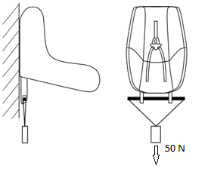

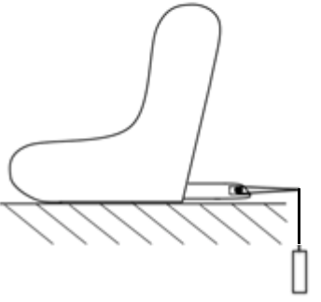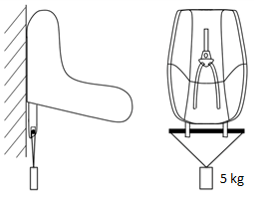

7.2.9. Lock-off devices

7.2.9.1. Class A devices

The Enhanced Child Restraint System and the largest manikin for which the Enhanced Child Restraint System is intended shall be set up as shown in Figure 4 below. The webbing used shall be as specified in Annex 23 to this Regulation. The lock-off shall be fully applied and a mark made on the belt where the belt enters the lock-off. The force gauges shall be attached to the belt via a D ring, and a force equal to twice (±5 per cent) the mass of the heaviest dummy for the size range shall be applied for at least one second. The lower position shall be used for lock-offs in position A and the upper position for lock-offs in position B. The force shall be applied for a further nine times. A further mark shall be made on the belt where it enters the lock-off and the distance between the two marks shall be measured. During this test, the retractor shall be unlocked.

Figure 4

Retractor

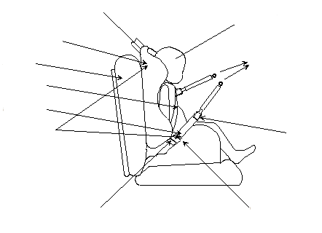

UN Regulation No. 129

Test seat

15 kg manikin

Buckle/tongue

Examine for slippage

"D" ring

"Lock off" clip

Abdominal

Diagonal

Child seat

7.2.9.2. Class B devices.

The child restraint shall be firmly secured, and the webbing as specified in Annex 23 to this Regulation, shall pass through the lock-off and frame following the routing described in the manufacturer's instructions. The belt shall pass through the testing equipment as described in Figure 5 below and be attached to a mass of 5.25 ± 0.05 kg. There shall be 650 ± 40 mm of free webbing between the mass and the point where the webbing leaves the frame. The lock-off shall be fully applied and a mark made on the belt where it enters the lock-off. The mass shall be raised and released so that it falls freely over a distance of 25 ± 1 mm. This shall be repeated 100 times ±2 at a frequency of 60 ± 2 cycles per minute, to simulate the jerking action of a child restraint in a vehicle. A further mark shall be made on the belt where it enters the lock-off and the distance between the two marks shall be measured.

The lock-off device shall cover the full width of the webbing in the installed condition with Q3 dummy installed. This test is to be conducted using the same webbing angles as those formed in normal use. The free end of the lap belt portion shall be fixed. The test shall be conducted with the child restraint system firmly attached to the test bench used in the overturning or dynamic test. The loading strap can be attached to the simulated buckle.

7.3. Certification of test bench cushion

7.3.1. The test bench cushion shall be certified when new to establish initial values for impact peak deceleration, and then after every 50 dynamic tests or at least every month, whichever is the sooner.

7.3.2. The certification and measuring procedures shall correspond to those specified in the latest version of ISO 6487; the measuring equipment shall correspond to the specification of a data channel with a channel filter class (CFC) 60.

Using the test device defined in Annex 14 to this Regulation, conduct three tests on the bench base prepared as described in Annex 6, foam covered with textile, 150 ± 5 mm from the front edge of the cushion on the centre line and at 150 ± 5 mm in each direction from the centre line.

Place the bench cushion on a flat rigid surface. Place the device vertically above the test point, at a height of 500 ± 5 mm and allow it to fall freely to make impact on the seat surface. Record the deceleration curve.

7.3.3. The initial peak recorded values for impact deceleration shall be 24 ± 4 g and subsequent peak values recorded shall not deviate by more than 15 per cent from the initial values.

7.4. Registration of dynamic behaviour

7.4.1. In order to determine the behaviour of the dummy and its displacements, all dynamic tests shall be registered according to the following conditions:

7.4.1.1. Filming and recording conditions:

(a) The frequency shall be at least 1,000 frames per second;

(b) The test shall be recorded on video or digital data carrier over at least the first 300 ms.

7.4.1.2. Estimation of uncertainty:

Testing laboratories shall have and shall apply procedures for estimating uncertainty of measurement of the displacement of the dummy's head. The uncertainty shall be within ±25 mm.

Examples of international standards of such procedure are EA–4/02 of the European Accreditation Organization or ISO 5725:1994 or the General Uncertainty Measurement (GUM) method.

7.5. The measuring procedures shall correspond to those defined in the latest version of ISO 6487. The channel frequency class shall be:

# Table 10

|  |  |  |
| --- | --- | --- |
| *Type of measurement* | *CFC(FH)* | *Cut-off frequency (FN)* |
| Trolley acceleration | 60 | see ISO 6487Annex A |
| Belt loads | 60 | see ISO 6487Annex A |
| Chest acceleration | 180 | see ISO 6487Annex A |
| Head acceleration | 1,000 | 1,650 Hz |
| Upper neck force | 1,000 |  |
| Upper neck moment | 600 |  |
| Chest deflection | 600 |  |
| Abdominal pressure | 180 |  |

The sampling rate should be a minimum of 10 times the channel frequency class (i.e. in installations with channel frequency class of 1,000, this corresponds to a minimum sampling rate of 10,000 samples per second per channel).

8. Test reports of type approval and of production qualification

8.1. The test report shall record the results of all tests and measurements including the following test data:

(a) The type of device used for the test (acceleration or deceleration device),

(b) The total velocity change,

(c) The trolley speed immediately before impact only for deceleration sleds,

(d) The acceleration or deceleration curve during all the velocity change of the trolley and at least 300 ms,

(e) The time (in ms) when the head of the manikin reaches its maximum displacement during the performance of the dynamic test,

(f) The place occupied by the buckle during the tests, if it can be varied, and

(g) The name and address of the laboratory where tests have been performed,

(h) And any failure or breakage,

(i) The following dummy criteria: HPC, Head acceleration Cum 3ms, Upper neck tension force, Upper neck moment, Chest acceleration Cum 3ms, Chest deflection; Abdominal Pressure (in frontal and rear impact); and

(j) Adult safety-belt bench installation forces.

8.2. If provisions relating to anchorages contained in Annex 6, Appendix 3, to this Regulation have not been respected, the test report shall describe how the child restraint is installed and shall specify important angles and dimensions.

8.3. When the child restraint is tested in a vehicle or vehicle structure, the test report shall specify the manner of attaching the vehicle structure to the trolley, the position of the Enhanced Child Restraint System and vehicle seat and the inclination of the vehicle seat-back.

8.4. The test reports of type approval and of production qualification shall record the verification of markings and of instructions on installation and use.

9. Production qualification

9.1. In order to make sure that the manufacturer's production system is satisfactory, the Technical Service, which conducted the type approval tests, shall carry out tests to qualify production in accordance with paragraph 9.2. below.

9.2. Qualifying the production of Enhanced Child Restraint Systems

The production of each new approved type of Enhanced Child Restraint System shall be subjected to production qualification tests. Additional qualifications of production may be prescribed following paragraph 11.4.

For this purpose, a random sample of 5 Enhanced Child Restraint Systems will be taken from the first production batch. The first production batch is considered to be the production of the first block containing a minimum of 50 Enhanced Child Restraint Systems and a maximum of 5,000 Enhanced Child Restraint Systems.

9.2.1. Dynamic tests for frontal and rear impact

9.2.1.1. Five Enhanced Child Restraint Systems shall be subjected to the dynamic test described in paragraph 7.1.3. above. The Technical Service that conducted the type approval tests shall choose the conditions that produced the maximum horizontal head excursion during the type approval dynamic tests, excluding the conditions described in paragraphs 6.6.4.1.6.1.1., 6.6.4.1.6.1.2. and paragraph 6.6.4.1.8.2. above. All the five Enhanced Child Restraint Systems shall be tested under the same conditions.

9.2.1.2. For each test described in paragraph 9.2.1.1. above, the injury criteria described in paragraph 6.6.4.3.1. above; and

For forward facing the head excursion described in paragraph 6.6.4.4.1.1. above;

For rearward facing and carrycots the head excursion described in paragraph 6.6.4.4.1.2.1. above;

Shall be measured.

9.2.1.3. The maximum head excursion results shall comply with the following two conditions:

9.2.1.3.1. No value shall exceed 1.05 L, and

X + S shall not exceed L

Where:

L = the limit value prescribed

X = the mean of the values

S = the standard deviation of the values.

9.2.1.3.2. The injury criteria results shall comply with the requirements of paragraph 6.6.4.3.1. above and, in addition, the X + S condition in paragraph 9.2.1.3.1. above shall be applied to the 3 ms clipped injury criteria results (as defined in paragraph 6.6.4.3.1. above) and recorded for information only.

9.2.2. Dynamic tests for lateral impact

The monitoring of head acceleration on production samples will define acceptance criteria in lateral impact for production qualification as defined in paragraph 9. (to be review before finalising phase 3).

9.2.3. Control of markings

9.2.3.1. The Technical Service that conducted the approval tests shall verify that the markings conform to the requirements of paragraph 4. of this Regulation.

9.2.3.2. Control of instructions on installation and the instructions for use.

9.2.3.3. The Technical Service that conducted the approval tests shall verify that the instructions on installation and the instructions for use conform to paragraph 14. of this Regulation.

10. Conformity of production and routine tests

The conformity of production procedures shall comply with those set out in the Agreement, Schedule 1 (E/ECE/TRANS/505/Rev.3), with the following requirements:

10.1. Any Enhanced Child Restraint System approved to this Regulation shall be so manufactured as to conform to the type approved by meeting the requirements set forth in paragraphs 6. to 7. above.

10.2. The minimum requirements for conformity of production control procedures set forth in Annex 12to this Regulation shall be complied with.

10.3. The Type Approval Authority which has granted type approval may at any time verify the conformity control methods applied in each production facility. The normal frequency of these verifications shall be twice a year.

11. Modification and extension of approval of an Enhanced Child Restraint System

11.1. Every modification of an Enhanced Child Restraint System shall be notified to the Type Approval Authority which approved the Enhanced Child Restraint System. The Type Approval Authority may then either:

11.1.1. Consider that the modifications made are unlikely to have an appreciable adverse effect and that in any case the Enhanced Child Restraint System still complies with the requirements; or

11.1.2. Require a further test report from the Technical Service responsible for conducting the tests.

11.2. Confirmation or refusal of approval, specifying the alterations, shall be communicated by the procedure specified in paragraph 5.3. above to the Contracting Parties to the Agreement applying this Regulation.

11.3. The Type Approval Authority issuing the extension of approval shall assign a series number for such an extension and inform thereof the other Contracting Parties to the 1958 Agreement applying this Regulation by means of a communication form conforming to the model in Annex 1 to this Regulation.

11.4. If a further test report is required, compare the horizontal head excursion result with the worst case from all results previously recorded:

(a) If the excursion is greater, then new production qualification testing shall be carried out;

(b) If the excursion is less, production qualification tests do not need to be carried out.

12. Penalties for non-conformity of production

12.1. The approval granted in respect of an Enhanced Child Restraint System pursuant to this Regulation may be withdrawn if an Enhanced Child Restraint System bearing the particulars referred to in paragraph 5.4. of this Regulation fails to pass the random checks described in paragraph 9. above or does not conform to the type approved.

12.2. If a Contracting Party to the Agreement which applies this Regulation withdraws an approval it has previously granted, it shall forthwith so notify the other Contracting Parties applying this Regulation by means of a communication form conforming to the model in Annex 1 to this Regulation.

13. Production definitively discontinued

13.1. If the holder of the approval completely ceases to manufacture a specific type of Enhanced Child Restraint System under this Regulation, he shall inform thereof the Type Approval Authority which granted the approval. Upon receiving the relevant communication, that Type Approval Authority shall inform the other Contracting Parties to the Agreement which apply this Regulation by means of a communication form conforming to the model in Annex 1 to this Regulation.

14. Information for users

14.1. Each Enhanced Child Restraint System shall be accompanied by instructions in the language of the country where the device is sold with the following content:

14.2. Instructions on installation shall include the following points:

14.2.1. For i-Size category Enhanced Child Restraint Systems the following label shall be clearly visible on the exterior of the packing:

|  |
| --- |
| *Notice* |
| This is an i-Size Enhanced Child Restraint System. It is approved according to UN Regulation No. 129, for use in, i-Size compatible vehicle seating positions as indicated by vehicle manufacturers in the vehicle users' manual. |
| If in doubt, consult either the Enhanced Child Restraint System manufacturer or the retailer. |

14.2.2. For i-Size booster seat category Enhanced Child Restraint Systems the following label shall be clearly visible on the exterior of the packing:

|  |
| --- |
| *Notice* |
| This is a i-Size booster seat Enhanced Child Restraint System. It is approved according to UN Regulation No. 129, for use primarily in " i-Size seating positions" as indicated by vehicle manufacturers in the vehicle user’s manual. |
| If in doubt, consult either the Enhanced Child Restraint System manufacturer or the retailer. |

14.2.3. For Universal Belted seat category Enhanced Child Restraint Systems the following label shall be clearly visible on the exterior of the packing:

| *Notice:*  This is Universal Belted Enhanced Child Restraint System. It is approved according to UN Regulation No. 129, for use primarily in "Universal seating positions" as indicated by vehicle manufacturers in the vehicle user's manual.  If in doubt, consult either the Enhanced Child Restraint System manufacturer or the retailer*.* |
| --- |

14.2.4. For Specific vehicle category Enhanced Child Restraint Systems information on the applicable vehicle shall be clearly visible at the point of sale without removing the Enhanced Child Restraint System from its packing;

14.2.5 The child restraint manufacturer shall provide information on the exterior packaging as to the address to which the customer can write to obtain further information on fitting the child restraint in specific cars;

14.2.6. The method of installation illustrated by photographs and/or very clear drawings;

14.2.7. The user shall be advised that the rigid items and plastic parts of an Enhanced Child Restraint System shall be so located and installed that they are not liable, during everyday use of the vehicle, to become trapped by a movable seat or in a door of the vehicle;

14.2.8. The user should be advised to use carry-cots perpendicular to the longitudinal axis of the vehicle;

14.2.9. In the case of rearward facing Enhanced Child Restraint Systems the customer shall be advised not to use them in seating positions where there is an active frontal airbag installed. This information shall be clearly visible at the point of sale without removing the packaging;

14.2.10. For "Special Needs Restraints" Enhanced Child Restraint Systems the following information shall be clearly visible at the point of sale without removing the Enhanced Child Restraint System from its packing:

|  |
| --- |
| This "Special Needs Restraint" is designed to give extra support to children who have difficulty in sitting correctly in conventional seats. Always consult your doctor to make sure that this restraint system is suitable for your child. |

14.3. The instructions for use shall include the following points:

14.3.1. The "Size range" and for integral Enhanced Child Restraint System the maximum occupant mass for which the device is intended:

14.3.2. The method of use shall be shown by photographs and/or very clear drawings. In the case of seats that can be used both forward and rearward facing, clear warning shall be given to keep the Enhanced Child Restraint System rearward facing until the child's age is greater than a stated limit, or some other dimensional criterion is exceeded;

14.3.3. For forward facing Enhanced Child Restraint System, the following information shall be clearly visible on the exterior of the packing:

"IMPORTANT - DO NOT USE FORWARD FACING BEFORE THE CHILD'S AGE EXCEEDS 15 months (Refer to instructions)".

14.3.4. The operation of the buckle and adjusting devices shall be explained clearly;

14.3.5. It shall be recommended that any straps holding the restraint to the vehicle should be tight, that any support-leg should be in contact with the vehicle floor, that any straps or impact shields restraining the child should be adjusted to the child's body, and that straps should not be twisted;

14.3.6. The importance of ensuring that any lap strap is worn low down, and that any impact shield installed properly, so that the pelvis is firmly engaged, shall be stressed;

14.3.7. It shall be recommended that the device should be replaced when it has been subject to violent stresses in an accident;

14.3.8. Instructions for cleaning shall be given;

14.3.9. A general warning shall be given to the user concerning the danger of making any alterations or additions to the device without the approval of the Type Approval Authority, and a danger of not following closely the installation instructions provided by the child restraint manufacturer;

14.3.10. When the chair is not provided with a textile cover, it shall be recommended that the chair should be kept away from sunlight, otherwise it may be too hot for the child's skin;

14.3.11. It shall be recommended that children are not left in their Enhanced Child Restraint System unattended;

14.3.12. It shall be recommended that any luggage or other objects liable to cause injuries in the event of a collision shall be properly secured.

14.3.13. It shall be recommended that:

14.3.13.1. The Enhanced Child Restraint Systemshall not be used without the cover;

14.3.13.2. The Enhanced Child Restraint System cover should not be replaced with any other than the one recommended by the manufacturer, because the cover constitutes an integral part of the restraint performance.

14.3.14. There shall be provisions made so that the instructions can be retained on the child restraint for its life period or in the vehicle handbook in the case of built-in restraints.

14.3.15. For an "i-Size Enhanced Child Restraint System", the user shall also be referred to the vehicle manufacturer's handbook.

15. Names and addresses of Technical Services responsible for conducting approval tests and of Type Approval Authorities

The Contracting Parties to the 1958 Agreement applying this Regulation shall communicate to the United Nations Secretariat the names and addresses of the Technical Services responsible for conducting approval tests and of the Type Approval Authorities which grant approval and to which forms certifying approval or extension or refusal or withdrawal of approval, or production definitively discontinued, issued in other countries, are to be sent.

16. Transitional provisions

16.1. As from the official date of entry into force of the 01 series of amendments, no Contracting Party applying this Regulation shall refuse to grant ECE approval under this Regulation as amended by the 01 series of amendments.

16.2. As from 1 September 2018, Contracting Parties applying this Regulation shall grant approvals only if the Enhanced Child Restraint System type to be approved meets the requirements of this Regulation as amended by the 01 series of amendments.

16.3. Until 1 September 2018, Contracting Parties applying this Regulation can continue to grant type approvals to Enhanced Child Restraint Systems which comply with the requirements of this Regulation as in its original version.

16.4. Until 1 September 2020, Contracting Parties applying this Regulation shall not refuse to grant extensions of approval to the original version of this Regulation.

16.5. As from the official date of entry into force of the 02 series of amendments to this Regulation, no Contracting Party applying this Regulation shall refuse to grant or refuse to accept type approvals to this Regulation as amended by the 02 series of amendments.

16.6. Until 1 September 2020, type approvals to the preceding series of amendments to the Regulation which are not affected by the 02 series of amendments to the Regulation shall remain valid and Contracting Parties applying this Regulation shall continue to accept them.

16.7. Until 1 September 2022, Contracting Parties applying this Regulation shall not refuse to grant extensions of approval to the 01 series of amendments to this Regulation.

16.8. As from the official date of entry into force of the 03 series of amendments, no Contracting Party applying this Regulation shall refuse to grant or refuse to accept UN type-approvals under this Regulation as amended by the 03 series of amendments.

16.9. As from 1 September 2020, Contracting Parties applying this Regulation shall not be obliged to accept UN type-approvals to the preceding series of amendments, first issued after 1 September 2020.

16.10. As from 1 September 2022, Contracting Parties applying this Regulation shall not be obliged to accept type-approvals issued to the preceding series of amendments to this Regulation.

16.11. Notwithstanding paragraphs 16.9 and 16.10, Contracting Parties applying the UN Regulation shall continue to accept UN type-approvals issued according to the preceding series of amendments to the UN Regulation, for the vehicles/vehicle systems which are not affected by the changes introduced by the 03 series of amendments.

Annex 1

Communication

(Maximum format: A4 (210 x 297 mm)

[6]

issued by: Name of administration:

**1**



Concerning:[7] Approval granted

Approval extended

Approval refused

Approval withdrawn

Production definitively discontinued

of restraining devices for child occupants of power-driven vehicles, pursuant to UN Regulation No. 129.

Approval No. ...................……………… Extension No. ...........................................

1.1. Forward-facing child restraint/rearward-facing child restraint/lateral-facing   
 child restraint

1.2. Integral/Non integral;2

1.3. Belt type:2

(Adult) three-point belt

(Adult) lap belt

Special type belt/retractor2

1.4. Other features: chair assembly/impact shield2

2. Trade name or mark

3. Manufacturer's designation of the Enhanced Child Restraint System

4. Manufacturer's name

5. If applicable, name of his representative

6. Address

7. Submitted for approval on

8. Technical Service conducting approval tests

9. Type of device: deceleration/acceleration2

10. Date of test report issued by that Service

11. Number of test report issued by that Service

12. Approval granted/extended/refused/withdrawn2 for size range x to x for i-Size specific vehicle or for use as a "special needs restraint", position in vehicle

13. Position and nature of the marking

14. Place

15. Date

16. Signature

17. The following documents, bearing the approval number shown above, are attached to this communication:

(a) Drawings, diagrams and plans of the child restraint, including any retractor, chair assembly, impact shield fitted;

(b) Drawings, diagrams and plans of the vehicle structure and the seat structure, as well as of the adjustment system and the attachments, including any energy absorber fitted;

(c) Photographs of the child restraint and/or vehicle structure and seat structure;

(d) Instructions for fitting and use;

(e) List of vehicle models for which the restraint is intended.

Annex 2

1. Arrangements of the approval mark

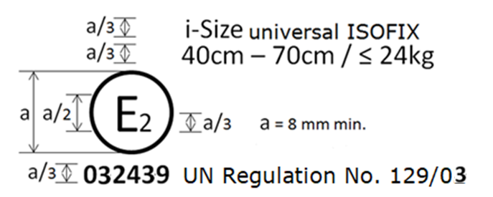

The Enhanced Child Restraint System bearing the above approval mark is a device capable of being fitted in any i-size seating position of the vehicle and of being used for the 40 cm - 70 cm size range and mass limit of 24 kg; it is approved in France (E 2) under the number 032439. The approval number indicates that the approval was granted in accordance with the requirements of the Regulation concerning the approval of Enhanced Child Restraint Systems used on-board of motor vehicles as amended by the 03series of amendments. In addition the name of the regulation has to be identified on the approval mark followed by the series of amendment according to which the approval has been granted.

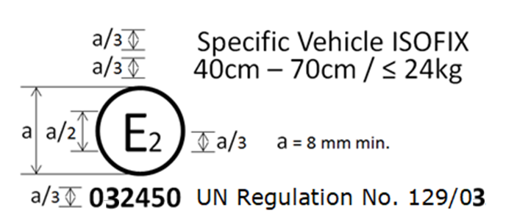

The Enhanced Child Restraint System bearing the above approval mark is a device not capable of being fitted in every vehicle and capable of being used for the 40 cm - 70 cm size range and mass limit of 24 kg; it is approved in France (E 2) under the number 032450. The approval number indicates that the approval was granted in accordance with the requirements of the Regulation concerning the approval of Specific vehicle ISOFIX Enhanced Child Restraint Systems used on-board of motor vehicles as amended by the 02series of amendments. In addition the name of the regulation has to be identified on the approval mark followed by the series of amendment according to which the approval has been granted.

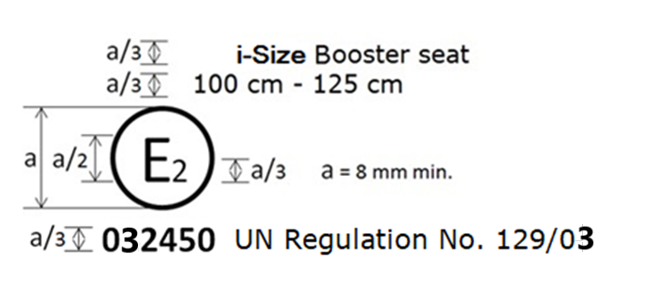

The Enhanced Child Restraint System bearing the above approval mark can be fitted in any i-Size booster seating position and used for the 100 cm - 125 cm size range; it is approved in France (E 2) under the number 032450. The approval number indicates that the approval was granted in accordance with the requirements of the Regulation concerning the approval of Enhanced Child Restraint Systems used on-board of motor vehicles as amended by the 03 series of amendments. In addition, the name of the regulation is to be identified on the approval mark followed by the series of amendment according to which the approval has been granted.

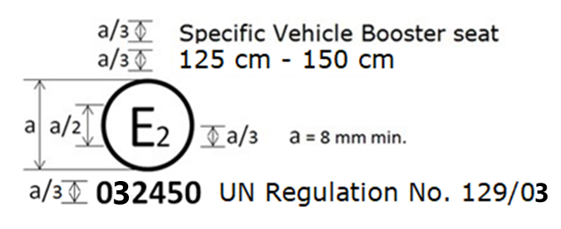

The Enhanced Child Restraint System bearing the above approval mark is a device not capable of being fitted in every vehicle but capable of except being used for the 125 cm - 145 cm size range; it is approved in France (E 2) under the number 022450. The approval number indicates that the approval was granted in accordance with the requirements of the Regulation concerning the approval of specific vehicle booster seat Enhanced Child Restraint Systems used on-board of motor vehicles as amended by the 03 series of amendments. In addition the name of the Regulation needs to be identified on the approval mark followed by the series of amendment according to which the approval has been granted.

In case the ECRS is equipped with a module, the size range is not on the approval mark but on the module mark.

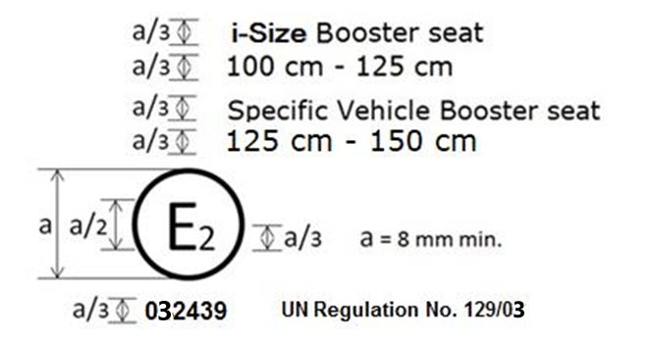

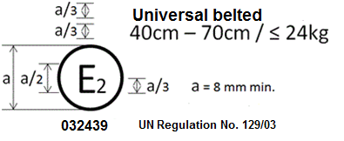

The Enhanced Child Restraint System bearing the above approval mark is a device capable of being fitted in any universal seating position of the vehicle and of being used for the 40 cm - 70 cm size range; it is approved in France (E 2) under the number 032439. The approval number indicates that the approval was granted in accordance with the requirements of the UN Regulation on approval of Universal Belted Enhanced Child Restraint Systems used on-board of motor vehicles as amended by the 03 series of amendments. In addition the name of the UN Regulation must be identified on the approval mark followed by the series of amendment according to which the approval has been granted.

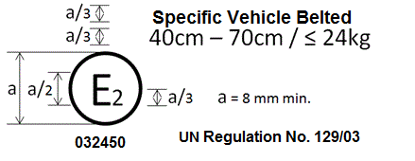

The Enhanced Child Restraint System bearing the above approval mark is a device not capable of being fitted in every vehicle and capable of being used for the 40 cm - 70 cm size range; it is approved in France (E 2) under the number 032450. The approval number indicates that the approval was granted in accordance with the requirements of the UN Regulation on the approval of Specific vehicle Belted Enhanced Child Restraint Systems used on-board of motor vehicles as amended by the 03 series of amendments. In addition the name of the UN Regulation must be identified on the approval mark followed by the series of amendment according to which the approval has been granted.

In case the Enhanced Child Restraint System is equipped with a module, the size range and the mass limit are not on the approval mark but on the module mark.

2. Arrangements of the approval mark in combination with a module mark

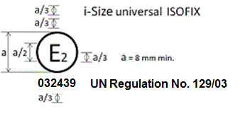

The Enhanced Child Restraint System bearing the above approval mark is a device, including module(s), capable of being fitted in any i-size compatible vehicle seating position. It is approved in France (E 2) under the number 032439. The approval number indicates that the approval was granted in accordance with the requirements of the UN Regulation concerning the approval of Enhanced Child Restraint Systems used on-board of motor vehicles as amended by the 03 series of amendments. In addition the name of the UN Regulation has to be identified on the approval mark followed by the series of amendment according to which the approval has been granted.

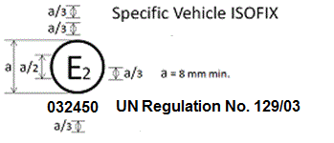

The Enhanced Child Restraint System bearing the above approval mark is a device, including module(s), not capable of being fitted in every vehicle. It is approved in France (E 2) under the number 032450. The approval number indicates that the approval was granted in accordance with the requirements of the UN Regulation concerning the approval of Specific vehicle ISOFIX Enhanced Child Restraint Systems used on-board of motor vehicles as amended by the 03 series of amendments. In addition the name of the UN Regulation has to be identified on the approval mark followed by the series of amendment according to which the approval has been granted.

## 2.1. Arrangements of the module mark in combination with an approval mark

2.1.1. Where a module is approved for use with more than one base, the individual base and module combinations shall be indicated on the module in separate module marks, each bearing their applicable size ranges.

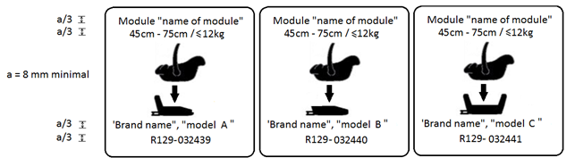

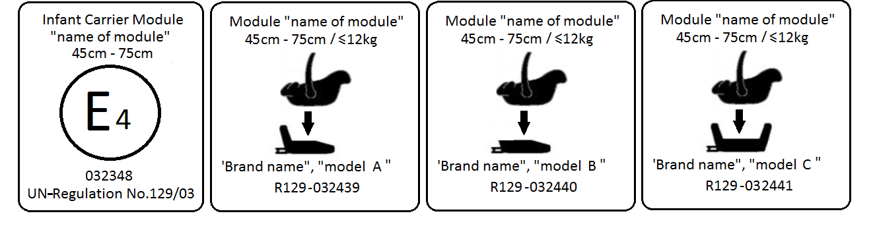

A Module that bears an approval mark for the stand-alone mode of use and a module mark for its use on three different bases, shall carry the following arrangement of approval and module marks:

The module bearing the above marks is capable of being used as a Universal Belted Enhanced Child Restraint System for the 45 cm - 75 cm size range; it is approved according to UN Regulation No. 129-03 under the number 032348.

The module can also be used as a module in combination with the base "brand name and model A", for the 45 cm - 75 cm size range and mass limit of 12 kg; approved according to UN Regulation No. 129-03 under the number 032439.

The module can also be used as a module in combination with the base "brand name and model B", for the 45 cm - 75 cm size range and mass limit of 12 kg; approved according to UN Regulation No. 129-03 under the number 032440.

The module can also be used as a module in combination with the base "brand name and model C", for the 45 cm - 75 cm size range and mass limit of 12 kg; approved according to UN Regulation No. 129-03 under the number 032441.

The approval numbers indicate that the approval was granted in accordance with the requirements of the UN Regulation on the approval of Enhanced Child Restraint Systems used on-board of motor vehicles as amended by the 03 series of amendments.

2.1.2. Where a module is capable of being installed in different orientations, separate module marks shall be indicated on the module, each bearing their applicable size ranges.

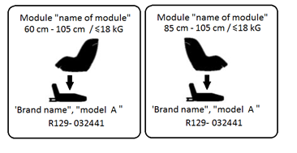

The module bearing the above marks is capable of being used in a rearward facing mode with the base "brand name and model A", for the 60 cm - 105 cm size range and with a mass limit of 18 kg; approved according to UN Regulation No. 129-03 under the number 032441.

The module bearing the above marks is also capable of being used in a forward facing mode with the base "brand name and model A", for the 85 cm - 105 cm size range and with a mass limit of 18 kg; approved according to UN Regulation No. 129-03 under the same number 032441.

The approval number indicates that the approval was granted in accordance with the requirements of the UN Regulation concerning the approval of Enhanced Child Restraint Systems used on-board motor vehicles as amended by the 03 series of amendments.

2.2. Examples of the symbols to be used on the module mark are given in the figures below. As chosen by the Enhanced Child Restraint Systems manufacturer, one of the symbols or an equivalent shall be used on the module mark.

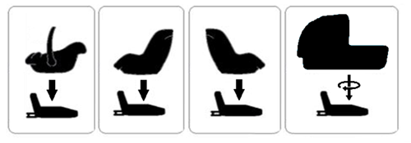

Annex 3

Arrangement of apparatus for dust resistance test

All dimensions in mm



Annex 4

Corrosion test

1. Test apparatus

1.1. The apparatus shall consist of a mist chamber, a salt solution reservoir, a supply of suitably conditioned compressed air, one or more atomizing nozzles, sample supports, provision for heating the chamber, and necessary means of control. The size and detailed construction of the apparatus shall be optional, provided that the test conditions are met.

1.2. It is important to ensure that drops of solution accumulated on the ceiling or cover of the chamber do not fall on test samples.

1.3. Drops of solution which fall from test samples shall not be returned to the reservoir for respraying.

1.4. The apparatus shall not be constructed of materials that will affect the corrosiveness of the mist.

2. Location of test samples in the mist cabinet

2.1. Samples, except retractors, shall be supported or suspended between 15° and 30° from the vertical and preferably parallel to the principal direction of horizontal flow of mist through the chamber, based upon the dominant surface being tested.

2.2. Retractors shall be supported or suspended so that the axes of the reel for storing the strap shall be perpendicular to the principal direction of horizontal flow of mist through the chamber. The strap opening in the retractor shall also be facing in this principal direction.

2.3. Each sample shall be so placed as to permit free settling of mist on all samples.

2.4. Each sample shall be so placed as to prevent salt solution from one sample dripping on to any other sample.

3. Salt solution

3.1. The salt solution shall be prepared by dissolving 5 ± 1 parts by mass of sodium chloride in 95 parts of distilled water. The salt shall be sodium chloride substantially free of nickel and copper and containing not more than 0.1 per cent of sodium iodide and not more than 0.3 per cent of total impurities in the dry state.

3.2. The solution shall be such that, when atomized at 35 °C, the collected solution is in the pH range of 6.5 to 7.2.

4. Compressed air

4.1. The compressed air supply to the nozzle or nozzles for atomizing the salt solution shall be free of oil and dirt, and maintained at a pressure between 70 kN/m2 and 170 kN/m2.

5. Conditions in the mist chamber

5.1. The exposure zone of the mist chamber shall be maintained at 35 °C ± 5 °C. At least two clean mist collectors shall be placed within the exposure zone, so that no drops of solution from the test samples or any other sources are collected. The collectors shall be placed near the test samples, one as near as possible to any nozzle and one as far as possible from all nozzles. The mist shall be such that, for each 80 cm2 of horizontal collecting area, from 1.0 to 2.0 ml of solution per hour, when measured over an average of at least 16 hours, is collected in each collector.

5.2. The nozzle or nozzles shall be directed or baffled, so that the spray does not impinge directly on the test samples.

Annex 5

Abrasion and microslip test

Figure 1

**Procedure type 1**

F = 10 ± 0.1 N**,** can be increased up to maximum F = 60 ± 0.5 N (see table 8, paragraph 7.2.5.2.6.2.)

Total travel:

300 ± 20 mm

Support

Protective strap for inner bar

Example a

Example b

Examples of test arrangements corresponding

to the type of adjusting device

F = 10 ± 0.1 N**,** can be increased up to maximum F = 60 ± 0.5 N (see table 8, paragraph 7.2.5.2.6.2.)

Total travel:

300 ± 20 mm

Lower stop

Rotating pin

Figure 2

**Procedure type 2**

**Following two examples of test set up**

**Example 1**

Straps in horizontal plane

**α**

**±**

**5°**

Total travel:

300 ± 20 mm

Test in the buckle

Minimum F = 10 ± 0.1 N

(see table 8, paragraph 7.2.5.2.6.2)

**Example 2**

**α**

**±**

**5º**

**β**

**±**

**5º**

Total travel:

300 ± 20 mm

Test in a guide or pulley

Minimum F = 10 ± 0.1 N F (see table 8, paragraph 7.2.5.2.6.2)

Where α and β reproduce the angles as in the real installation (in three dimensions)

# Figure 3

**Microslip Test**

Total travel: 300 ± 20 mm



Taut position Slack position

The load of 50 N on the testing device shall be vertically guided in such a way as to prevent load-swing and twisting of the strap.

The attaching device shall be fixed to the load of 50 N in the same manner as in the vehicle.

Annex 6

Description of trolley

1. Trolley

1.1. For tests on child restraints, the trolley, carrying the seat only, shall have a mass greater than 380 kg. For tests on Enhanced Child Restraint Systems in the "Specific vehicle' ISOFIX" category, the trolley with the attached vehicle structure shall have a mass greater than 800 kg.

2. Calibration screen

2.1. A calibration screen shall be attached firmly to the trolley with a movement limit line plainly marked on it to enable compliance with forward movement criteria to be determined from photographic records.

3. Test bench

3.1. The test bench shall be constructed as follows:

3.1.1. A rigid back, fixed, dimensions of which are given in Appendix 1 to this annex;

3.1.2. Rigid seating, made from a rigid metal sheet, dimensions of which are given in Appendix 1 to this annex;

3.1.3. For access to the ISOFIX anchorage system, openings shall be made at the rear of the test bench seat cushion, as prescribed in Appendix 1 to this annex;

3.1.4. The width of the test bench shall be 800 mm;

3.1.5. The back and the seating shall be covered with polyurethane foam, the characteristics of which are given in Table 1. The dimensions of the cushion are given in Appendix 1 to this annex;

# Table 1

|  | *Standard* | *Value* | *Unit* |
| --- | --- | --- | --- |
| Density | EN ISO 845 | 68-74 | kg/m3 |
| Compression resistance | EN ISO 3386/1 (40 % compression) | 13 | kPa |
| Indentation Load Deflection (ILD) | EN ISO 2439B (40 % compression) | 480 (+/15 %) | N |
| Tensile strength | EN ISO 1798 | ≥ 150 | kPa |
| Ultimate elongation | EN ISO 1798 | ≥ 120 | % |
| Compression set | EN ISO 1856 (22hr/50 %/70 °C) | ≤ 3 | % |

3.1.6. The polyurethane foam shall be covered with a sun shade cloth, made of poly-acrylate fibre, the characteristics of which are given in Table 2.

# Table 2

|  |
| --- |
|  |
| Specific mass (g/m2) 290 |
| Breaking strength according to DIN 53587 on test specimen 50 mm wide: |
| Lengthwise (kg): 120 |
| Breadth wise (kg): 80 |
|  |

3.1.7. Covering the test bench seat cushion and the test bench seat back cushion

3.1.7.1. The test bench seat cushion is produced out of a square foam block (800 x 575 x 135 mm) in such a way (see Figure 1 of Appendix 1 to this annex) that its shape resembles the shape of the aluminium bottom-plate specified in Figure 2 of Appendix 1 to this annex.

3.1.7.2. Six holes are drilled in the bottom-plate in order to fasten it to the trolley with bolts. The holes are drilled alongside the longest side of the plate, three on each side, their position being dependent on the construction of the trolley. Six bolts are put through the holes. It is recommended to glue the bolts on the plate with an appropriate adhesive. Afterwards, the bolts are fastened with nuts.

3.1.7.3. The cover material (1,250 x 1,200 mm, see Figure 3 of Appendix 1 to this annex) is cut across the width in such a way that it is not possible for the material to overlap after covering. There should be a gap of about 100 mm between the edges of the cover material. Therefore the material has to be cut at about 1,200 mm.

3.1.7.4. The cover material is marked with two lines which run across the width. They are drawn 375 mm from the centreline of the cover material (see Figure 3 of Appendix 1 to this annex).

3.1.7.5. The test bench seat cushion is placed upside down on the cover material with the aluminium bottom-plate on top.

3.1.7.6. On both sides the cover material is stretched until the lines drawn on it match the edges of the aluminium bottom-plate. At each bolt position, small incisions are made and the cover material is pulled over the bolts.

3.1.7.7. At the position of the grooves in the bottom-plate and in the foam, the cover material should be incised.

3.1.7.8. The cover is glued to the aluminium plate with flexible glue. The nuts have to be removed before gluing.

3.1.7.9. The flaps on the side are folded onto the plate and are glued as well.

3.1.7.10. The flaps in the grooves are folded inside and taped with a strong tape.

3.1.7.11. The flexible glue has to dry for at least 12 hours.

3.1.7.12. The test bench seat-back cushion is covered in exactly the same way as the test bench seat cushion, only the lines on the cover material (1,250 x 850 mm) are drawn 333 mm apart from the centreline of the material.

3.1.8. Line Cr is coincident with the intersection line between the top plane of the test bench seat cushion and the front plane of the test bench seat-back cushion.

3.2. Test of rearward-facing devices

3.2.1. A special frame shall be fitted on the trolley in order to support the Enhanced Child Restraint Systemas shown in Figure 1.

3.2.2. A steel tube shall be attached firmly to the trolley in such a way that a load of 5,000 ± 50 N applied horizontally to the centre of the tube does not cause a movement greater than 2 mm.

3.2.3. The dimensions of the tube shall be: 500 x 100 x 90 mm.

# Figure 1

**Arrangements for testing a rearward –facing device**

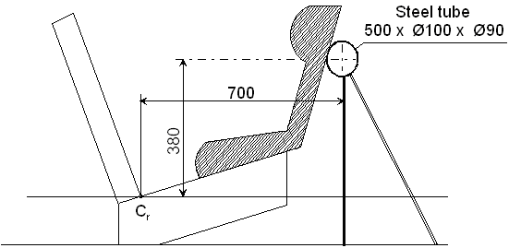

Dimension in mm

3.3. Trolley floor pan

3.3.1. The floor pan of the trolley shall be constructed of a flat sheet of metal of uniform thickness and material, see Figure 2 of Appendix 3 to this annex.

3.3.1.1. The floor pan shall be rigidly mounted on the trolley. The height of the floor pan relative to the Cr axis projection point, dimension[8] in Appendix 2 to this annex, Figure 2, shall be adjusted to meet the requirements of paragraph 7.1.3.6.3. of this Regulation.

3.3.1.2. The floor pan shall be designed so that the surface hardness should not be below 120 HB, according to EN ISO 6506-1:1999.

3.3.1.3. The floor pan shall withstand an applied vertical concentrated load of 5 kN without causing a vertical movement greater than 2 mm referring to Cr axis and without any permanent deformation occurring.

3.3.1.4. The floor pan shall have a surface roughness not exceeding Ra 6.3 according to ISO 4287:1997.

3.3.1.5. The floor pan shall be designed so that no permanent deformation is occurring after a dynamic test of an Enhanced Child Restraint System, according to this Regulation.

4. Stopping device

4.1. The device consists of two identical absorbers mounted in parallel.

4.2. If necessary, an additional absorber shall be used for each 200 kg increase in nominal mass. Each absorber shall comprise:

4.2.1. An outer casing formed from a steel tube;

4.2.2. A polyurethane energy-absorber tube;

4.2.3. A polished-steel olive-shaped knob penetrating into the absorber; and

4.2.4. A shaft and an impact plate.

4.3. The dimensions of the various parts of this absorber are shown in the diagram reproduced in Appendix 2 to this annex.

4.4. The characteristics of the absorbing material are given in Table 3 and Table 4 of this annex.

4.5. The stopping device assembly shall be maintained for at least 12 hours at a temperature between 15 °C and 25 °C before being used for the calibration tests described in Annex 7 to this Regulation. The stopping device shall, for each type of test, meet the performance requirements laid down in Annex 7, Appendices 1 and 2. For dynamic tests of an Enhanced Child Restraint System, the stopping device assembly shall be maintained for at least 12 hours at the same temperature, to within ±2 °C, as that of the calibration test. Any other device giving equivalent results can be accepted.

# Table 3

**Characteristics of the absorbing material "A"[9]**

| *(ASTM Method 2000 (1980) unless otherwise stated)* | |
| --- | --- |
| Shore hardness A: | 88 ± 2 at 20 °C ± 5 °C temperature |
| Breaking strength: | Ro ≥ 300 kg/cm2 |
| Minimum elongation: | Ao ≥ 400 % |
| Module at 100 % elongation: | ≥ 70 kg/cm2 |
| Module at 300 % elongation: | ≥ 130 kg/cm2 |
| Low temperature brittleness (ASTM Method D 736): | 5 hours at -55 °C |
| Compression set (Method B): | 22 hours at 70 °C ≤ 45 % |
| Density at 25 °C: | 1.08 to 1.12 |
| Ageing in air (ASTM Method D 573 (1981)): |  |
| 70 hours at 100 °C: | Shore hardness: max. variation ±3  Breaking strength: decrease < 10 % of Ro  Elongation: decrease < 10 % of Ao  Weight: decrease < 1 % |
| Immersion in oil (ASTM Method D 471 (1979) Oil No. 1): |  |
| 70 hours at 100 °C: | Shore hardness: max. variation ±4  Breaking strength: decrease < 15 % of Ro  Elongation: decrease < 10 % of Ao  Volume: swelling < 5 % |
| Immersion in oil (ASTM Method D 471 (1979) Oil No. 3): |  |
| 70 hours at 100 °C: | Breaking strength: decrease < 15 % of Ro  Elongation: decrease < 15 % of Ao  Volume: swelling < 20 % |
| Immersion in distilled water: |  |
| 1 week at 70 °C: | Breaking strength: decrease < 35 % of Ro |
|  | Elongation: increase < 20 % of Ao |

# Table 4

**Characteristics of the Absorbing Material "B"**

| *ASTM Method 2000 (1980) unless otherwise stated* | |
| --- | --- |
| Shore hardness A: | 88 ± 2 at 20 °C ± 5 °C temperature |
| Breaking strength: | Ro ≥ 300 kg/cm2 |
| Minimum elongation: | Ao ≥ 400 % |
| Module at 100 % elongation: | ≥ 70 kg/cm2 |
| Module at 300 % elongation: | ≥ 130 kg/cm2 |
| Low temperature brittleness (ASTM Method D 736): | 5 hours at -55 °C |
| Compression set (Method B): | 22 hours at 70 °C ≤ 45 % |
| Density at 25 °C: | 1.08 to 1.12 |
| Ageing in air (ASTM Method D 573 (1981)): |  |
| 70 hours at 100 °C: | Shore hardness: max. variation ±4  Breaking strength: decrease < 15 % of Ro  Elongation: decrease < 10 % of Ao  Volume: swelling < 5 % |
| Immersion in oil (ASTM Method D 471 (1979) Oil No. 3): |  |
| 70 hours at 100 °C: | Breaking strength: decrease < 15 % of Ro  Elongation: decrease < 15 % of Ao  Volume: swelling < 20 % |
| Immersion in distilled water: |  |
| 1 week at 70 °C | Breaking strength: decrease < 35 % of Ro |
|  | Elongation: increase < 20 % of Ao |

Annex 6 - Appendix 1

# Figure 1

**Dimensions in mm of the seat and the seat cushions**

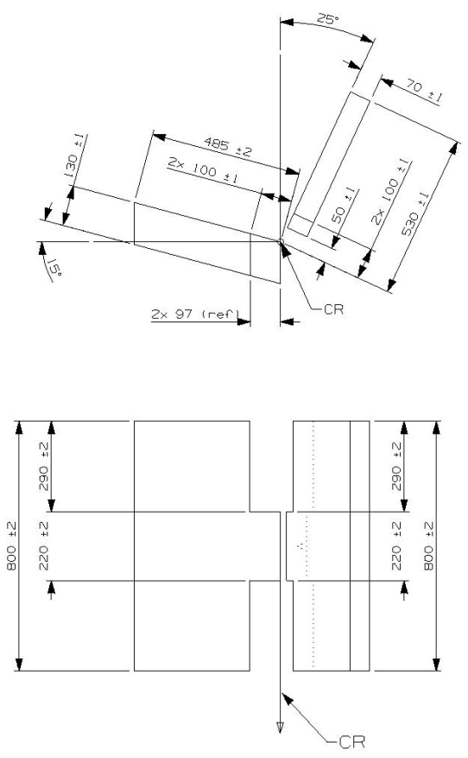Figure 2

**Dimensions of the aluminium bottom-plate and dimensions of the aluminium backrest plate** (dimensions in mm)

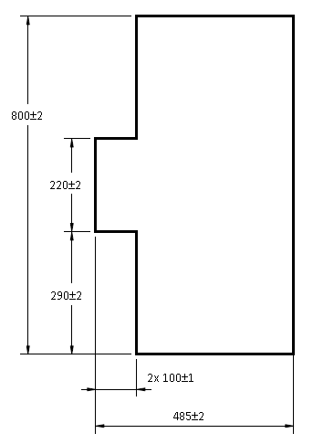



# Figure 3

**Dimensions of the cover material** (dimensions in mm)

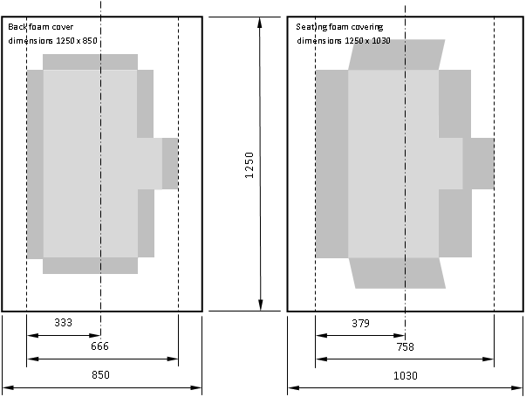

Annex 6 - Appendix 2

Arrangement and use of anchorages on the test trolley

1. The anchorages shall be positioned as shown in the Figure below.

2. Enhanced Child Restraint Systems in the i-Size universal, specific and restricted categories shall use the following anchorage points: H1 and H2.

3. For testing of Enhanced Child Restraint Systems with top tether, the anchorage G1 or G2 shall be used.

4. In the case of Enhanced Child Restraint Systems utilising a support-leg, the Technical Service shall select the anchorages to be used according to paragraph 3. above and with the support-leg adjusted as specified in paragraph 7.1.3.6.3. of this Regulation.

5. The structure carrying the anchorages shall be rigid. The upper anchorages shall not be displaced by more than 0.2 mm in the longitudinal direction when a load of 980 N is applied to them in that direction. The trolley shall be so constructed that no permanent deformation shall occur in the parts bearing the anchorages during the test.

# Figure 1

**Top View – Bench with ISOFIX anchorages (Dimensions in mm; Tolerance general: ±2 mm)**



# Figure 2

**Side View – Bench with anchorages (Dimensions in mm; Tolerance general: ±2 mm)**

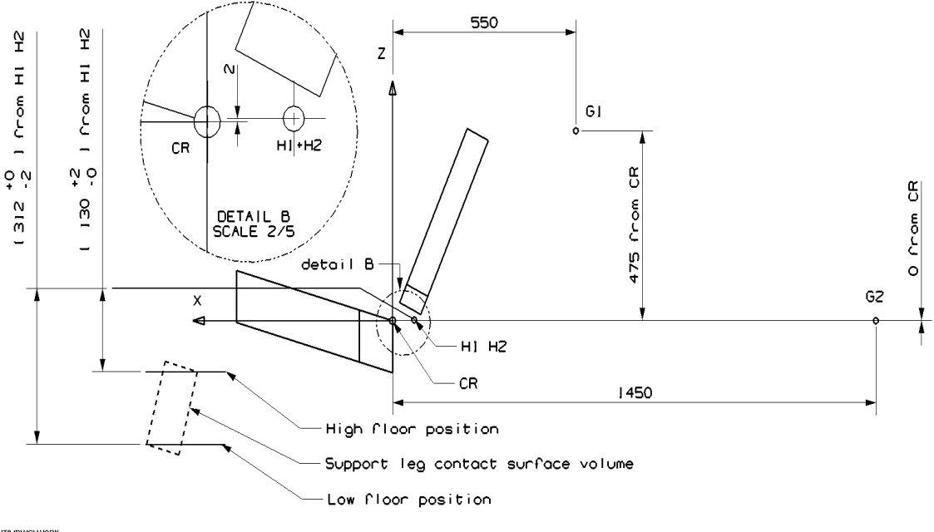

Definition of belt anchorages

# Table 1

**Belt anchorages points**

|  |  |  |  |  |  |  |  |  |  |
| --- | --- | --- | --- | --- | --- | --- | --- | --- | --- |
|  | *Upper Anchorage (P)* | | | *Buckle (A2)* | | | *Lower outer (A1)* | | |
| Direction | X | Y | Z | X | Y | Z | X | Y | Z |
| Distance  (mm) | -240 | -220 | -630 | -29 | 200 | 59 | 10 | -200 | 14.5 |

# Figure 3

**Top View – Bench with belt anchorages (Dimensions in mm; Tolerance general: ±2 mm)**

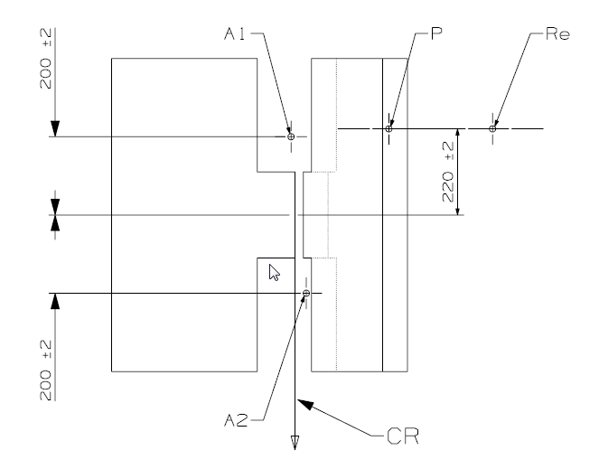

"Re" is located on the centre line of the retractor spool

# Figure 4

**Side View – Bench with belt anchorages (Dimensions in mm; Tolerance general: ±2 mm)**

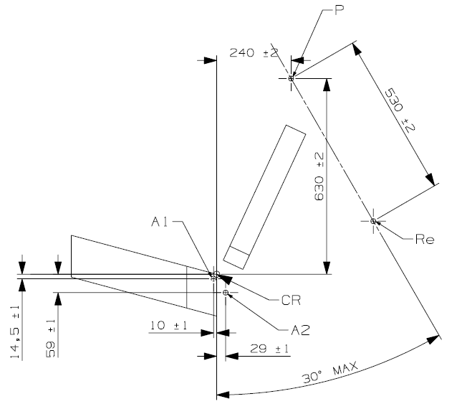

"Re" is located on the centre line of the retractor spool

Figure 5  
**Lower strap anchorages (LSA 1, LSA 2, LSA 3 and LSA 4)**

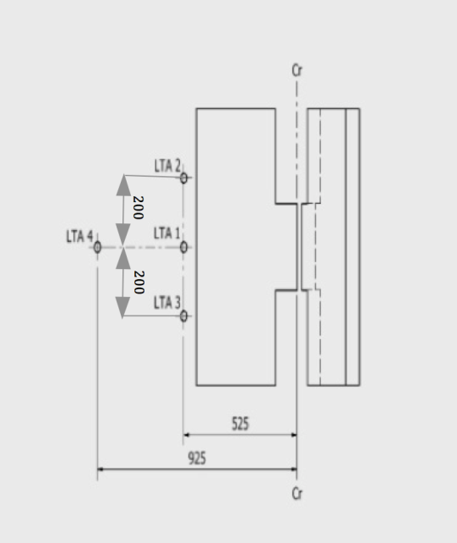

Dimensions in mm

Annex 6 - Appendix 3

Definition of side impact door

1. Door panel definition

The dimension and initial position of the impact door relative to the bench are described in the following figures.

The stiffness and strength of the door panel shall be sufficient to avoid excessive oscillation or significant deformation during lateral dynamic test.

# Figure 1

**Door panel geometry and position at T0 – Top view**

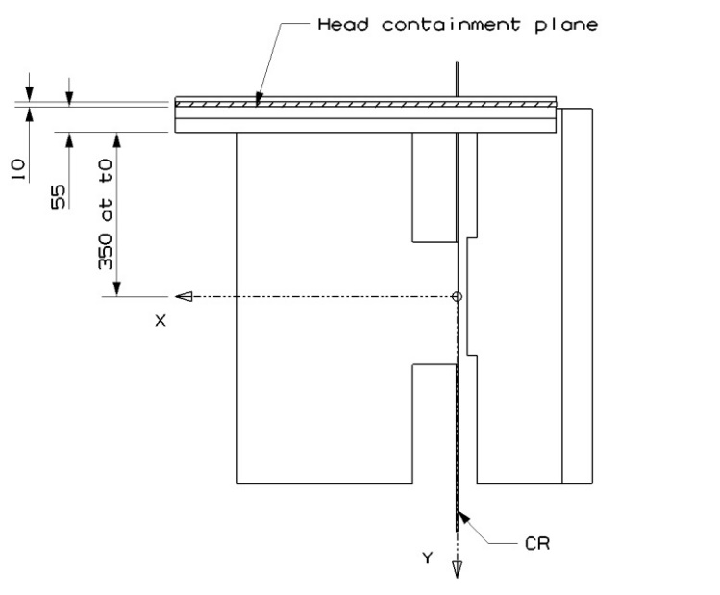Dimensions in mm

# Figure 2

**Door panel geometry – Side view (Tolerance general: ±2 mm and ±1 degree)**

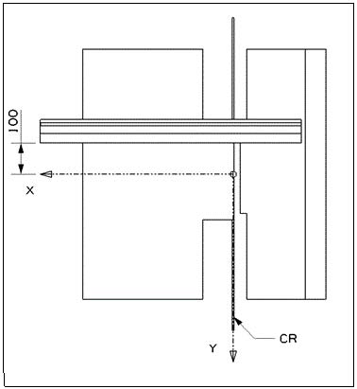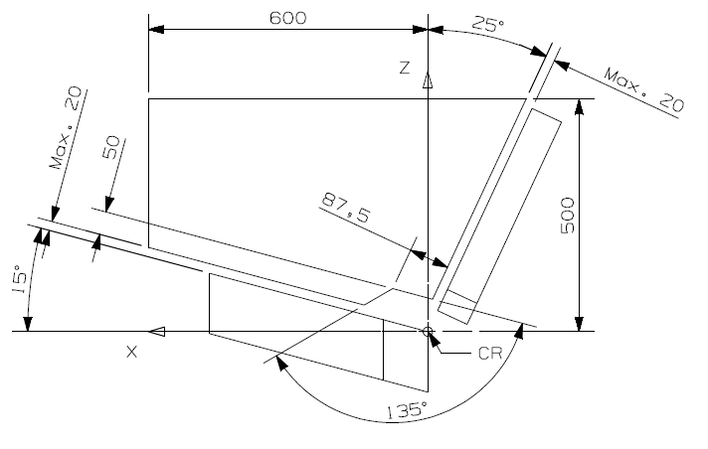

Dimensions in mm

# Figure 3

**Door panel approximate maximum intrusion – Side view (For information)**

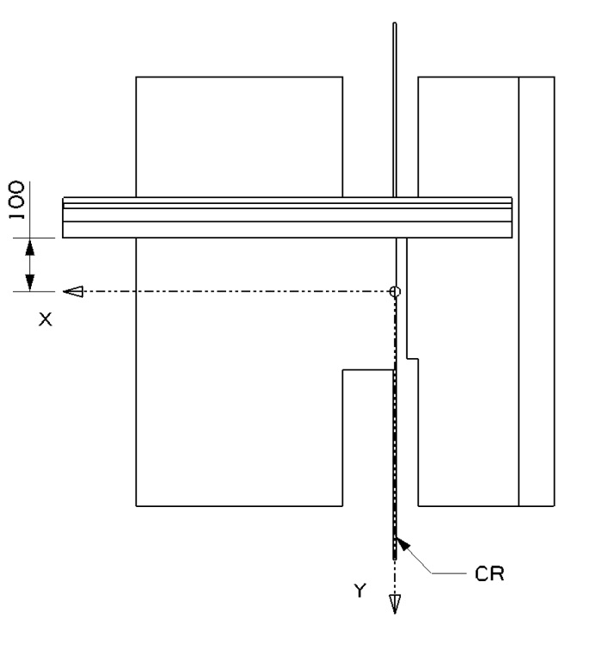

Dimensions in mm

2. Panel padding specification

2.1. General

The impact surface of the door panel shall be entirely covered with a padding material of 55 mm in thickness (see Figure 1 above). The material shall comply with the performance criteria specified in paragraph 2.3. (Figure 4 below) of this appendix when tested in accordance with paragraph 2.2. of this appendix.

A material combination meeting these requirements is described in paragraph 2.4. of this appendix.

2.2. Test procedure for the assessment of panel padding material

The test set up consists of a simple drop test using a spherical head form. The spherical head form has a diameter of 150 mm and a mass of 6 kg (±0.1 kg). The impact speed is 4 m/s (±0.1 m/s). The instrumentation should allow the assessment of the time of first contact between the impactor and the sample as well as the head form acceleration at least in direction of impact (Z-direction).

The material sample should have the dimensions of 400 x 400 mm. The sample should be impacted in its centre.

2.3. Performance criteria for the padding material

The time of first contact between sample material and head form (t0) is 0 ms.

The impactor acceleration shall not exceed 58 g.

# Figure 4

**Corridor for the padding material**



*Key:*

1 - Upper limit of 58 g

2 - Lower limit for the maximum peak at 53 g (11 to 12 ms)

3 - Upper limit for the decline of acceleration (15 g at 20,5 ms to 10 g at 21,5 ms)

4 - Lower limit for the decline of acceleration (10 g at 20 ms to 7 g at 21 ms)

2.4. Example of material meeting the test requirements:

Rubber cell foam Polychloropren CR4271 measuring 35 mm in thickness attached to the door panel structure to which shall then be attached a subsequent layer of Styrodur C2500 20 mm in thickness. The Styrodur needs to be replaced after each test.

Annex 6 - Appendix 4

Stopping device frontal impact

# Figure 1

dimensions (in mm)



# Figure 1a

**Material A**



# Figure 1b

**Material B**



# Figure 2

**Stopping device olive-shaped knob**



# Figure 3

**Stopping device olive-shaped knob**

1. 

# Figure 4

**Stopping Device (assembled)**



# Figure 5

**Stopping Device – polyurethane tube**



Annex 7

Curve of trolley's deceleration or acceleration, as function of time

In all cases the calibration and measuring procedures shall correspond to those defined in the International Standard ISO 6487; the measuring equipment shall correspond to the specification of a data channel with a channel frequency class (CFC) 60.

Annex 7 - Appendix 1

Frontal impact

Curve of trolley's deceleration or acceleration, as function of time

Frontal impact – Test pulse 1

|  |  |  |
| --- | --- | --- |
| *Definition of the different curves* | | |
| *Time (ms)* | *Acceleration (g) Low corridor* | *Acceleration (g) High corridor* |
| 0 | - | 10 |
| 20 | 0 | - |
| 50 | 20 | 28 |
| 65 | 20 | - |
| +80 | - | 28 |
| 100 | 0 | - |
| 120 | 0 | - |

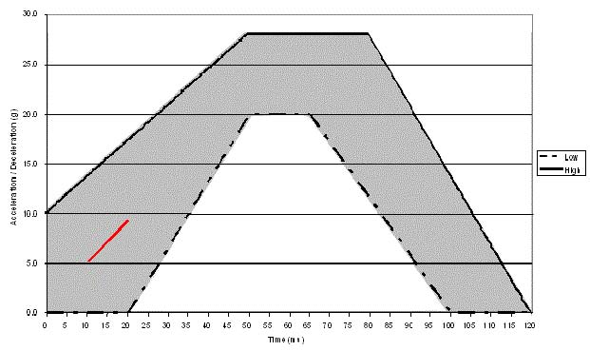

The additional segment applies only for the acceleration sled**.**

Annex 7 - Appendix 2

Rear impact

Curves of trolley's deceleration or acceleration, as function of time

Rear impact – Test pulse 2

|  |  |  |
| --- | --- | --- |
| *Definition of the different curves* | | |
| *Time (ms)* | *Acceleration (g) Low corridor* | *Acceleration (g) High corridor* |
| 0 | - | 21 |
| 10 | 0 |  |
| 10 | 7 | - |
| 20 | 14 | - |
| 37 | 14 | - |
| 52 | 7 | - |
| 52 | 0 |  |
| 70 | - | 21 |
| 70 | - | 0 |

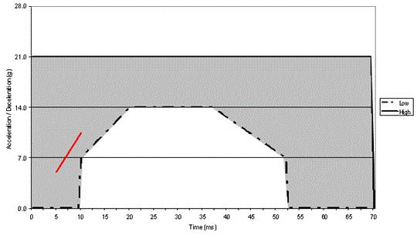

The additional segment applies only for the acceleration sled**.**

Annex 7 - Appendix 3

Lateral impact

Curve of relative velocity between trolley and door panel as function of time

Lateral impact – Test velocity corridor 3

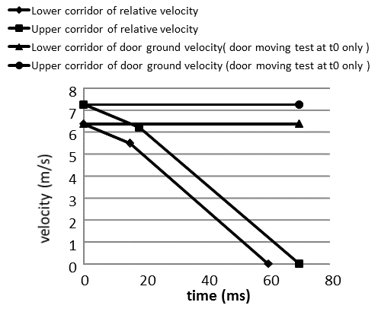

|  |  |  |
| --- | --- | --- |
| *Definition of the different curves* | | |
| *Time (ms)* | *Door bench Relative velocity (m/s) Lower corridor* | *Door bench Relative velocity (m/s) Upper corridor* |
| 0 | 6.375 | 7.25 |
| 15 | 5.5 | - |
| 18 | - | 6.2 |
| 60 | 0 | - |
| 70 | - | 0 |

*Remark*: The corridor shall be defined on experiences of respective test labs.

Annex 8

Description of dummies

1. General

1.1. The dummies prescribed in this Regulation are described in this annex, in technical drawings[10] and in the user manuals. The abdominal pressure sensors prescribed in this Regulation are described in this annex, in technical drawings and in the user manuals.

1.2. Alternative dummies and abdominal instrumentation may be used provided that:

1.2.1. Their equivalence can be demonstrated to the satisfaction of the Type Approval Authority, and

1.2.2. Their use is recorded in the test report, and in the communication form described in Annex 1 to this Regulation.

2. Description of the dummies

2.1. The dimensions and masses of the Q0, Q1, Q1.5, Q3, Q6 and Q10 dummies described below are based on the anthropometry of 50th per centile children aged 0, 1, 1.5, 3, 6 and 10.5 years respectively.

2.2. The dummies consist of a metal and plastic skeleton covered with plastic skinned foam parts to complete body components.

3. Construction

3.1. Head

The head is largely made from synthetics. The head cavity is large enough to allow use of several instruments, including linear accelerometers and angular velocity sensors.

3.2. Neck

The neck is flexible and allows shear and bending in all directions. The segmented design allows a realistic rotational behaviour. The neck is equipped with low stretch neck-cord in order to prevent excessive elongation. The neck-cord is also designed to act as a safety cord in case of rubber failure. A six channel load cell can be mounted at the neck-head and neck-torso interface. The Q0, Q1 and Q1.5 cannot accommodate the load cell between neck and torso.

3.3. Thorax

The thorax of the child is represented by a single rib-cage. The deformation can be measured with a string potentiometer in Q1 and Q1.5 and an IR-TRACC sensors in Q3, Q6 and Q10. The shoulders are connected with a flexible joint to the thorax, allowing deformation forwards.

3.4. Accelerometers can be mounted on the spine to measure linear accelerations. The Q0 thorax has a simplified layout with an integral foam part for the complete torso.

3.5. Abdomen

The abdomen is foam covered with skin. Biomechanical data from children has been used to determine the required stiffness. The Q0 abdomen has a simplified layout with an integral foam part for the complete torso. For frontal impact, the abdomen of the Q1.5, Q3, Q6 and Q10 are instrumented using Abdominal Pressure Twin Sensors (APTS).

3.6. Lumbar spine

The lumbar spine is a flexible rubber column, which allows shear and bending in all directions. A six channel load cell can be mounted between the lumbar spine and the pelvis, except for the Q0.

3.7. Pelvis

The pelvis is constructed from an iliac-sacrum bone part covered with a plastic flesh outer contour simulation. In the bone part removable hip joints are inserted. An accelerometer array can be mounted in the pelvis. Special hip joints are available that allow to position the dummy in a standing position. The Q0 pelvis has a simplified layout with an integral foam part for the complete torso.

3.8. Legs

The legs are constructed with metal reinforced plastic bones cover with PVC skinned foam parts that represent the upper and lower flesh. The knee joints can be locked in any position. This feature can be used to facilitate positioning the dummy in a standing position. (Note that the dummy does not have the ability to stand without external support.) The Q0 legs have a simplified layout with one integral part per leg with a fixed angle at the knee.

3.9. Arms

The arms are constructed with plastic bones cover with PVC skinned foam parts that represent the upper and lower flesh. The elbow joints can be locked in any position. The Q0 arms have a simplified layout with one integral part per arm with a fixed angle at the elbow.

4. Main characteristics

4.1. Mass

# Table 1

**Q-dummy mass distributions**

|  | *Q0* | *Q1* | *Q1.5* | *Q3* | *Q6* | *Q10* |
| --- | --- | --- | --- | --- | --- | --- |
| *Mass in [kg]* | | | | | | |
| Head + Neck (incl. acc. mount) | 1.13 ± 0.06 | 2.41 ± 0.10 | 2.80 ± 0.10 | 3.17 ± 0.10 | 3.94 ± 0.10 | 4.21 ± 0.15 |
| Torso (incl. acc. mount and chest deflection sensor, not including APTS) | 1.40 ± 0.08 | 4.21 ± 0.25 | 4.74 ± 0.25 | 6.00 ± 0.30 | 9.07 ± 0.40 | 14.28 ± 0.50  (incl. suit) |
| Legs (together) | 0.58 ± 0.03 | 1.82 ± 0.20 | 2.06 ± 0.20 | 3.54 ± 0.10 | 6.90 ± 0.10 | 12.48 ± 0.44 |
| Arms (together) | 0.28 ± 0.02 | 0.89 ± 0.20 | 1.20 ± 0.20 | 1.48 ± 0.10 | 2.49 ± 0.10 | 3.98 ± 0.20 |
| Suit | 0.08 ± 0.02 | 0.27 ± 0.05 | 0.30 ± 0.05 | 0.40 ± 0.10 | 0.55 ± 0.10 | 0.63± 0.10 |
| Total | 3.47 ± 0.21 | 9.6 ± 0.80 | 11.10 ± 0.80 | 14.59 ± 0.70 | 22.95 ± 0.80 | 35.58 ± 1.39 |

The installation of Abdominal Pressure Twin Sensors (APTS) in frontal and rear impact may add up 0.2 kg to the Q1.5 and 0.5kg to the Q3, Q6 and Q10 dummies.

4.2. Principal dimensions

Figure 2

**Main dimensions of dummy**

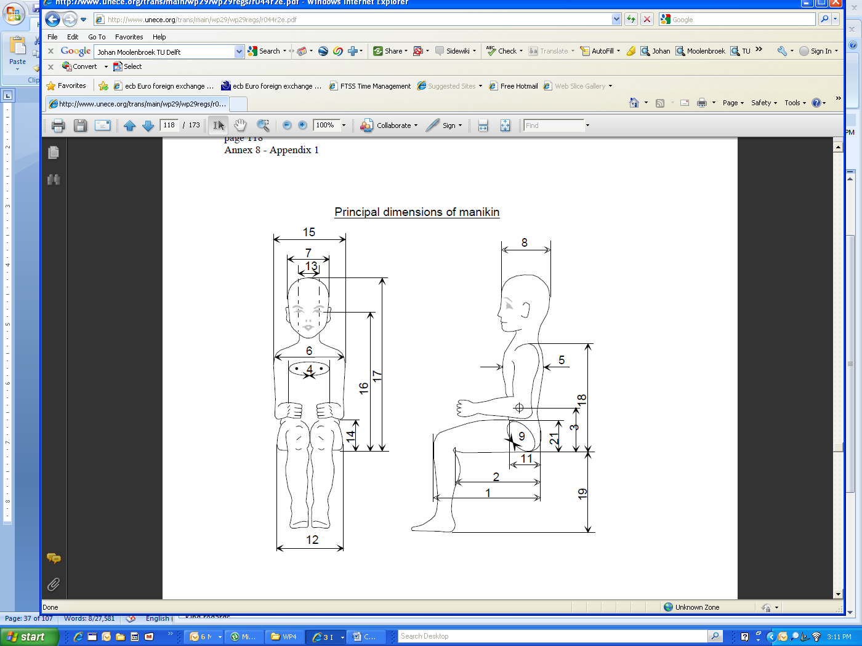

Table 2

**Q-dummy dimensions**

| *No.* |  | *Q0* | *Q1* | *Q1.5* | *Q3* | *Q6* | *Q10 (design targets)* |
| --- | --- | --- | --- | --- | --- | --- | --- |
|  |  | *Dimensions in mm* | | | | | |
| 17 | Seating height  (head tilted forward) | 355 ± 9 | 479 ± 9 | 499 ± 9 | 544 ± 9 | 601 ± 9 | 733.7 ± 9 |
| 18 | Shoulder height  (sitting) | 255 ± 5 | 298 ± 7 | 309 ± 7 | 329 ± 7 | 362 ± 7 | 473 ± 7 |
|  | Stature (head tilted forward) | - | 740 ± 9 | 800 ± 9 | 985 ± 9 | 1143 ± 9 | 1453.2 ± 12 |
| 5 | Chest depth | - | 114 ± 5 | 113 ± 5 | 146 ± 5 | 141 ± 5 | 171 ± 5 |
| 15 | Shoulder width | 145 ± 5 | 227 ± 7 | 227 ± 7 | 259 ± 7 | 305 ± 7 | 334.8 ± 7 |
| 12 | Hip width | - | 191 ± 7 | 194 ± 7 | 200 ± 7 | 223 ± 7 | 270 ± 7 |
| 1 | Back of buttocks to front of knees | 130 ± 5 | 211 ± 5 | 235 ± 5 | 305 ± 5 | 366 ± 5 | 485.4 ± 6 |
| 2 | Back of buttocks to popliteus | - | 161 ± 5 | 185 ± 5 | 253 ± 5 | 299 ± 5 | 414,9 ± 6 |
| 21 | Thigh height, sitting |  | 69 | 72 | 79 | 92 | 114 ± 3 |
|  | Height of spacer device for positioning of dummy1 |  | 229 ± 2 | 237 ± 2 | 250 ± 2 | 270 ± 2 | 359 ± 2 |
| 1 The neck diameter is taken as the diameter of the top and bottom plate of the Q dummy necks.  Middle disks are 56.9 mm  2 Q6 neck disk at top  3 Q6 neck disk at bottom  4 Neck shield diameter | | | | | | | |

*Notes:*

1. Adjustments of joints

Joints should preferably be adjusted according to procedures included in the Q-dummy manuals.[11]

2. Instrumentation

Instrumentation in the Q family of dummies shall preferably be installed and calibrated according to procedures contained in the Q-dummy manuals1and the APTS manual.

Annex 9

Frontal impact test against a barrier

1.1. Testing ground

The test area shall be large enough to accommodate the run-up track, barrier and technical installations necessary for the test. The last part of the track, for at least 5 m before the barrier, shall be horizontal, flat and smooth.

1.2. Barrier

The barrier consists of a block of reinforced concrete not less than 3 m wide at the front and not less than 1.5 m high. The barrier shall be of such thickness that it weighs at least 70 tonnes. The front face shall be vertical, perpendicular to the axis of the run-up track, and covered with plywood boards 20 ± 1 mm thick in good condition. The barrier shall be either anchored in the ground or placed on the ground with, if necessary, additional arresting devices to limit its displacement. A barrier with different characteristics, but giving results at least equally conclusive, may likewise be used.

1.3. Propulsion of the vehicle

At the moment of impact, the vehicle shall no longer be subjected to the action of any additional steering or propelling device or devices. It shall reach the obstacle on a course perpendicular to the collision wall; the maximum lateral disalignment permitted between the vertical median line of the front of the vehicle and the vertical median line of the collision wall is ±30 cm.

1.4. State of the vehicle

1.4.1. The vehicle under test shall either be fitted with all the normal components and equipment included in its unladen service weight or be in such a condition as to fulfil this requirement in so far as the components and equipment of concern to the passenger compartment and the distribution of the service weight of the vehicle as a whole are concerned.

1.4.2. If the vehicle is driven by external means, the fuel installation shall be filled to at least 90 per cent of its capacity, either with fuel or with a non-inflammable liquid, having a density and a viscosity close to those of the fuel normally used. All other systems (brake-fluid containers, radiator, etc.) shall be empty.

1.4.3. If the vehicle is driven by its own engine, the fuel tank shall be at least 90 per cent full. All other liquid-holding tanks shall be filled to capacity.

1.4.4. If the manufacturer so requests, the Technical Service responsible for conducting the tests may allow the same vehicle as is used for tests prescribed by other Regulations (including tests capable of affecting its structure) to be used also for the tests prescribed by this Regulation.

1.5. Impact velocity

The impact velocity shall be 50 +0/-2 km/h. However, if the test has been carried out at a higher impact velocity and the vehicle has satisfied the conditions prescribed, the test is considered satisfactory.

1.6. Measuring instruments

The instrument used to record the speed referred to in paragraph 1.5. above shall be accurate within 1 per cent.

Annex 10

Rear impact test procedure

1. Installations, procedures and measuring instruments

1.1. Testing ground

The test area shall be large enough to accommodate the propulsion system of the impactor and to permit after-impact displacement of the vehicle impacted and installation of the test equipment. The part in which vehicle impact and displacement occur shall be horizontal. (The slope shall be less than 3 per cent measured over any length of one metre.)

1.2. Impactor

1.2.1. The impactor shall be of steel and of rigid construction.

1.2.2. The impacting surface shall be flat and at least 2,500 mm wide and 800 mm high. Its edges shall be rounded to a radius of curvature of between 40 and 50 mm. It shall be clad with a layer of plywood 20 ± 1 mm thick.

1.2.3. At the moment of impact the following requirements shall be met:

1.2.3.1. The impacting surface shall be vertical and perpendicular to the median longitudinal plane of the impacted vehicle;

1.2.3.2. The direction of movement of the impactor shall be substantially horizontal and parallel to the median longitudinal plane of the impacted vehicle;

1.2.3.3. The maximum lateral deviation permitted between the median vertical line of the surface of the impactor and the median longitudinal plane of the impacted vehicle shall be 300 mm. In addition, the impacting surface shall extend over the entire width of the impacted vehicle;

1.2.3.4. The ground clearance of the lower edge of the impacting surface shall be 175 ± 25 mm.

1.3. Propulsion of the impactor

The impactor may either be secured to a carriage (moving barrier) or form part of a pendulum.

1.4. Special provisions applicable where a moving barrier is used

1.4.1. If the impactor is secured to a carriage (moving barrier) by a restraining element, the latter shall be rigid and be incapable of being deformed by the impact; the carriage shall, at the moment of impact, be capable of moving freely and no longer be subject to the action of the propelling device.

1.4.2. The combined mass of carriage and impactor shall be 1,100 ± 20 kg.

1.5. Special provisions applicable where a pendulum is used

1.5.1. The distance between the centre of the impacting surface and the axis of rotation of the pendulum shall be not less than 5 m.

1.5.2. The impactor shall be freely suspended by rigid arms, rigidly secured to it. The pendulum so constituted shall be substantially incapable of being deformed by the impact.

1.5.3. A stopping device shall be incorporated in the pendulum to prevent any secondary impact by the impactor on the test vehicle.

1.5.4. At the moment of impact, the velocity of the centre of percussion of the pendulum shall be between 30 and 32 km/h.

1.5.5. The reduced mass "mr" at the centre of percussion of the pendulum is defined as a function of the total mass "m", of the distance "a"[12] between the centre of percussion and the axis of rotation, and of the distance "l" between the centre of gravity and the axis of rotation, by the following equation:



1.5.6. The reduced mass "mr" shall be 1,100 ± 20 kg.

1.6. General provisions relating to the mass and velocity of the impactor

If the test has been conducted at an impact velocity higher than those prescribed in paragraph 1.5.4. above and/or with a mass greater than those prescribed in paragraphs 1.5.3. or 1.5.6. above, and the vehicle has met the requirements prescribed, the test shall be considered satisfactory.

1.7. State of the vehicle during the test

The vehicle being tested shall either be fitted with all the normal components and equipment included in its unladen service weight or be in such condition as to fulfil this requirement in so far as the distribution of the service weight of the vehicle as a whole is concerned.

1.8. The complete vehicle with the Enhanced Child Restraint System installed in accordance with the fitting instructions shall be placed on a hard, flat and level surface, with the handbrake off and in neutral gear. More than one Enhanced Child Restraint System may be tested in the same impact test.

Annex 11

Type approval scheme (Flow chart ISO 9002:2000)

*Notes:*

Yes

COP Test3 & visit2

**COP by Technical Service**

**COP Test3** **& visit2**

**Laboratory Inspection**

**by**

**Type Approval Authority Approval Authority**

**COP In-House**

**Granting**

**Type approval**

**Type Approval Test &**

**Qualification Test**1

No

**Factory Inspection**

**by**

**Type Approval Authority**

**ISO 9002:2000 0**

Known Applicant

Unknown Applicant

**Type Approval Request**

0. Or an equivalent standard to this one with the permissible exclusion of the requirements related to the concepts of design and development; point 7.3. of ISO 9002:2000 "Customer satisfaction and continual improvement"

1. These tests shall be done by Technical Services

2. Visit to the manufacturer for inspection and random sampling by the Type Approval Authority or Technical Service

(a) If there is no ISO 9002:2000: 2 times a year;

(b) If there is an ISO 9002:2000: 1 time a year.

3. Tests in accordance with Annex 13

(a) If there is no ISO 9002:2000:

(i) Of the Type Approval Authority or Technical Service during the visit of note 2a above;

(ii) Of the manufacturer between the visits of note 2b above;

(b) If there is an ISO 9002:2000: taken by the manufacturer, procedure checked during visit of note 2b above.

Annex 12

Control of conformity of production

1. Tests

Enhanced Child Restraint Systems shall be required to demonstrate compliance with the requirements on which the following tests are based:

1.1. Verification of the locking threshold and durability of emergency locking retractors

According to the provisions of paragraph 7.2.4.3. of this Regulation in the most unfavourable direction as appropriate after having undergone the durability testing detailed in paragraphs 7.2.4.2., 7.2.4.4. and 7.2.4.5. of this Regulation as a requirement of paragraph 6.7.3.2.6. of this Regulation.

1.2. Verification of the durability of automatically locking retractors

According to the provisions of paragraph 7.2.4.2. of this Regulation supplemented by the tests in paragraphs 7.2.4.4. and 7.2.4.5. of this Regulation as a requirement of paragraph 6.7.3.1.3. of this Regulation.

1.3. Test for strength of straps after conditioning

According to the procedure described in paragraph 6.7.4.2. of this Regulation after conditioning according to the requirements of paragraphs 7.2.5.2.1. to 7.2.5.2.5. of this Regulation.

1.3.1. Test for strength of straps after abrasion

According to the procedure described in paragraph 6.7.4.2. of this Regulation after conditioning according to the requirements described in paragraph 7.2.5.2.6. of this Regulation.

1.4. Microslip test

According to the procedure described in paragraph 7.2.3. of this Regulation.

1.5. Energy absorption

According to the provisions of paragraph 6.6.2. of this Regulation.

1.6. Verification of the performance requirements of the Enhanced Child Restraint System when subjected to the appropriate dynamic test:

According to the provisions set out in paragraph 7.1.3. of this Regulation with any buckle having been pre-conditioned according to the requirements of paragraph 6.7.1.6. of this Regulation such that the appropriate requirements of paragraph 6.6.4. of this Regulation (for the overall performance of the Enhanced Child Restraint System) and paragraph 6.7.1.7.1. of this Regulation (for the performance of any buckle under load) are complied with.

1.7. Temperature test

According to the provisions of paragraph 6.6.5. of this Regulation.

2. Test frequency and results

2.1. The frequency of testing to the requirements of paragraphs 1.1. to 1.5. and 1.7. above shall be on a statistically controlled and random basis in accordance with one of the regular quality assurance procedure, and shall be conducted at least once per year.

2.2. Minimum conditions for the control of conformity of Enhanced Child Restraint Systems of categories "Universal", in relation to the dynamic tests according to paragraph 1.6. above.

2.2.1. Batch control for the Enhanced Child Restraint Systems

2.2.1.1. The holder of an approval shall divide the Enhanced Child Restraint Systems into batches which are as uniform as possible in regard to raw material or intermediate products involved in their manufacture (different colour of shell, different manufacture of harness) and in regard to production conditions. The numbers in a batch shall not exceed 5,000 units.

In agreement with the relevant authorities the tests can be carried out by the Technical Service or under the responsibility of the holder of an approval.

2.2.1.2. A sample shall be taken in each batch in accordance with the provisions of paragraph 2.2.1.4. below from a minimum of 20 per cent of the batch quantity, which has to be produced of the actual batch.

2.2.1.3. The characteristics of the Enhanced Child Restraint Systems and the number of dynamic tests to be conducted are given in paragraph 2.2.1.4. below

2.2.1.4. In order to be accepted, a batch of Enhanced Child Restraint Systems shall satisfy the following conditions.

# Table 1

|  |  |  |  |  |  |
| --- | --- | --- | --- | --- | --- |
| *Number in the batch* | *Number of samples/ Enhanced Child Restraint Systems characteristics* | *Combined number of samples* | *Acceptance criteria* | *Rejection criteria* | *Degree of control rigour* |
| N<500 | 1st = 1MH 2nd = 1MH | 1 2 | 0 1 | - 2 | Normal |
| 500<N<5,000 | 1st = 1MH+1LH 2nd = 1MH+1LH | 2 4 | 0 1 | 2 2 | Normal |
| N<500 | 1st = 2MH 2nd = 2MH | 2 4 | 0 1 | 2 2 | Strengthened |
| 500<N<5,000 | 1st = 2MH+2LH 2nd = 2MH+2LH | 4 8 | 0 1 | 2 2 | Strengthened |

*Notes:* MH means harder condition (the least good results obtained in approval or extension of approval) LH signifies a less hard condition. LH signifies a less hard configuration.

This dual sampling plan functions as follows:

For a normal control, if the first sample does not contain any defective units the batch is accepted without testing a second sample. If it contains two defective units the batch is rejected. Finally, if it contains one defective unit a second sample is extracted and it is the cumulative number, which shall satisfy the condition of column 5 of the table above.

There is a change from normal control to strengthened control if, out of 5 consecutive batches, two are rejected. Normal control is resumed if 5 consecutive batches are accepted.

If any batch is rejected, the production is considered to be non-conforming and the batch shall not be released.

If two consecutive batches subjected to the strengthened control are rejected, the provisions of paragraph 13. of this Regulation are applied.

2.2.1.5. The control of Enhanced Child Restraint Systems conformity is undertaken starting with the batch manufactured after the first batch which was subjected to production qualification.

2.2.1.6. The test results described in paragraph 2.2.1.4. above shall not exceed L, where L is the limit value prescribed for each approval test.

2.2.2. Continuous control

2.2.2.1. The holder of an approval shall be obliged to carry out continuous quality control of his manufacturing process on a statistical basis and by sampling. In agreement with the relevant authorities, the tests can be carried out by the Technical Service or under the responsibility of the holder of an approval which is responsible for the traceability of the product.

2.2.2.2. The samples shall be taken in accordance with the provisions of paragraph 2.2.2.4. below.

2.2.2.3. The characteristic of the Enhanced Child Restraint Systems is taken at random and the tests to be carried out are described in paragraph 2.2.2.4. below.

2.2.2.4. Control shall meet the following requirements:

# Table 2

|  |  |
| --- | --- |
| *Enhanced Child Restraint Systems taken* | *Degree of control rigour* |
| 0.02 per cent means one Enhanced Child Restraint System taken from every 5,000 manufactured | Normal |
| 0.05 per cent means one Enhanced Child Restraint System taken from every 2,000 manufactured | Strengthened |

This dual sampling plan functions as follows:

If the Enhanced Child Restraint System is considered to conform, the production conforms.

If the Enhanced Child Restraint System does not meet the requirements, a second Enhanced Child Restraint System shall be taken.

If the second Enhanced Child Restraint System meets the requirements, the production conforms.

If both (the first and the second) Enhanced Child Restraint Systems do not meet the requirements, the production does not conform and Enhanced Child Restraint Systems that are likely to present the same failure shall be withdrawn and necessary steps shall be taken to re-establish the conformity of the production.

Strengthened control will replace normal control if, out of 10,000 Enhanced Child Restraint Systems manufactured consecutively, the production has to be withdrawn twice.

Normal control is resumed if 10,000 Enhanced Child Restraint Systems manufactured consecutively are considered to conform.

If production subjected to the strengthened control has been withdrawn on two consecutive occasions, the provisions of paragraph 13. of this Regulation are applied.

2.2.2.5. The continuous control of Enhanced Child Restraint Systems is undertaken starting after the production qualification.

2.2.2.6. The test results described in paragraph 2.2.2.4. above shall not exceed L, where L is the limit value prescribed for each approval test.

2.3. For Specific vehicle ECRS devices according to paragraph 2.1.2.4.1. above, the Enhanced Child Restraint System manufacturer may choose Conformity of Production procedures according to either paragraph 2.2. above, on a test bench, or paragraphs 2.3.1. and 2.3.2. below, in a vehicle body shell.

2.3.1. For Specific vehicle ECRS devices, the following test frequencies shall apply once every eight weeks:

At each test all requirements according to paragraphs 6.6.4. and 6.7.1.7.1. of this Regulation shall be fulfilled. If all tests during one year show satisfactory results, the manufacturer may, after agreement with the Type Approval Authority, reduce the frequencies as follows: once every 16 weeks.

However, a minimum frequency of one test per year shall be permitted where annual production is 1,000 Enhanced Child Restraint Systems or less.

2.3.2. Where a test sample fails a particular test to which it has been subjected, a further test to the same requirement shall be carried out on at least three other samples. In the case of dynamic tests if one of the latter fails, the production is considered to be non-conforming and the frequency shall be raised to the higher one if the lower one was used according to paragraph 2.3. above and necessary steps shall be taken to re-establish the conformity of the production.

2.4. When production is found to be non-conforming according to paragraphs 2.2.1.4., 2.2.2.4. or 2.3.2. above, the holder of the approval or his duly accredited representative shall:

2.4.1. Notify the Type Approval Authority which has granted type approval indicating what steps have been taken to re-establish the conformity of production.

2.5. The manufacturer shall advise the Type Approval Authority on a quarterly basis, the volume of products produced against each approval number, providing a means of identifying which products correspond to that approval number.

Annex 13

Test of energy absorbing material

1. Headform

1.1. The headform shall consist of a solid wooden hemisphere with an added smaller spherical segment as shown in Figure A below. It shall be constructed so that it can be dropped freely along the axis marked and it shall have provision for mounting an accelerometer in order to measure the acceleration along the direction of fall.

1.2. The headform shall have a total mass, including the accelerometer of 2.75 ± 0.05 kg.

# Figure A

**Headform**

 Dimensions in mm

2. Instrumentation

The acceleration shall be recorded during the test, using equipment in accordance with channel frequency class 1000 as specified in the latest version of ISO 6487.

3. Procedure

3.1. The child restraint shall be placed in the region of impact on a rigid flat surface, whose minimum dimensions are 500 x 500 mm, so that the direction of impact is perpendicular to the inner surface of the Enhanced Child Restraint System in the area of impact.

3.2.Raise the headform to a height of 100 -0/+5 mm from the respective upper surfaces of the assembled Enhanced Child Restraint System to the lowest point on the headform, and allow it to fall. Record the acceleration experienced by the headform during impact.

Annex 14

Method of defining head impact area of devices with backrests or impact shields and for rearward-facing devices defining the minimum size of side wings

1. Head impact area

1.1. Definition of backrest head impact area

Place the device on the test bench described in Annex 6. Reclinable devices shall be set in the most upright position. Place the smallest manikin in the device in accordance with the manufacturer's instructions. Mark a point "A" on the backrest on the same horizontal level as the shoulder of the smallest manikin at a point 2 cm inside the outer edge of the arm. All internal surfaces above the horizontal plane passing through point A, shall be tested in accordance with Annex 13. This area shall include the backrest and side wings, including the inner edges (zone of radius) of the side wings. In the case of carrycot devices where a symmetrical installation of the dummy is not possible according to the device and manufacturer instructions, the area complying with Annex 13 shall be all internal surfaces above a point "A", as previously defined, in the head direction, when measured with this dummy in the carrycot in its worst position consistent with the manufacturer instructions and the carrycot positioned on the test bench.

If a symmetrical installation of the dummy in the carrycot may be possible, the whole inner area shall comply with Annex 13.

For rearward-facing devices there shall be side wings with a depth of minimum 90 mm measured from the median of the surface of the backrest. These side wings shall start at the horizontal plane passing through point "A" and continue to the top of the Enhanced Child Restraint System seat-back. Starting from a point 90 mm below the top of the Enhanced Child Restraint System seat-back, the depth of the side wing may be gradually reduced.

1.2. Definition of impact shield head impact area

The impact shield head impact area is the whole upper surface of the impact shield, which comprises any surfaces visible from the top, looking down on the shield.

Annex 15

Description of conditioning for adjusters connected to a strap

# Figure 1

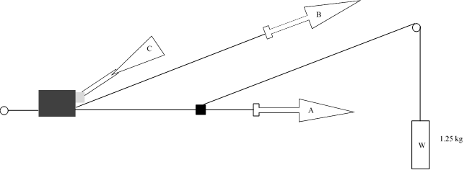

Strap

Adjuster (rigidly clamped)

Strap end clamped or fixed to ECRS

1. Method

1.1. Rigidly clamp the adjuster

1.2. With the strap set at the reference position described in paragraph 7.2.6., withdraw at least 50 mm of strap from the adjuster by pulling on the free end of the strap.

1.3. Attach the adjuster part of the strap to the pulling device A.

1.4. Activate the adjuster (C) and pull at least 150 mm of strap through the adjuster. This represents half of one cycle and puts pulling device A to the maximum strap extraction position.

1.5. Connect the free end of the strap to pulling device B.

2. The cycle is:

2.1. Pull B at least 150 mm while A does not exert tension on the strap.

2.2. Activate the adjuster (C) and pull A while B does not exert tension on the free end of the strap.

2.3. At the end of the stroke, de-activate the adjuster.

2.4. Repeat the cycle as specified in paragraph 6.7.2.7. of this Regulation.

Annex 16

Typical buckle strength test device



Annex 17

Determination of performance criteria

1. Head Performance Criterion (HPC)

1.1. This criterion is considered to be satisfied when, during the test, there is no contact between the head and any vehicle component.

1.2. If that is not the case, a calculation of the value of HPC is made, on the basis of the acceleration (a),[13] by the following expression:



In which:

1.2.1. The term "a" is the resultant acceleration is measured in units of gravity, g (1 g = 9,81 m/s2);

1.2.2. If the beginning of the head contact can be determined satisfactorily, t1 and t2 are the two time instants, expressed in seconds, defining an interval between the beginning of the head contact and the end of the recording for which the value of HPC is maximum;

1.2.3. If the beginning of the head contact cannot be determined, t1 and t2 are the two time instants, expressed in seconds, defining a time interval between the beginning and the end of the recording for which the value of HPC is maximum;

1.2.4. Values of HPC for which the time interval (t1 - t2) is greater than 15 ms are ignored for the purposes of calculating the maximum value.

1.3. The value of the resultant head acceleration during forward impact which is exceeded for 3 ms cumulatively is calculated from the resultant head acceleration.

Annex 18

Geometrical dimensions of Enhanced Child Restraint Systems

# Figure 1

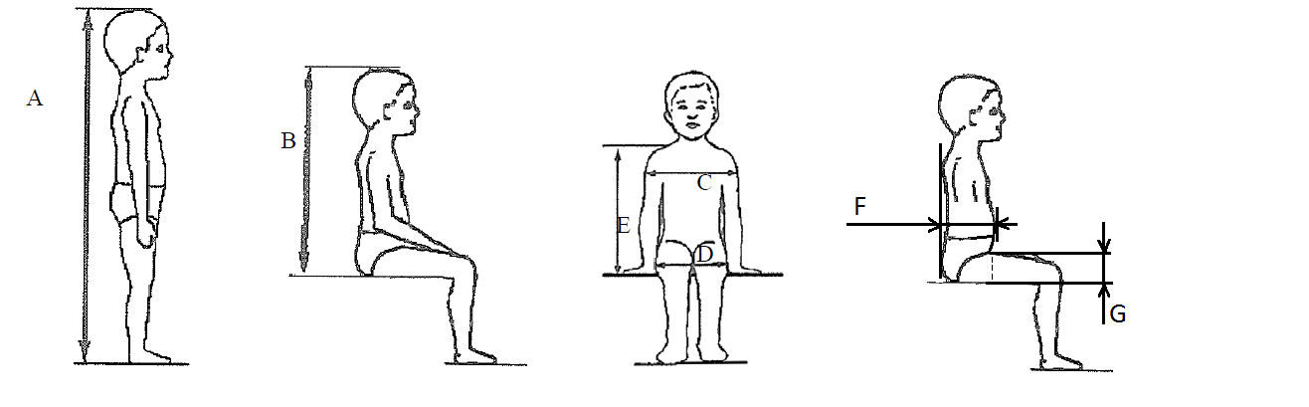

Table 1

|  |  |  |  |  |  |  |  |  |  |  |  |  |  |
| --- | --- | --- | --- | --- | --- | --- | --- | --- | --- | --- | --- | --- | --- |
| *Applicable to all ECRS* | | | | | |  | *Additional internal dimensions for ECRS with impact shield systems* | | | | | | |
|  | Min | Min | Min | Min | Max | Min | | Max | | Min | | Max |
| Stature  cm | Sitting height cm | Shoulder breadth cm | Hip breadth  cm | Shoulder height cm | Shoulder height cm | Abdomen depth cm | | Abdomen depth cm | | Upper leg thickness cm | | Upper leg thickness cm |
| A | B | C | D | E1 | E2 | F1 | | F2 | | G1 | | G2 |
|  | 95%ile | 95%ile | 95%ile | 5%ile | 95%ile | 5%ile | | 95%ile | | 5%ile | | 95%ile |
| ≤40 |  |  |  | < 27.4 |  | Not allowed for these dimensions and stature bellow 76 cm | | | | | | |
| 45 | 39.0 | 12.1 | 14.2 | 27.4 | 29.0 |
| 50 | 40.5 | 14.1 | 14.8 | 27.6 | 29.2 |
| 55 | 42.0 | 16.1 | 15.4 | 27.8 | 29.4 |
| 60 | 43.5 | 18.1 | 16.0 | 28.0 | 29.6 |
| 65 | 45.0 | 20.1 | 17.2 | 28.2 | 29.8 |
| 70 | 47.1 | 22.1 | 18.4 | 28.3 | 30.0 |
| 75 | 49.2 | 24.1 | 19.6 | 28.4 | 31.3 | 12.5 | 15.1 | | 5.7 | | 8.4 | |
| 80 | 51.3 | 26.1 | 20.8 | 29.2 | 32.6 | 12.7 | 15.7 | | 5.8 | | 8.4 | |
| 85 | 53.4 | 26.9 | 22.0 | 30.0 | 33.9 | 12.9 | 16.2 | | 5.9 | | 8.5 | |
| 90 | 55.5 | 27.7 | 22.5 | 30.8 | 35.2 | 13.1 | 16.8 | | 6.2 | | 8.5 | |
| 95 | 57.6 | 28.5 | 23.0 | 31.6 | 36.5 | 13.3 | 17.8 | | 6.5 | | 8.9 | |
| 100 | 59.7 | 29.3 | 23.5 | 32.4 | 37.8 | 13.5 | 18.2 | | 6.5 | | 9.6 | |
| 105 | 61.8 | 30.1 | 24.9 | 33.2 | 39.1 | 13.6 | 18.8 | | 6.6 | | 10.3 | |
| 110 | 63.9 | 30.9 | 26.3 | 34.0 | 40.4 | 13.9 | 19.6 | | 6.6 | | 10.3 | |
| 115 | 66.0 | 32.1 | 27.7 | 35.5 | 41.7 | 13.9 | 19.9 | | 6.6 | | 10.4 | |
| *Applicable to all ECRS* | | | | | |  | *Additional internal dimensions for ECRS with impact shield systems* | | | | | | |
|  | Min | Min | Min | Min | Max |  | Min | | Max | | Min | | Max |
| Stature  cm | Sitting height cm | Shoulder breadth cm | Hip breadth  cm | Shoulder height cm | Shoulder height cm |  | Abdomen depth cm | | Abdomen depth cm | | Upper leg thickness cm | | Upper leg thickness cm |
| A | B | C | D | E1 | E2 |  | F1 | | F2 | | G1 | | G2 |
|  | 95%ile | 95%ile | 95%ile | 5%ile | 95%ile |  | 5%ile | | 95%ile | | 5%ile | | 95%ile |
| 120 | 68.1 | 33.3 | 29.1 | 37.0 | 43.0 |  | 14.3 | 20.2 | | 6.8 | | 10.5 | |
| 125 | 70.2 | 33.3 | 29.1 | 38.5 | 44.3 | 14.7 | 20.7 | | 7.5 | | 10.9 | |
| 130 | 72.3 | 33.3 | 29.1 | 40.0 | 46.1 | Not allowed for these dimensions and stature over 125 cm | | | | | | |
| 135 | 74.4 | 33.3 | 29.1 | 41.5 | 47.9 |
| 140 | 76.5 | 34.2 | 29.6 | 43.0 | 49.7 |
| 145 | 78.6 | 35.3 | 30.8 | 44.5 | 51.5 |
| 150 | 81.1 | 36.4 | 32.0 | 46.3 | 53.3 |

All lateral dimensions are measured under a contact force of 50 N with the devices described in Figure 2 and Figure 3 of this annex and the following tolerances will applied:

Minimum Sitting height:

(a) Up to 87 cm B - 5 per cent;

(b) From stature from 87 cm and up to 150 cm B - 10 per cent.

Minimum shoulder height (5 percentile): E1 -2+0 cm

Maximum shoulder height (95 percentile): E2 -0+2 cm

The mass of the devices described in Figure 2 and Figure 3 of this annex shall be   
10 kg +/- 1 kg

Figure 2 **ECRS Measurement Device - Side and Front View of the measuring device**

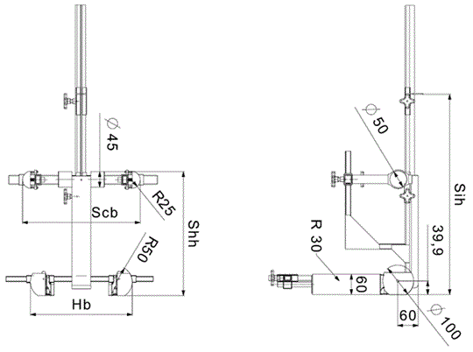

All dimensions in mm

Figure 3

**Side and Front View of the measuring device for measurements applicable to Enhanced Child Restraint Systems that feature an impact shield**

|  |  |
| --- | --- |
|  |  |

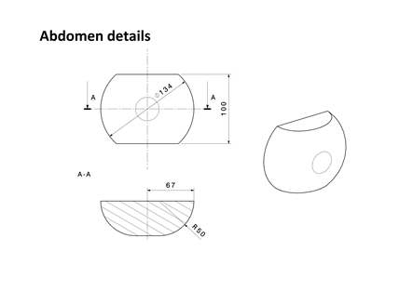

All dimensions in mm

Internal geometry assessment method

This method describes how to conduct the internal geometry assessment, as required by paragraph 6.3.2.1., to verify the stature range of the Enhanced Child Restraint System declared by the manufacturer.

This assessment shall be carried out for each of the following:

(a) For each Enhanced Child Restraint System orientation (e.g. rearward and forward facing);

(b) For each Enhanced Child Restraint System type (e.g. integral and non-integral);

(c) For any removable insert (e.g. for use as described by manufacturer’s instructions);

(d) For each occupant restraint method (e.g. harness and shield).

The internal geometry assessment should be conducted with the Enhanced Child Restraint System placed on a flat surface or connected to a base in the case of ECRS modules.

For integral or non-integral Enhanced Child Restraint System the device shown in Annex 18, Figure 2 shall be used.

For Enhanced Child Restraint System with an impact shield the device shown in Annex 18, Figure 3 shall be used.

1. Determining the Minimum Occupant size

The Enhanced Child Restraint System should be adjusted to fit the smallest occupant (i.e. headrest height, harness height adjustment, appropriate insert, internal padding, impact shield position), while still fitting within the required ISO volumetric envelope as defined in paragraph 6.3.2.2.

The measurement device shall then be placed in the Enhanced Child Restraint System. The device shall be aligned centrally to the Enhanced Child Restraint System.

All measurements shall be taken with the device base in contact with the seat pan of the Enhanced Child Restraint System and the device backrest in contact with the backrest of the Enhanced Child Restraint System.

The measurements shall be taken in the following order:

1.1. Minimum Shoulder Height (E1)

1.1.1. For integral Enhanced Child Restraint System:

This measurement shall be taken when the top of the shoulder height cylinders of the device are aligned with the lowest harness slot position. For this alignment, the top of the shoulder cylinder shall be aligned perpendicular to the harness webbing outlet in the Enhanced Child Restraint System backrest.

A tolerance may be subtracted from this measurement to allow the shoulders of the occupant to be lower than the harness shoulder slots.

Either:

(a) If the Enhanced Child Restraint System instruction manual provided by the manufacturer quantifies the distance the child’s shoulder may be below the harness slots, then this distance shall be subtracted from the minimum shoulder height measurement;

(b) If no distance is specified a 2 cm tolerance may be subtracted from the minimum shoulder height measurement.

1.1.2. For non-integral Enhanced Child Restraint System

This measurement shall be taken when the top of the shoulder height cylinders of the device are aligned without interference with the lowest part of the headrest.

1.1.3. For Enhanced Child Restraint System with an impact shield:

This measurement shall be taken when the top of the shoulder height cylinders of the device are aligned without interference with the lowest part of the headrest.

1.2. Minimum Upper Leg Thickness (G1)

This requirement only applies to Enhanced Child Restraint System with impact shields.

Whilst maintaining the minimum shoulder height position (E1), the minimum leg measurement shall be measured when the device is adjusted so that the simulated thighs contact the bottom of the impact shield.

1.3. Minimum Abdomen Depth (F1)

This requirement only applies to Enhanced Child Restraint System with impact shields

This measurement shall be taken whilst maintaining the minimum leg thickness measurement position (G1) and minimum shoulder height position (E1).

The bottom of the simulated abdomen of the device shall be aligned with the top of the simulated thighs.

The abdomen depth shall be measured when the simulated abdomen contacts the shield.

2. Determining the Maximum Occupant Size

Integral Enhanced Child Restraint System shall be adjusted to fit the largest occupant (i.e. headrest height, harness height adjustment, impact shield position), while still fitting within the required ISO volumetric envelope as defined in paragraph 6.3.2.2.1.

Non-integral Enhanced Child Restraint System shall be adjusted to accommodate children of 135 cm stature or to the largest size of its declared stature range if the upper limit is below 135 cm (i.e. headrest), while still fitting within the required ISO volumetric envelope as defined in paragraph 6.3.2.2.2.

The measurement device shall then be placed in the Enhanced Child Restraint System. The device shall be aligned centrally to the Enhanced Child Restraint System.

The measurements shall then be taken in the following order:

2.1. Sitting Height (B)

This measurement shall be taken to the highest part of the Enhanced Child Restraint System that is the effective headrest (head pad or backrest).

A tolerance is added to this measurement to allow part of the head to protrude from the Enhanced Child Restraint System:

(a) +5 per cent for stature ranges below 87 cm;

(b) +10 per cent for statures ranges above 87 cm.

2.2. Hip Breadth (D)

The hip breadth measurement shall be taken while maintaining the sitting height measurement (B).

The hip breadth measurement shall be taken while asserting a 50 N contact force on the Enhanced Child Restraint System.

If 50 N force cannot be achieved, because the Enhanced Child Restraint System restricts the space at the simulated thighs then the measurement should be taken at the point the simulated thighs contact the Enhanced Child Restraint System. There shall be no lateral deformation of the Enhanced Child Restraint System caused by the measuring device.

2.3. Maximum Shoulder Height (E2)

The maximum shoulder height measurement shall be taken while maintaining the sitting height (B) and hip breadth (D) measurements.

2.3.1. For integral Enhanced Child Restraint System

This measurement shall be taken when the top of the shoulder height cylinders of the device are aligned with the highest harness slot position still fitting within the required ISO volumetric envelope. For this alignment, the top of the shoulder cylinder shall be aligned perpendicular to the harness webbing outlet in the Enhanced Child Restraint System backrest.

A tolerance may be added to this measurement to allow the shoulders of the occupant to be higher than the harness shoulder slots. However if there is a physical restriction due to the design of the Enhanced Child Restraint System (e.g. the headrest) that would prevent a child with taller shoulders fitting the tolerance should not be added.

If there is no possible interference then the following tolerances may be added:

(a) If the Enhanced Child Restraint System instruction manual provided by the manufacturer quantifies the distance the child’s shoulder may be above the harness slots, then this distance shall be added to the maximum shoulder height measurement;

(b) If no distance is specified a 2 cm tolerance may be added to the maximum shoulder height measurement.

2.3.2. For non-integral Enhanced Child Restraint System

This measurement shall be taken when the top of the shoulder height cylinders of the device are aligned without interference with the lowest point of the headrest, this includes any belt routing guide.

No tolerance shall be added to this measurement.

2.3.3. For Enhanced Child Restraint System with an impact shield

This measurement shall be taken when the top of the shoulder height cylinders of the device are aligned without interference with the lowest point of the headrest, this includes any belt routing guide.

No tolerance shall be added to this measurement.

2.4. Maximum Upper Leg Thickness (G2)

This requirement only applies to Enhanced Child Restraint System with impact shields.

This measurement shall be taken whilst maintaining the sitting height (B), hip breadth (D) and maximum shoulder height (E2) measurements.

The maximum upper leg thickness measurement shall be measured when the device is adjusted so that the simulated thighs contact the bottom of the impact shield.

2.5. Maximum Abdomen Depth (F2)

This requirement only applies to Enhanced Child Restraint System with impact shields.

This measurement shall be taken while maintaining the maximum upper leg thickness (G2), maximum shoulder height (E2), hip breadth (D) and sitting height (B) measurement positions.

The bottom of the simulated abdomen of the device shall be aligned with the top of the simulated thighs.

The abdomen depth shall be measured when the simulated abdomen contacts the shield.

2.6. Shoulder Breadth (C)

The shoulder breadth measurement shall be taken while maintaining the sitting height (B) and hip breadth (D) measurements.

The width of the ECRS at the maximum shoulder height measurement position shall be measured while asserting a 50 N contact force on the Enhanced Child Restraint System.

If there is no side wing structure to the Enhanced Child Restraint System at the maximum shoulder height (E2), the shoulder breadth measurement shall be taken at a height, which is the closest proximity to the maximum shoulder height, with side wing structure.

If the width of the Enhanced Child Restraint System between the minimum and maximum shoulder height measurements is not a consistent width, i.e. significantly narrower at any point between the E1 and E2 measurements, then an intermediate shoulder breadth measurements shall be taken.

3. Stature Calculation

The measurements taken in Sections 1 and 2 shall then be compared to the values shown in Annex 18, Table 1.

Interpolation between the values shown in the table is allowed at one-centimetre intervals.

For each measurement, the corresponding stature at the nearest whole lower centimetre shall be calculated.

Maximum stature

For the measurements B, C, D, E2, F2 and G2, the measured value must be greater than or equal to the value shown in the table to meet the stature requirement.

For example to declare a stature of 105 cm the measured sitting height after applying tolerances must be greater or equal to 61.8 cm.

The maximum stature is the smallest stature calculated from the measurements B, C, D, E2, F2 and G2.

Minimum stature

For the measurements E1, F1 and G1, the measured value must be less than or equal to the value shown in the table to meet the stature requirement.

For example to declare a stature of 100 cm, the measured shoulder height after applying tolerances must be less than or equal to 32.4 cm.

The minimum stature is the largest stature calculated from the measurements E1, F1 and G1.

Annex 19

Assessment volumes for i-size support-legs and support-leg feet

# Figure 1

**Side view of the support leg dimension assessment volume**

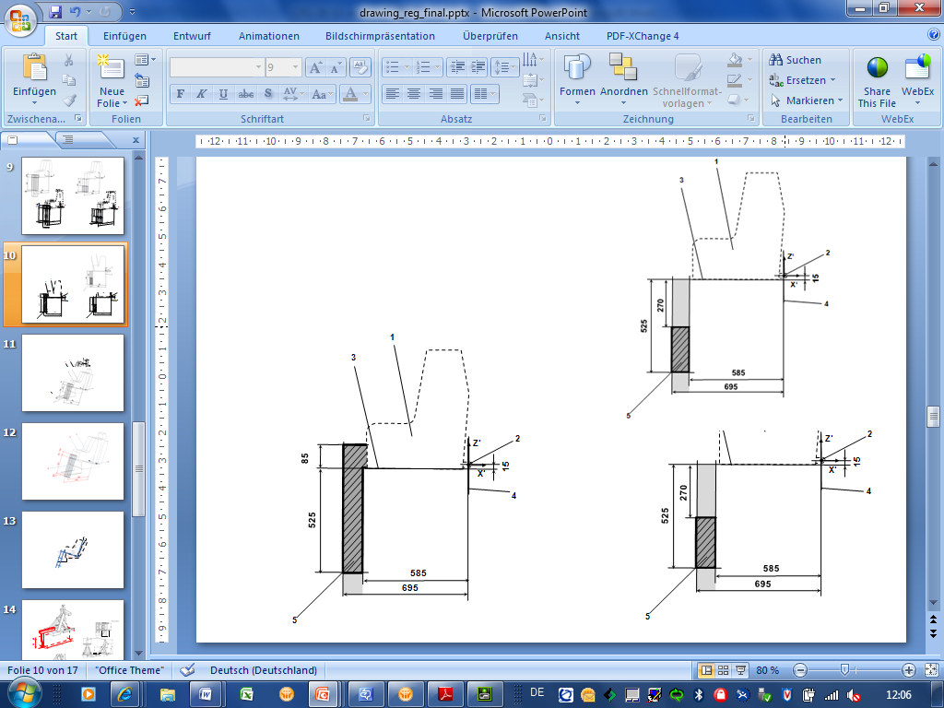(dimensions in mm)

*Key:*

1. Enhanced Child Restraint Fixture (CRF).

2. ISOFIX low anchorages bar.

3. Plane formed by the bottom surface of the CRF, which is parallel to and 15 mm below the X'-Y' plane of the coordinate system.

4. Z'-Y' plane of the coordinate system.

5. Upper part of the support-leg dimension assessment volume, which shows the dimensional limitations in X' and Y' direction, the upper height limit in Z' direction, as well as the lower height limitation in Z' direction for rigid, not in Z' direction adjustable support leg components.

*Note:*

1. Drawing not to scale.

# Figure 2

**3D view of the support leg dimension assessment volume**

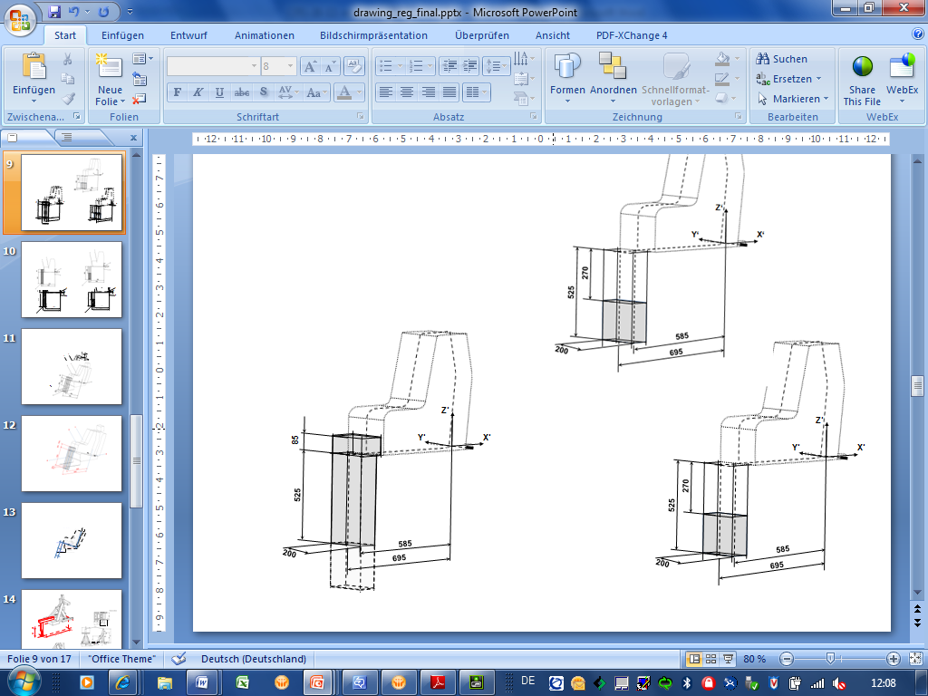(dimensions in mm)

*Note:*

1. Drawing not to scale.

# Figure 3

**Side view of the support leg foot assessment volume**

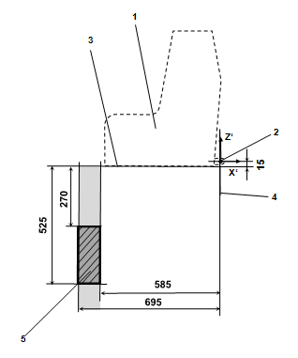(dimensions in mm)

6

6

*Key:*

1. Child Restraint Fixture (CRF)

2. ISOFIX low anchorages bar

3. Plane formed by the bottom surface of the CRF, which is parallel to and 15 mm below the X'-Y' plane of the coordinate system

4. Z'-Y' plane of the coordinate system

5. Support-leg foot assessment volume, which shows the required adjustment range of the support-leg foot in Z' directions, as well as the dimensional limitations in X' and Y' direction

6. Additional volumes shows the additional permissible adjustment range in Z' direction for the support-leg foot

*Note:*

1. Drawing not to scale.

# Figure 4

**3D view of the support leg foot assessment volume**

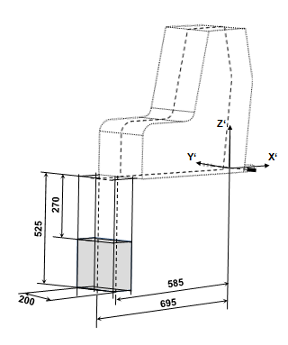(dimensions in mm)

*Note:*

1. Drawing not to scale.

Annex 20

Minimum list of documents required for approval

|  | *i-Size or i-Size booster seat Enhanced Child Restraint System* | *Specific vehicle, ISOFIX or booster seat Enhanced Child Restraint System* | *paragraph:* |
| --- | --- | --- | --- |
| General documents | Application letter/request | Application letter/request | 3.1. |
|  | Technical description of the Enhanced Child Restraint System | Technical description of the Enhanced Child Restraint System | 3.2.1. |
|  | Installation instruction for retractors | Installation instruction for retractors | 3.2.1. |
|  | Declaration on toxicity | Declaration on toxicity | 3.2.1. |
|  | Declaration on flammability | Declaration on flammability | 3.2.1. |
|  | Instructions and details of packaging | Instructions and details of packaging | 3.2.6. |
|  | Material specifications of the parts | Material specifications of the parts | 2.46. and 2.2.1.1. of Annex 12 |
|  | Assembly instructions for removable parts | Assembly instructions for removable parts | 6.2.3. |
|  | Documentation on information for users | Documentation on information for users, including reference to the applicable vehicle(s) | 14. |
|  |  | List of vehicle model(s) | Annex 1 |
|  | CoP clearance documents including company organisation chart, Chamber of Commerce registry, production plant declaration, quality system certificate, CoP procedure declaration | CoP clearance documents including company organisation chart, Chamber of Commerce registry, production plant declaration, quality system certificate, CoP procedure declaration and declaration on procedures for sampling per product type | 3.1. and  Annex 11 |
| Drawings/ pictures | Exploded view drawing of Enhanced Child Restraint System and drawings of all its relevant parts | Exploded view drawing of Enhanced Child Restraint System and drawings of all its relevant parts | 3.2.1. and  Annex 1 |
|  | Position of approval mark | Position of approval mark | 3.2.1. |
|  |  | Drawings or pictures regarding the combination of the Enhanced Child Restraint System and the car or the ISOFIX seating position and the relevant car environment1 | 3.2.3. |
|  |  | Drawings of vehicle and seat structure, adjustment system and attachments1 | Annex 1 |
|  | Photographs of Enhanced Child Restraint System | Photographs of Enhanced Child Restraint System and/or vehicle and seat structure | Annex 1 |
|  | In case not marked on the sample(s) at the time of submission for approval:  Example of marking of manufacturer's name, initials or trade mark, the year of production, orientation, warning labels, i-Size logo, size range, occupant mass and additional markings. | In case not marked on the sample(s) at the time of submission for approval:  Example of marking of manufacturer's name, initials or trade mark, the year of production, orientation, warning labels, i-Size logo, size range, occupant mass, specific vehicle ISOFIX marking and additional markings. | 4. |
| 1 In case tested on the test trolley in a vehicle body shell in conformity with paragraph 7.1.3.2. or in a complete vehicle in conformity with paragraph 7.1.3.3. of this Regulation. | | | |

Annex 21

Load application devices

Load application device I

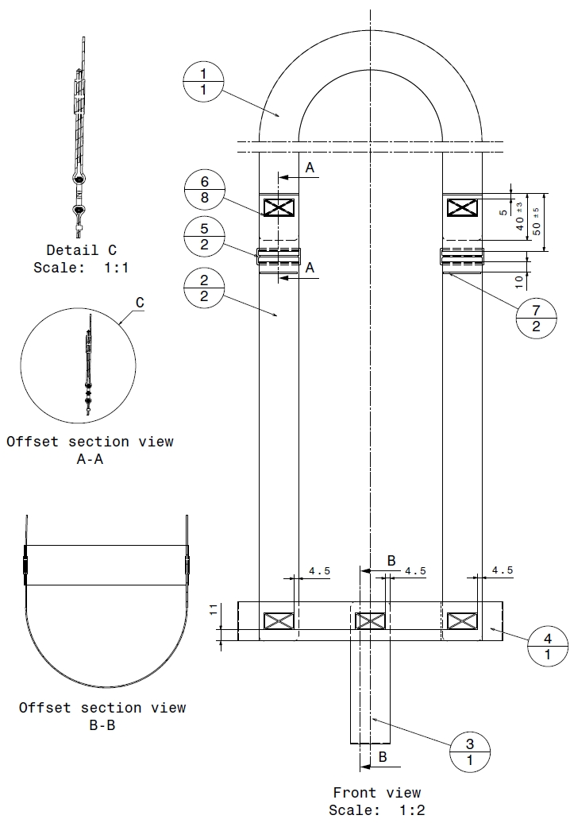

# Table 1

| *No.* | *Part Number* | *Name* | *Information* | *Quantity* |
| --- | --- | --- | --- | --- |
| 1 | PV000009.1 | Head belt – 39 mm | - | 1 |
| 2 | PV000009.2 | Shoulder belt lh-rh – 39 mm | - | 2 |
| 3 | PV000009.3 | Crotch belt – 39 mm | - | 1 |
| 4 | PV000009.4 | Hip belt – 39 mm | - | 1 |
| 5 | 102 18 31 | Stitch pattern (30 x 17) | Stitch: 77, thread: 30, colour: SABA grey | 8 |
| 6 | PV000009.5 | Plastic buckle |  | 2 |
| 7 | PV000009.6 | Stitch pattern (2 x 37) | Stitch: 77, thread: 30, colour: SABA grey | 2 |

# Table 2

| *Stretch length* | *(***±***5 mm)* |  |  |  |  |  |
| --- | --- | --- | --- | --- | --- | --- |
|  | *Dummy Q 0* | *Q 1* | *Q 1.5* | *Q 3* | *Q 6* | *Q 10* |
| Head belt | 1,000 mm | 1,000 mm | 1,000 mm | 1,200 mm | 1,200 mm | 1,200 mm |
| Shoulder belt | 750 mm | 850 mm | 950 mm | 1,000 mm | 1,100 mm | 1,300 mm |
| Crotch belt | 300 mm | 350 mm | 400 mm | 400 mm | 450 mm | 570 mm |
| Hip belt | 400 mm | 500 mm | 550 mm | 600 mm | 700 mm | 800 mm |
| Dimension X | 120 mm | 130 mm | 140 mm | 140 mm | 150 mm | 160 mm |

# Table 3

| *Belt* |  |  |  |
| --- | --- | --- | --- |
| *Width* | *Thickness* | *Expansion* | *Fastness* |
| 39 mm ± 1 mm | 1 mm ± 0.1 mm | 5.5 – 6.5 % | Min. 15,000 N |

# Table 4

|  |  |
| --- | --- |
| *Stich pattern* | *Min. required force* |
| 12 x 12 mm | 3.5 kN |
| 30 x 12 mm | 5.3 kN |
| 30 x 17 mm | 5.3 kN |
| 30 x 30 mm | 7.0 kN |

all belt radius = 5 mm

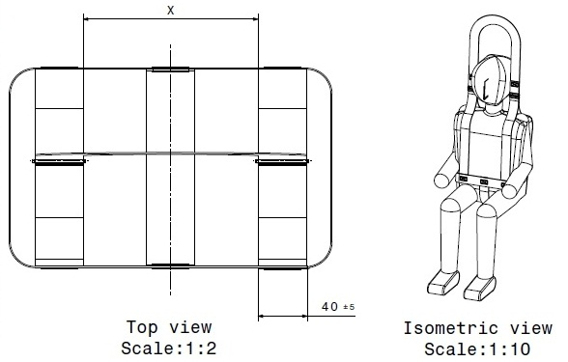

Load application device II



# Table 5

|  |  |  |  |
| --- | --- | --- | --- |
| *No.* | *Name* | *Information* | *Quantity* |
| 1 | Main belt – 39 mm | - | 1 |
| 2 | Hip belt (upper/lower) – 39 mm | - | 2 |
| 3 | Stitch pattern (30 x 17) | Stitch 77, thread 30 | 4 |

# Table 6

| *Stretch length* | *(+/- 5 mm)* |  |  |  |  |
| --- | --- | --- | --- | --- | --- |
|  | *Q 0* | *Q 1* | *Q 1,5* | *Q 3* | *Q 6* |
| Main belt (A) | 1 740 mm | 1 850 mm | 1 900 mm | 2 000 mm | 2 000 mm |
| Hip belt (B) | 530 mm | 560 mm | 600 mm | 630 mm | 660 mm |
| Lower dimension (C) | 125 mm | 150 mm | 150 mm | 170 mm | 200 mm |
| Mid dimension (D) | 270 mm | 300 mm | 350 mm | 380 mm | 380 mm |

# Table 7

| *Belt* |  |  |  |
| --- | --- | --- | --- |
| *Width* | *Thickness* | *Expansion* | *Fastness* |
| 39 mm ± 1 mm | 1 mm ± 0.1 mm | 5.5 – 6.5 % | Min. 15,000 N |

# Table 8

|  |  |
| --- | --- |
| *Stich pattern* | *Min. required force* |
| 12 x 12 mm | 3.5 kN |
| 30 x 12 mm | 5.3 kN |
| 30 x 17 mm | 5.3 kN |
| 30 x 30 mm | 7.0 kN |

all belt radius = 5 mm

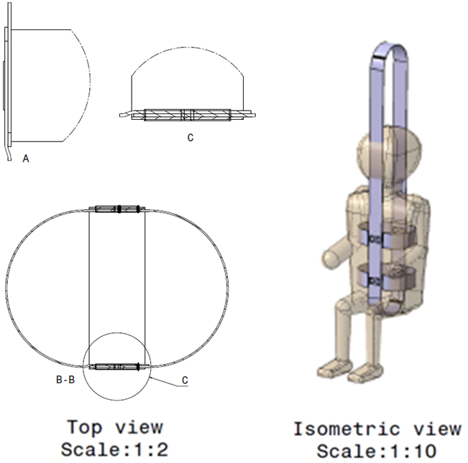

All dimensions in millimetres (mm)

Annex 22

Flammability of materials intended to be used in built-in Enhanced Child Restraint Systems

1. Definitions

*"Occupant compartment air space"* means the space within the occupant compartment that normally contains refreshable air.

2. Material selection (see Figure 1 below)

2.1. Any portion of a single or composite material which is within 13 mm of the occupant compartment air space shall meet the requirements in Paragraph 6.1.6.

2.1.1. Any material that does not adhere to other material(s) at every point of contact shall meet the requirements of paragraph 6.1.6. when tested separately

2.1.2. Any material that adheres to other materials at every point of contact shall meet the requirements of paragraph 6.1.6. when tested as a composite with the other material(s).

Material A has a non-adhering interface with material B and is tested separately.

Part of material B is within 13 mm of the occupant compartment air space, and materials B and C adhere at every point of contact; therefore, B and C are tested as a composite.

The cut is in material C as shown in Figure 1, to make a specimen 13 mm thick.

# Figure 1



3. Test procedure

3.1. The test is conducted in a metal cabinet for protecting the test specimens from drafts. The interior of the cabinet is 381 mm long, 203 mm deep, and 356 mm high. It has a glass observation window in the front, a closable opening to permit insertion of the specimen holder, and a hole to accommodate tubing for a gas burner. For ventilation, it has a 13 mm clearance space around the top of the cabinet, ten holes in the base of the cabinet, each hole 19 mm in diameter and legs to elevate the bottom of the cabinet by 10 mm, all located as shown in Figure 2.

3.2. Prior to testing, each specimen is conditioned for 24 hours at a temperature of 21° C, and a relative humidity of 50 per cent, and the test is conducted under those ambient conditions.

3.3. The test specimen is inserted between two matching U-shaped frames of metal stock 25 mm wide and 10 mm high.

The interior dimensions of the U-shaped frames are 51 mm wide by 330 mm long.

A specimen that softens and bends at the flaming end so as to cause erratic burning is kept horizontal by supports consisting of thin, heat-resistant wires, spanning the width of the U-shaped frame under the specimen at 25 mm intervals.

A device that may be used for supporting this type of material is an additional U-shaped frame, wider than the U-shaped frame containing the specimen, spanned by 10-mil wires of heat-resistant composition at 25 mm intervals, inserted over the bottom U-shaped frame.

3.4. A bunsen burner with a tube of 10 mm inside diameter is used.

The gas adjusting valve is set to provide a flame, with the tube vertical, of 38 mm in height. The air inlet to the burner is closed.

3.5. The gas supplied to the burner has a flame temperature equivalent to that of natural gas.

4. Preparation of specimens

4.1. Each specimen of material to be tested shall be a rectangle 102 mm wide by 356 mm long, wherever possible.

The thickness of the specimen is that of the single or composite material used in the vehicle, except that if the material's thickness exceeds 13 mm, the specimen is cut down to that thickness measured from the surface of the specimen closest to the occupant compartment air space.

Where it is not possible to obtain a flat specimen because of surface curvature, the specimen is cut to not more than 13 mm in thickness at any point.

The maximum available length or width of a specimen is used where either dimension is less than 356 mm or 102 mm.

4.2. The specimen is produced by cutting the material in longitudinal as well as transvers direction.

The specimen is oriented so that the surface closest to the occupant compartment air space faces downward on the test frame.

4.3. Material with a napped or tufted surface is placed on a flat surface and combed twice against the nap with a comb having seven to eight smooth, rounded teeth per 25 mm.

5. Test

5.1. Mount the specimen so that both sides and one end are held by the U-shaped frame, and specimen is not more than 51 mm, so that the sides of the specimen cannot be held in the U-shaped frame, place the specimen in position on wire supports as described in 2.3, with one end held by the closed end of the U-shaped frame.

5.2. Place the mounted specimen in a horizontal position, in the center of the cabinet.

5.3. With the flame adjusted according to 2.4, position the bunsen burner and specimen so that the center of the burner tip is 19 mm below the center of the bottom edge of the open end of the specimen.

5.4. Expose the specimen to the flame for 15 seconds.

5.5. Begin timing (without reference to the period of application of the burner flame) when the flame from the burning specimen reaches a point 38 mm from the open end of the specimen.

5.6. Measure the time that it takes the flame to progress to a point 38 mm from the clamped end of the specimen. If the flame does not reach the specified end point, time its progress to the point where flaming stops.

5.7. Calculate the burn rate from the formula:

B = 60 x (D/T)

Where:

B = Burn rate in millimeters per minute

D = Length the flame travels in millimeters, and

T = Time in seconds for the flame to travel D millimeters.

# Figure 2

All dimensions in millimeters (mm)



Annex 23

Standard safety-belt

1. The safety-belt for the dynamic test and for the maximum length requirements shall be made according to the definition shown in Figure 1. These are a three-point retracting belt system.

2. The three-point retracting belt has the following rigid parts: a retractor (R), a pillar loop (P), two anchorage points (A1 and A2) (see Figure 1), and a central part (N, in detail in Figure 3). The retractor shall comply with the requirements of UN Regulation No. 16 (paragraph 6.2.5.2.2.) for retraction force. The retractor spool diameter is 33 ±0.5 mm (example is given in Mutual Resolution No. 1 (M.R.1)).

3. The retracting belt shall be fitted to the anchorages on the test bench, described in Annex 6, Appendix 2 as follows:

(a) Belt anchorage A1 shall be fitted to trolley anchorages B0 (outboard);

(b) Belt anchorage A2 shall be fitted to trolley anchorage A (inboard);

(c) Belt pillar loop P shall be fitted to trolley anchorage C;

(d) Belt retractor R shall be fitted to trolley anchorage such that the spool centre line is positioned on Re.

The value of X in Figure 1 below is 200 ±5 mm. The effective strap length between A1 and the centre line of the retractor spool Re (when the webbing is fully extracted including the minimum length of 150 mm for testing of Enhanced Child Restraint System shall be 2,820 ±5 mm when measured in a straight line without load and on a horizontal surface. This length may be increased for the testing of restricted categories; for all categories with the Enhanced Child Restraint System installed, there shall be a minimum of 150 mm of strap length on the retractor spool.

4. The strap requirements for the belt as follows:

(a) Material: polyester spinnblack;

(b) Width: 48 ±2 mm at 10,000 N;

(c) Thickness: 1.0 ±0.2 mm;

(d) Elongation: 8 ±2 per cent at 10,000 N.

# Figure 1

**Standard seat belt configurations**

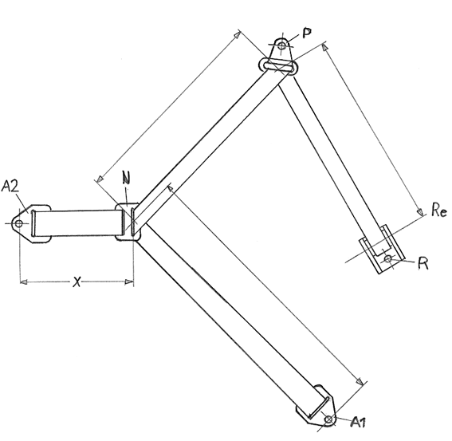

# Figure 2

**Typical standard anchorage plate**

(Dimensions in mm)



# Figure 3

**Central part of the standard belt configuration**



# Figure 4

**Pillar loop**

Finish: Chromium plated

(Dimensions in mm)



**Annex 24**

Additional attachment points required for securing rearward facing Enhanced Child Restraint System, of category Specific vehicle Belted, to motor vehicles

1. This annex applies only to the additional anchorages for attaching Enhanced Child Restraint in the Specific vehicle Belted category or to bars or other special items used to secure child-restraining devices to the bodywork, whether or not they make use of UN Regulation No. 14 or UN Regulation No. 144on ISOFIX anchorage systems, ISOFIX top tether anchorages and i-Size seating positions.

2. The anchorages shall be determined by the manufacturer of the child restraint system and details shall be submitted for approval to the Technical Service conducting the tests.

The Technical Services may consider information obtained from the vehicle manufacturer.

3. The manufacturer of the child restraint shall provide the necessary parts for fitting the anchorages and a special plan for each vehicle showing their exact location.

4. The child restraint manufacturer shall indicate if the anchorages required for attaching the restraint to the vehicle structure are in accordance with the position and strength requirements of paragraph 3. onwards in the recommendation given to Governments intending to adopt specific requirements relating to anchorages for child restraints used in passenger cars.

1. * Former titles of the Agreement:

   Agreement concerning the Adoption of Uniform Conditions of Approval and Reciprocal Recognition of Approval for Motor Vehicle Equipment and Parts, done at Geneva on 20 March 1958 (original version);

   Agreement concerning the Adoption of Uniform Technical Prescriptions for Wheeled Vehicles, Equipment and Parts which can be Fitted and/or be Used on Wheeled Vehicles and the Conditions for Reciprocal Recognition of Approvals Granted on the Basis of these Prescriptions, done at Geneva on 5 October 1995 (Revision 2).
2. Detail B describes the standard dimensions without ISOFIX attachments. Figure 1 gives the dimensions for optional stowable ISOFIX attachments.
3. The distinguishing numbers of the Contracting Parties to the 1958 Agreement are reproduced in Annex 3 to the Consolidated Resolution on the Construction of Vehicles (R.E.3), document ECE/TRANS/WP.29/78/Rev.6, Annex 3 –

   [www.unece.org/trans/main/wp29/wp29wgs/wp29gen/wp29resolutions.html](http://www.unece.org/trans/main/wp29/wp29wgs/wp29gen/wp29resolutions.html)
4. Child restraint fixture (CRF) as defined in UN Regulation No. 16 (Safety-belts)
5. g = 9.81 m/s2.
6. Distinguishing number of the country which has granted/extended/refused/withdrawn approval (see approval provisions in this Regulation).
7. Strike out what does not apply.
8. The dimension shall be of 210 mm with an adjustment range of ±70 mm.
9. The address to obtain the relevant ASTM standards is: ASTM, 1916 Race Street, Philadelphia, USA PA 19 103.
10. The configurations of each dummy or abdominal pressure sensors are described and deposited in a transitory way on the website of the informal working group on Child Restraint Systems: https://www2.unece.org/wiki/display/trans/Q-Dummy+drawings
11. The technical specifications and detailed drawings of Q-dummy and APTS, and the technical specifications for their adjustment for the tests of this Regulation are deposited in a transitory way on the website of the informal working group on Child Restraint Systems (https://www2.unece.org/wiki/display/trans/Q-dummy+drawings) of the UNECE, Palais de Nations, Geneva, Switzerland. At the time of the adoption of this Regulation by the World Forum for Harmonization of Vehicle Regulations (WP.29), the text restricting the use of the drawings and technical specifications will be removed from the individual pages and they will be reloaded on the above-mentioned website. After a time period needed by the Informal Working Group to finalize the examination of the technical specifications and drawings of dummies to cover the phase 2 of the Regulation, the final and agreed drawings will be relocated in the Mutual Resolution of the 1958 and 1998 Agreements, hosted in the website of the World Forum WP.29.
12. The distance "a" is equal to the length of the synchronous pendulum under consideration.
13. The acceleration (a) referring to the centre of gravity is calculated from the triaxial components of the acceleration measured with a CFC of 1,000.